Philippine Bidding Documents
(As Harmonized with Development Partners)

Government of the Republic of the Philippines
Department of Education
Region X
DIVISION OF MISAMIS ORIENTAL
Cagayan de Oro City

Bidding Documents

SUPPLY AND DOOR TO DOOR DELIVERY OF SCHOOL FURNITURE to various Schools within the DepED, Division of Misamis Oriental, chargeable against the CY 2016 BEFF – Provision of School Furniture Batch 7 for the New Classrooms Programmed under CY 2016 BEFF Construction of Classrooms

Basic Educational Facilities Funds

P.B. No. 2017-BEFF-02

Fifth Edition
August 2016

Preface

These Philippine Bidding Documents (PBDs) for the procurement of Goods through Competitive Bidding have been prepared by the Government of the Philippines (GOP) for use by all branches, agencies, departments, bureaus, offices, or instrumentalities of the government, including government-owned and/or -controlled corporations (GOCCs), government financial institutions (GFIs), state universities and colleges (SUCs), and local government units (LGUs) and autonomous regional government. The procedures and practices presented in this document have been developed through broad experience, and are for mandatory use in projects that are financed in whole or in part by the GOP or any foreign government/foreign or international financing institution in accordance with the provisions of the 2016 Revised Implementing Rules and Regulations (IRR) of Republic Act (RA) 9184.

The Bidding Documents shall clearly and adequately define, among others: (a) the objectives, scope, and expected outputs and/or results of the proposed contract; (b) the eligibility requirements of bidders, such as track record to be determined by the Head of the Procuring Entity; (c) the expected contract duration, the estimated quantity in the case of procurement of goods, delivery schedule and/or time frame; and (d) the obligations, duties, and/or functions of the winning bidder.

In order to simplify the preparation of the Bidding Documents for each procurement, the PBDs groups the provisions that are intended to be used unchanged in Section II. Instructions to Bidders (ITB) and in Section IV. General Conditions of Contract (GCC). Data and provisions specific to each procurement and contract should be included in Section III. Bid Data Sheet (BDS); Section V. Special Conditions of Contract (SCC); Section VI. Schedule of Requirements; Section VII. Technical Specifications, and Section IX. Foreign-Assisted Projects. The forms to be used are provided in Section VIII. Bidding Forms.

Care should be taken to check the relevance of the provisions of the PBDs against the requirements of the specific Goods to be procured. In addition, each section is prepared with notes intended only as information for the Procuring Entity or the person drafting the Bidding Documents. They shall not be included in the final documents, except for the notes introducing Section VIII. Bidding Forms where the information is useful for the Bidder. The following general directions should be observed when using the documents:

- All the documents listed in the Table of Contents are normally required for the procurement of Goods. However, they should be adapted as necessary to the circumstances of the particular Project.

- Specific details, such as the “name of the Procuring Entity” and “address for bid submission,” should be furnished in the ITB, BDS, and SCC. The final documents should contain neither blank spaces nor options.

- This Preface and the footnotes or notes in italics included in the Invitation to Bid, BDS, SCC, Schedule of Requirements, and Specifications are not part of the text of the final document, although they contain instructions that the Procuring Entity should strictly follow. The Bidding Documents should contain no footnotes except Section VIII. Bidding Forms since these provide important guidance to Bidders.

- The cover should be modified as required to identify the Bidding Documents as to the names of the Project, Contract, and Procuring Entity, in addition to date of issue.

- If modifications must be made to bidding requirements, they can be presented in the BDS. Modifications for specific Project or Contract details should be provided in the SCC as amendments to the Conditions of Contract. For easy completion, whenever reference has to be made to specific clauses in the BDS or SCC these terms shall be printed in bold type face on Section I. Instructions to Bidders and Section III. General Conditions of Contract, respectively.

TABLE OF CONTENTS

Section I. Invitation to Bid 5
Section II. Instructions to Bidders 11
Section III. Bid Data Sheet 42
Section IV. General Conditions of Contract 50
Section V. Special Conditions of Contract 67
Section VI. Schedule of Requirements 74
Section VII. Technical Specifications 75
Section VIII. Bidding Forms 81
Section IX. Foreign-Assisted Projects 95

Section I. Invitation to Bid
Notes on the Invitation to Bid

The Invitation to Bid provides information that enables potential Bidders to decide whether to participate in the procurement at hand. The Invitation to Bid shall be:

(a) Posted continuously in the Philippine Government Electronic Procurement System (PhilGEPS) website, the website of the Procuring Entity concerned, if available, and the website prescribed by the foreign government/foreign or international financing institution, if applicable, for seven (7) calendar days starting on the date of advertisement;

(b) Posted at any conspicuous place reserved for this purpose in the premises of the Procuring Entity concerned for seven (7) calendar days, as certified by the head of the Bids and Awards Committee (BAC) Secretariat of the Procuring Entity concerned; and

(c) Advertised at least once in a newspaper of general nationwide circulation which has been regularly published for at least two (2) years before the date of issue of the advertisement, subject to Section 21.2.1(c) of the IRR of RA 9184.

Apart from the essential items listed in the Bidding Documents, the Invitation to Bid should also indicate the following:

- The date of availability of the Bidding Documents, which shall be from the time the Invitation to Bid is first advertised/posted until the deadline for the submission and receipt of bids;

- The place where the Bidding Documents may be acquired or the website where it may be downloaded;

- The deadline for the submission and receipt of bids from the last day of posting of the Invitation to Bid; and

- Any important bid evaluation criteria (e.g., the application of a margin of preference in bid evaluation).

The Invitation to Bid should be incorporated in the Bidding Documents. The information contained in the Invitation to Bid must conform to the Bidding Documents and in particular to the relevant information in the BDS.

For foreign-assisted projects, the Invitation to Bid to be used is provided in Section IX-Foreign-Assisted Projects.

Department of Education

Region X
DIVISION OF MISAMIS ORIENTAL
Cagayan de Oro City
Tel Nos. (088)856-4454 & (08822) 72-46-15
FAX No. (088)856-4524/ e-mail: deped misoriental@yahoo.com

Invitation to Bid

SUPPLY AND DOOR TO DOOR DELIVERY OF SCHOOL FURNITURE to various Schools within the DepED, Division of Misamis Oriental, chargeable against the CY 2016 BEFF – Provision of School Furniture Batch 7 for the New Classrooms Programmed under CY 2016 BEFF Construction of Classrooms

- The Department of Education Division of Misamis Oriental, through the [FY 2016 General Appropriations Act] intends to apply the sum of EIGHT MILLION EIGHT HUNDRED SEVENTY FIVE THOUSAND (Php 8,875,000.00) Pesos) being the Approved Budget for the Contract (ABC) to payments under the contract for each lot/item for SUPPLY AND DOOR TO DOOR DELIVERY OF SCHOOL FURNITURE to various Schools within the DepED, Division of Misamis Oriental, chargeable against the CY 2016 BEFF – Provision of School Furniture Batch 7 for the New Classrooms Programmed under CY 2016 BEFF Construction of Classrooms]. Bids received in excess of the ABC for each lot shall be automatically rejected at bid opening.

Lot No. | Item Description | Quantity | Unit | ABC (PhP)
1 | ES/ JHS Armchairs, per approved DepED Design  Specifications | 11,250 | pcs | Php 7,875,000.00
2 | Teacher’s Table and Chair, per approved DepED Design  Specifications | 250 | set | Php 1,000,000.00

- The Department of Education Division of Misamis Oriental now invites bids for SUPPLY AND DOOR TO DOOR DELIVERY OF SCHOOL FURNITURE to various Schools within the DepED, Division of Misamis Oriental, chargeable against the CY 2016 BEFF – Provision of School Furniture Batch 7 for the New Classrooms Programmed under CY 2016 BEFF Construction of Classrooms. Delivery of the Goods is required in 120 calendar days. Bidders should have completed, within ten years from the date of submission and receipt of bids, a contract similar to the Project. The description of an eligible bidder is contained in the Bidding Documents, particularly, in Section II. Instructions to Bidders.

- Bidding will be conducted through open competitive bidding procedures using a non-discretionary “pass/fail” criterion as specified in the 2016 Revised Implementing Rules and Regulations (IRR) of Republic Act (RA) 9184, otherwise known as the “Government Procurement Reform Act”.

- Bidding is open to all interested bidders, whether local or foreign, subject to the conditions for eligibility provided in the IRR of RA 9184.

- Interested bidders may obtain further information from [The Chairman of the Bids and Awards Committee of the DepED, Division of Misamis Oriental] and inspect the Bidding Documents at the address given below during [September 4, 2017 to October 2, 2017, 8:30am PST.].

- A complete set of Bidding Documents may be acquired by interested Bidders on [September 4, 2017 to October 2, 2017 8:30am PST] from the address below {Insert if necessary: and upon payment of the applicable fee for the Bidding Documents, pursuant to the latest Guidelines issued by the GPPB, in the amount of [TEN THOUSAND (Php 10,000.00) Pesos.] Note: For lot procurement, the maximum fee for the Bidding Documents for each lot shall be based on its ABC, in accordance with the Guidelines issued by the GPPB; provided that the total fees for the Bidding Documents of all lots shall not exceed the maximum fee prescribed in the Guidelines for the sum of the ABC of all lots.}.

It may also be downloaded free of charge from the website of the Philippine Government Electronic Procurement System (PhilGEPS) and the website of the Procuring Entity, provided that Bidders shall pay the applicable fee for the Bidding Documents not later than the submission of their bids.

The bidder shall have the option to participate in any or in all of the two (2) lots in the project stated in Paragraph 1 provided that it is within bidder’s contracting capacity based on the NFCC.

- The DepED, Division of Misamis Oriental ] will hold a Pre-Bid Conference on [September 12, 2017, 1:00 o’clock in the afternoon] at Department of Education, Division of Misamis Oriental, Division Office Conference Room, A. Velez St., Cagayan de Oro City temporarily located at 2nd floor of Gregorio Pelaez Sports Center in the same street, which shall be open to prospective bidders.

- Sample of the Armchairs and Teacher’s table and chair is a requirement. Prospective bidders are encourage to submit the samples a day before the Opening of Bid.

- During the Contract Implementation, the school furniture must be inspected following the inspection procedures: (1) Pre-Delivery Inspection Stage (2) On-Site Delivery Inspection Stage (3) Post-Delivery Inspection Stage

- Bids must be duly received by the BAC Secretariat at the address below on or before [October 2, 2017, 1:00pm PST]. All Bids must be accompanied by a bid security in any of the acceptable forms and in the amount stated in ITB Clause 18.

Bidders shall submit their bids through their duly authorized representative using the appropriate forms provided in Bidding Forms on or before the deadline opening of bids in two (2) separate sealed bid envelopes, and which shall be submitted simultaneously. A duly authorized representative shall submit special power of attorney/ a notarized certification authorizing him/her to represent the proprietor/ manager/ owner.

Bid opening shall be on [October 2, 2017, 1:00pm PST] at Department of Education, Division of Misamis Oriental, Division Office Conference Room, A. Velez St., Cagayan de Oro City temporarily located at 2nd floor of Gregorio Pelaez Sports Center in the same street. Bids will be opened in the presence of the bidders’ representatives who choose to attend at the address below. Late bids maybe received by the Secretariat but shall be declared late by the BAC and shall not be accepted as an eligible bid during the Opening of bids. It shall be recorded in the Minutes of Submission and Opening of Bids per ITB 22.

- Based on GPPB Circular 03-2016, bidders are required to submit their PhilGEPS
certificate of Registration (Platinum Membership) during bid submission.

- The DepED, Division of Misamis Oriental ] reserves the right to reject any and all bids, declare a failure of bidding, or not award the contract at any time prior to contract award in accordance with Section 41 of RA 9184 and its IRR, without thereby incurring any liability to the affected bidder or bidders.

- For further information, please refer to:

ELEONOR P. CRUZ
Supply Officer II
Chairman, BAC Secretariat
DepED Division of Misamis Oriental
A.Velez Street, Cagayan de Oro City
Tel. No. 08822-724615
www.depedmisor.net

JEAN G. VELOSO
Assistant Schools Division Superintendent
Chairman, Bids and Awards Committee

Section II. Instructions to Bidders
Notes on the Instructions to Bidders

This Section of the Bidding Documents provides the information necessary for bidders to prepare responsive bids, in accordance with the requirements of the Procuring Entity. It also provides information on bid submission, eligibility check, opening and evaluation of bids, post-qualification and on the award of contract.

This Section also contains provisions that are to be used unchanged. Section III consists of provisions that supplement, amend, or specify in detail, information or requirements included in Section II which are specific to each procurement.

Matters governing performance of the Supplier, payments under the contract, or matters affecting the risks, rights, and obligations of the parties under the contract are not normally included in this Section, but rather under Section IV. General Conditions of Contract (GCC), and/or Section V. Special Conditions of Contract (SCC). If duplication of a subject is inevitable in other sections of the document prepared by the Procuring Entity, care must be exercised to avoid contradictions between clauses dealing with the same matter.

TABLE OF CONTENTS

A. General 14
1. Scope of Bid 14
2. Source of Funds 14
3. Corrupt, Fraudulent, Collusive, and Coercive Practices 14
4. Conflict of Interest 15
5. Eligible Bidders 17
6. Bidder’s Responsibilities 18
7. Origin of Goods 20
8. Subcontracts 20
B. Contents of Bidding Documents 21
9. Pre-Bid Conference 21
10. Clarification and Amendment of Bidding Documents 21
C. Preparation of Bids 22
11. Language of Bid 22
12. Documents Comprising the Bid: Eligibility and Technical Components 22
13. Documents Comprising the Bid: Financial Component 24
14. Alternative Bids 25
15. Bid Prices 25
16. Bid Currencies 27
17. Bid Validity 27
18. Bid Security 28
19. Format and Signing of Bids 30
20. Sealing and Marking of Bids 30
D. Submission and Opening of Bids 31
21. Deadline for Submission of Bids 31
22. Late Bids 31
23. Modification and Withdrawal of Bids 32
24. Opening and Preliminary Examination of Bids 32
E. Evaluation and Comparison of Bids 34
25. Process to be Confidential 34
26. Clarification of Bids 34
27. Domestic Preference 34
28. Detailed Evaluation and Comparison of Bids 35
29. Post-Qualification 36
30. Reservation Clause 37
F. Award of Contract 38
31. Contract Award 38
32. Signing of the Contract 39
33. Performance Security 40
34. Notice to Proceed 41
35. Protest Mechanism…………………………………………………………………37

General

Scope of Bid
    - The Procuring Entity named in the BDS invites bids for the supply and delivery of the Goods as described in Section VII. Technical Specifications.
    - The name, identification, and number of lots specific to this bidding are provided in the BDS. The contracting strategy and basis of evaluation of lots is described in ITB Clause 28.

Source of Funds
The Procuring Entity has a budget or has received funds from the Funding Source named in the BDS, and in the amount indicated in the BDS. It intends to apply part of the funds received for the Project, as defined in the BDS, to cover eligible payments under the contract.

Corrupt, Fraudulent, Collusive, and Coercive Practices
    - Unless otherwise specified in the BDS, the Procuring Entity as well as the bidders and suppliers shall observe the highest standard of ethics during the procurement and execution of the contract. In pursuance of this policy, the Procuring Entity:
      - defines, for purposes of this provision, the terms set forth below as follows:
        - “corrupt practice” means behavior on the part of officials in the public or private sectors by which they improperly and unlawfully enrich themselves, others, or induce others to do so, by misusing the position in which they are placed, and includes the offering, giving, receiving, or soliciting of anything of value to influence the action of any such official in the procurement process or in contract execution; entering, on behalf of the government, into any contract or transaction manifestly and grossly disadvantageous to the same, whether or not the public officer profited or will profit thereby, and similar acts as provided in RA 3019.
        - “fraudulent practice” means a misrepresentation of facts in order to influence a procurement process or the execution of a contract to the detriment of the Procuring Entity, and includes collusive practices among Bidders (prior to or after bid submission) designed to establish bid prices at artificial, non-competitive levels and to deprive the Procuring Entity of the benefits of free and open competition.
        - “collusive practices” means a scheme or arrangement between two or more Bidders, with or without the knowledge of the Procuring Entity, designed to establish bid prices at artificial, non-competitive levels.
        - “coercive practices” means harming or threatening to harm, directly or indirectly, persons, or their property to influence their participation in a procurement process, or affect the execution of a contract;
        - “obstructive practice” is
(aa) deliberately destroying, falsifying, altering or concealing of evidence material to an administrative proceedings or investigation or making false statements to investigators in order to materially impede an administrative proceedings or investigation of the Procuring Entity or any foreign government/foreign or international financing institution into allegations of a corrupt, fraudulent, coercive or collusive practice; and/or threatening, harassing or intimidating any party to prevent it from disclosing its knowledge of matters relevant to the administrative proceedings or investigation or from pursuing such proceedings or investigation; or

(bb) acts intended to materially impede the exercise of the inspection and audit rights of the Procuring Entity or any foreign government/foreign or international financing institution herein.

      - will reject a proposal for award if it determines that the Bidder recommended for award has engaged in any of the practices mentioned in this Clause for purposes of competing for the contract.
    - Further, the Procuring Entity will seek to impose the maximum civil, administrative, and/or criminal penalties available under applicable laws on individuals and organizations deemed to be involved in any of the practices mentioned in ITB Clause (a).
    - Furthermore, the Funding Source and the Procuring Entity reserve the right to inspect and audit records and accounts of a bidder or supplier in the bidding for and performance of a contract themselves or through independent auditors as reflected in the GCC Clause 38.

Conflict of Interest
    - All Bidders found to have conflicting interests shall be disqualified to participate in the procurement at hand, without prejudice to the imposition of appropriate administrative, civil, and criminal sanctions. A Bidder may be considered to have conflicting interests with another Bidder in any of the events described in paragraphs (a) through (c) below and a general conflict of interest in any of the circumstances set out in paragraphs (d) through (g) below:
      - A Bidder has controlling shareholders in common with another Bidder;
      - A Bidder receives or has received any direct or indirect subsidy from any other Bidder;
      - A Bidder has the same legal representative as that of another Bidder for purposes of this bid;
      - A Bidder has a relationship, directly or through third parties, that puts them in a position to have access to information about or influence on the bid of another Bidder or influence the decisions of the Procuring Entity regarding this bidding process;
      - A Bidder submits more than one bid in this bidding process. However, this does not limit the participation of subcontractors in more than one bid;
      - A Bidder who participated as a consultant in the preparation of the design or technical specifications of the Goods and related services that are the subject of the bid; or
      - A Bidder who lends, or temporarily seconds, its personnel to firms or organizations which are engaged in consulting services for the preparation related to procurement for or implementation of the project, if the personnel would be involved in any capacity on the same project.
    - In accordance with Section 47 of the IRR of RA 9184, all Bidding Documents shall be accompanied by a sworn affidavit of the Bidder that it is not related to the Head of the Procuring Entity (HoPE), members of the Bids and Awards Committee (BAC), members of the Technical Working Group (TWG), members of the BAC Secretariat, the head of the Project Management Office (PMO) or the end-user unit, and the project consultants, by consanguinity or affinity up to the third civil degree. On the part of the Bidder, this Clause shall apply to the following persons:
      - If the Bidder is an individual or a sole proprietorship, to the Bidder himself;
      - If the Bidder is a partnership, to all its officers and members;
      - If the Bidder is a corporation, to all its officers, directors, and controlling stockholders;
      - If the Bidder is a cooperative, to all its officers, directors, and controlling shareholders or members; and
      - If the Bidder is a joint venture (JV), the provisions of items (a), (b), (c), or (d) of this Clause shall correspondingly apply to each of the members of the said JV, as may be appropriate.

Relationship of the nature described above or failure to comply with this Clause will result in the automatic disqualification of a Bidder.

Eligible Bidders
    - Unless otherwise provided in the BDS, the following persons shall be eligible to participate in this bidding:
      - Duly licensed Filipino citizens/sole proprietorships;
      - Partnerships duly organized under the laws of the Philippines and of which at least sixty percent (60%) of the interest belongs to citizens of the Philippines;
      - Corporations duly organized under the laws of the Philippines, and of which at least sixty percent (60%) of the outstanding capital stock belongs to citizens of the Philippines;
      - Cooperatives duly organized under the laws of the Philippines; and
      - Persons/entities forming themselves into a Joint Venture (JV), i.e., a group of two (2) or more persons/entities that intend to be jointly and severally responsible or liable for a particular contract: Provided, however, that Filipino ownership or interest of the JV concerned shall be at least sixty percent (60%).
    - Foreign bidders may be eligible to participate when any of the following circumstances exist, as specified in the BDS:
      - When a Treaty or International or Executive Agreement as provided in Section 4 of RA 9184 and its IRR allow foreign bidders to participate;
      - Citizens, corporations, or associations of a country, the laws or regulations of which grant reciprocal rights or privileges to citizens, corporations, or associations of the Philippines;
      - When the Goods sought to be procured are not available from local suppliers; or
      - When there is a need to prevent situations that defeat competition or restrain trade.
    - Government owned or –controlled corporations (GOCCs) may be eligible to participate only if they can establish that they (a) are legally and financially autonomous, (b) operate under commercial law, and (c) are not attached agencies of the Procuring Entity.
    - Unless otherwise provided in the BDS, the Bidder must have completed a Single Largest Completed Contract (SLCC) similar to the Project and the value of which, adjusted, if necessary, by the Bidder to current prices using the Philippine Statistics Authority (PSA) consumer price index, must be at least equivalent to a percentage of the ABC stated in the BDS.

For this purpose, contracts similar to the Project shall be those described in the BDS, and completed within the relevant period stated in the Invitation to Bid and ITB Clause 12.1(a)(ii).
    - The Bidder must submit a computation of its Net Financial Contracting Capacity (NFCC), which must be at least equal to the ABC to be bid, calculated as follows:
NFCC = [(Current assets minus current liabilities) (15)] minus the value of all outstanding or uncompleted portions of the projects under ongoing contracts, including awarded contracts yet to be started, coinciding with the contract to be bid.

The values of the domestic bidder’s current assets and current liabilities shall be based on the latest Audited Financial Statements submitted to the BIR.

For purposes of computing the foreign bidders’ NFCC, the value of the current assets and current liabilities shall be based on their audited financial statements prepared in accordance with international financial reporting standards.

If the prospective bidder opts to submit a committed Line of Credit, it must be at least equal to ten percent (10%) of the ABC to be bid. If issued by a foreign universal or commercial bank, it shall be confirmed or authenticated by a local universal or commercial bank.

Bidder’s Responsibilities
    - The Bidder or its duly authorized representative shall submit a sworn statement in the form prescribed in Section VIII. Bidding Forms as required in ITB Clause 12.(iii).
    - The Bidder is responsible for the following:
      - Having taken steps to carefully examine all of the Bidding Documents;
      - Having acknowledged all conditions, local or otherwise, affecting the implementation of the contract;
      - Having made an estimate of the facilities available and needed for the contract to be bid, if any;
      - Having complied with its responsibility to inquire or secure Supplemental/Bid Bulletin(s) as provided under ITB Clause 10.4.
      - Ensuring that it is not “blacklisted” or barred from bidding by the GOP or any of its agencies, offices, corporations, or LGUs, including foreign government/foreign or international financing institution whose blacklisting rules have been recognized by the GPPB;

      - Ensuring that each of the documents submitted in satisfaction of the bidding requirements is an authentic copy of the original, complete, and all statements and information provided therein are true and correct;

      - Authorizing the HoPE or its duly authorized representative/s to verify all the documents submitted;

      - Ensuring that the signatory is the duly authorized representative of the Bidder, and granted full power and authority to do, execute and perform any and all acts necessary and/or to represent the Bidder in the bidding, with the duly notarized Secretary’s Certificate attesting to such fact, if the Bidder is a corporation, partnership, cooperative, or joint venture;

      - Complying with the disclosure provision under Section 47 of RA 9184 and its IRR in relation to other provisions of RA 3019;

      - Complying with existing labor laws and standards, in the case of procurement of services; Moreover, bidder undertakes to:

        - Ensure the entitlement of workers to wages, hours of work, safety and health and other prevailing conditions of work as established by national laws, rules and regulations; or collective bargaining agreement; or arbitration award, if and when applicable.

In case there is a finding by the Procuring Entity or the DOLE of underpayment or non-payment of workers’ wage and wage-related benefits, bidder agrees that the performance security or portion of the contract amount shall be withheld in favor of the complaining workers pursuant to appropriate provisions of Republic Act No. 9184 without prejudice to the institution of appropriate actions under the Labor Code, as amended, and other social legislations.

        - Comply with occupational safety and health standards and to correct deficiencies, if any.

In case of imminent danger, injury or death of the worker, bidder undertakes to suspend contract implementation pending clearance to proceed from the DOLE Regional Office and to comply with Work Stoppage Order; and

        - Inform the workers of their conditions of work, labor clauses under the contract specifying wages, hours of work and other benefits under prevailing national laws, rules and regulations; or collective bargaining agreement; or arbitration award, if and when applicable, through posting in two (2) conspicuous places in the establishment’s premises; and

      - Ensuring that it did not give or pay, directly or indirectly, any commission, amount, fee, or any form of consideration, pecuniary or otherwise, to any person or official, personnel or representative of the government in relation to any procurement project or activity.

Failure to observe any of the above responsibilities shall be at the risk of the Bidder concerned.

    - The Bidder is expected to examine all instructions, forms, terms, and specifications in the Bidding Documents.
    - It shall be the sole responsibility of the Bidder to determine and to satisfy itself by such means as it considers necessary or desirable as to all matters pertaining to the contract to be bid, including: (a) the location and the nature of this Project; (b) climatic conditions; (c) transportation facilities; and (d) other factors that may affect the cost, duration, and execution or implementation of this Project.
    - The Procuring Entity shall not assume any responsibility regarding erroneous interpretations or conclusions by the prospective or eligible bidder out of the data furnished by the procuring entity. However, the Procuring Entity shall ensure that all information in the Bidding Documents, including bid/supplemental bid bulletin/s issued, are correct and consistent.
    - Before submitting their bids, the Bidder is deemed to have become familiar with all existing laws, decrees, ordinances, acts and regulations of the Philippines which may affect this Project in any way.
    - The Bidder shall bear all costs associated with the preparation and submission of his bid, and the Procuring Entity will in no case be responsible or liable for those costs, regardless of the conduct or outcome of the bidding process.
    - The Bidder should note that the Procuring Entity will accept bids only from those that have paid the applicable fee for the Bidding Documents at the office indicated in the Invitation to Bid.

Origin of Goods

Unless otherwise indicated in the BDS, there is no restriction on the origin of goods other than those prohibited by a decision of the United Nations Security Council taken under Chapter VII of the Charter of the United Nations, subject to ITB Clause 27.1.

Subcontracts
    - Unless otherwise specified in the BDS, the Bidder may subcontract portions of the Goods to an extent as may be approved by the Procuring Entity and stated in the BDS. However, subcontracting of any portion shall not relieve the Bidder from any liability or obligation that may arise from the contract for this Project.
    - Subcontractors must submit the documentary requirements under ITB Clause 12 and comply with the eligibility criteria specified in the BDS. In the event that any subcontractor is found by the Procuring Entity to be ineligible, the subcontracting of such portion of the Goods shall be disallowed.
    - The Bidder may identify the subcontractor to whom a portion of the Goods will be subcontracted at any stage of the bidding process or during contract implementation. If the Bidder opts to disclose the name of the subcontractor during bid submission, the Bidder shall include the required documents as part of the technical component of its bid.

Contents of Bidding Documents

Pre-Bid Conference
    - (a) If so specified in the BDS, a pre-bid conference shall be held at the venue and on the date indicated therein, to clarify and address the Bidders’ questions on the technical and financial components of this Project.

(b) The pre-bid conference shall be held at least twelve (12) calendar days before the deadline for the submission and receipt of bids, but not earlier than seven (7) calendar days from the posting of the invitation to bid/bidding documents in the PhilGEPS website. If the Procuring Entity determines that, by reason of the method, nature, or complexity of the contract to be bid, or when international participation will be more advantageous to the GOP, a longer period for the preparation of bids is necessary, the pre-bid conference shall be held at least thirty (30) calendar days before the deadline for the submission and receipt of bids, as specified in the BDS.
    - Bidders are encouraged to attend the pre-bid conference to ensure that they fully understand the Procuring Entity’s requirements. Non-attendance of the Bidder will in no way prejudice its bid; however, the Bidder is expected to know the changes and/or amendments to the Bidding Documents as recorded in the minutes of the pre-bid conference and the Supplemental/Bid Bulletin. The minutes of the pre-bid conference shall be recorded and prepared not later than five (5) calendar days after the pre-bid conference. The minutes shall be made available to prospective bidders not later than five (5) days upon written request.

9.3 Decisions of the BAC amending any provision of the bidding documents shall be issued in writing through a Supplemental/Bid Bulletin at least seven (7) calendar days before the deadline for the submission and receipt of bids.

Clarification and Amendment of Bidding Documents
    - Prospective bidders may request for clarification on and/or interpretation of any part of the Bidding Documents. Such request must be in writing and submitted to the Procuring Entity at the address indicated in the BDS at least ten (10) calendar days before the deadline set for the submission and receipt of Bids.
    - The BAC shall respond to the said request by issuing a Supplemental/Bid Bulletin, to be made available to all those who have properly secured the Bidding Documents, at least seven (7) calendar days before the deadline for the submission and receipt of Bids.
    - Supplemental/Bid Bulletins may also be issued upon the Procuring Entity’s initiative for purposes of clarifying or modifying any provision of the Bidding Documents not later than seven (7) calendar days before the deadline for the submission and receipt of Bids. Any modification to the Bidding Documents shall be identified as an amendment.
    - Any Supplemental/Bid Bulletin issued by the BAC shall also be posted in the PhilGEPS and the website of the Procuring Entity concerned, if available, and at any conspicuous place in the premises of the Procuring Entity concerned. It shall be the responsibility of all Bidders who have properly secured the Bidding Documents to inquire and secure Supplemental/Bid Bulletins that may be issued by the BAC. However, Bidders who have submitted bids before the issuance of the Supplemental/Bid Bulletin must be informed and allowed to modify or withdraw their bids in accordance with ITB Clause 23.

Preparation of Bids

Language of Bids

The eligibility requirements or statements, the bids, and all other documents to be submitted to the BAC must be in English. If the eligibility requirements or statements, the bids, and all other documents submitted to the BAC are in foreign language other than English, it must be accompanied by a translation of the documents in English. The documents shall be translated by the relevant foreign government agency, the foreign government agency authorized to translate documents, or a registered translator in the foreign bidder’s country; and shall be authenticated by the appropriate Philippine foreign service establishment/post or the equivalent office having jurisdiction over the foreign bidder’s affairs in the Philippines. The English translation shall govern, for purposes of interpretation of the bid.

Documents Comprising the Bid: Eligibility and Technical Components
    - Unless otherwise indicated in the BDS, the first envelope shall contain the following eligibility and technical documents:
      - Eligibility Documents –

Class “A” Documents:

(i) PhilGEPS Certificate of Registration and Membership in accordance with Section 8.5.2 of the IRR, except for foreign bidders participating in the procurement by a Philippine Foreign Service Office or Post, which shall submit their eligibility documents under Section 23.1 of the IRR, provided, that the winning bidder shall register with the PhilGEPS in accordance with section 37.1.4 of the IRR.

(ii) Statement of all its ongoing government and private contracts, including contracts awarded but not yet started, if any, whether similar or not similar in nature and complexity to the contract to be bid; and

Statement of the Bidder’s SLCC similar to the contract to be bid, in accordance with ITB Clause 5.4, within the relevant period as provided in the BDS.

The two statements required shall indicate for each contract the following:

(ii.1) name of the contract;

(ii.2) date of the contract;

(ii.3) contract duration;

(ii.4) owner’s name and address;

(ii.5) kinds of Goods;

(ii.6) For Statement of Ongoing Contracts - amount of contract and value of outstanding contracts;

(ii.7) For Statement of SLCC - amount of completed contracts, adjusted by the Bidder to current prices using PSA’s consumer price index, if necessary for the purpose of meeting the SLCC requirement;

(ii.8) date of delivery; and

(ii.9) end user’s acceptance or official receipt(s) or sales invoice issued for the contract, if completed, which shall be attached to the statements.

(iii) NFCC computation in accordance with ITB Clause 5.5 or a committed Line of Credit from a universal or commercial bank.

Class “B” Document:

(iv) If applicable, the Joint Venture Agreement (JVA) in case the joint venture is already in existence, or duly notarized statements from all the potential joint venture partners in accordance with Section 23.1(b) of the IRR.
      - Technical Documents –
        - Bid security in accordance with ITB Clause 18. If the Bidder opts to submit the bid security in the form of:
          - a bank draft/guarantee or an irrevocable letter of credit issued by a foreign bank, it shall be accompanied by a confirmation from a Universal or Commercial Bank; or
          - a surety bond, it shall be accompanied by a certification by the Insurance Commission that the surety or insurance company is authorized to issue such instruments;
        - Conformity with technical specifications, as enumerated and specified in Sections VI and VII of the Bidding Documents; and
        - Sworn statement in accordance with Section 25.3 of the IRR of RA 9184 and using the form prescribed in Section VIII. Bidding Forms.
        - For foreign bidders claiming eligibility by reason of their country’s extension of reciprocal rights to Filipinos, a certification from the relevant government office of their country stating that Filipinos are allowed to participate in their government procurement activities for the same item or product.

Documents Comprising the Bid: Financial Component
    - Unless otherwise stated in the BDS, the financial component of the bid shall contain the following:
      - Financial Bid Form, which includes bid prices and the applicable Price Schedules, in accordance with ITB Clauses 15.1 and 15.4;
      - If the Bidder claims preference as a Domestic Bidder, a certification from the DTI issued in accordance with ITB Clause 27, unless otherwise provided in the BDS; and
      - Any other document related to the financial component of the bid as stated in the BDS.
    - (a) Unless otherwise stated in the BDS, all bids that exceed the ABC shall not be accepted.

(b) Unless otherwise indicated in the BDS, for foreign-funded procurement, a ceiling may be applied to bid prices provided the following conditions are met:
(i) Bidding Documents are obtainable free of charge on a freely accessible website. If payment of Bidding Documents is required by the procuring entity, payment could be made upon the submission of bids.
(ii) The procuring entity has procedures in place to ensure that the ABC is based on recent estimates made by the responsible unit of the procuring entity and that the estimates reflect the quality, supervision and risk and inflationary factors, as well as prevailing market prices, associated with the types of works or goods to be procured.
(iii) The procuring entity has trained cost estimators on estimating prices and analyzing bid variances.
(iv) The procuring entity has established a system to monitor and report bid prices relative to ABC and engineer’s/procuring entity’s estimate.
(v) The procuring entity has established a monitoring and evaluation system for contract implementation to provide a feedback on actual total costs of goods and works.

Alternative Bids

14.1 Alternative Bids shall be rejected. For this purpose, alternative bid is an offer made by a Bidder in addition or as a substitute to its original bid which may be included as part of its original bid or submitted separately therewith for purposes of bidding. A bid with options is considered an alternative bid regardless of whether said bid proposal is contained in a single envelope or submitted in two (2) or more separate bid envelopes.

14.2 Each Bidder shall submit only one Bid, either individually or as a partner in a JV. A Bidder who submits or participates in more than one bid (other than as a subcontractor if a subcontractor is permitted to participate in more than one bid) will cause all the proposals with the Bidder’s participation to be disqualified. This shall be without prejudice to any applicable criminal, civil and administrative penalties that may be imposed upon the persons and entities concerned.

Bid Prices
    - The Bidder shall complete the appropriate Schedule of Prices included herein, stating the unit prices, total price per item, the total amount and the expected countries of origin of the Goods to be supplied under this Project.
    - The Bidder shall fill in rates and prices for all items of the Goods described in the Schedule of Prices. Bids not addressing or providing all of the required items in the Bidding Documents including, where applicable, Schedule of Prices, shall be considered non-responsive and, thus, automatically disqualified. In this regard, where a required item is provided, but no price is indicated, the same shall be considered as non-responsive, but specifying a zero (0) or a dash (-) for the said item would mean that it is being offered for free to the Government, except those required by law or regulations to be accomplished.
    - The terms Ex Works (EXW), Cost, Insurance and Freight (CIF), Cost and Insurance Paid to (CIP), Delivered Duty Paid (DDP), and other trade terms used to describe the obligations of the parties, shall be governed by the rules prescribed in the current edition of the International Commercial Terms (INCOTERMS) published by the International Chamber of Commerce, Paris.
    - Prices indicated on the Price Schedule shall be entered separately in the following manner:
      - For Goods offered from within the Procuring Entity’s country:
        - The price of the Goods quoted EXW (ex works, ex factory, ex warehouse, ex showroom, or off-the-shelf, as applicable);
        - The cost of all customs duties and sales and other taxes already paid or payable;
        - The cost of transportation, insurance, and other costs incidental to delivery of the Goods to their final destination; and
        - The price of other (incidental) services, if any, listed in the BDS.
      - For Goods offered from abroad:
        - Unless otherwise stated in the BDS, the price of the Goods shall be quoted DDP with the place of destination in the Philippines as specified in the BDS. In quoting the price, the Bidder shall be free to use transportation through carriers registered in any eligible country. Similarly, the Bidder may obtain insurance services from any eligible source country.
        - The price of other (incidental) services, if any, listed in the BDS.
      - For Services, based on the form which may be prescribed by the Procuring Entity, in accordance with existing laws, rules and regulations
    - Prices quoted by the Bidder shall be fixed during the Bidder’s performance of the contract and not subject to variation or price escalation on any account. A bid submitted with an adjustable price quotation shall be treated as non-responsive and shall be rejected, pursuant to ITB Clause 24.

All bid prices for the given scope of work in the contract as awarded shall be considered as fixed prices, and therefore not subject to price escalation during contract implementation, except under extraordinary circumstances. Upon the recommendation of the Procuring Entity, price escalation may be allowed in extraordinary circumstances as may be determined by the National Economic and Development Authority in accordance with the Civil Code of the Philippines, and upon approval by the GPPB. Nevertheless, in cases where the cost of the awarded contract is affected by any applicable new laws, ordinances, regulations, or other acts of the GOP, promulgated after the date of bid opening, a contract price adjustment shall be made or appropriate relief shall be applied on a no loss-no gain basis.

Bid Currencies
    - Prices shall be quoted in the following currencies:
      - For Goods that the Bidder will supply from within the Philippines, the prices shall be quoted in Philippine Pesos.
      - For Goods that the Bidder will supply from outside the Philippines, the prices may be quoted in the currency(ies) stated in the BDS. However, for purposes of bid evaluation, bids denominated in foreign currencies shall be converted to Philippine currency based on the exchange rate as published in the Bangko Sentral ng Pilipinas (BSP) reference rate bulletin on the day of the bid opening.
    - If so allowed in accordance with ITB Clause 16.1, the Procuring Entity for purposes of bid evaluation and comparing the bid prices will convert the amounts in various currencies in which the bid price is expressed to Philippine Pesos at the foregoing exchange rates.
    - Unless otherwise specified in the BDS, payment of the contract price shall be made in Philippine Pesos.

Bid Validity
    - Bids shall remain valid for the period specified in the BDS which shall not exceed one hundred twenty (120) calendar days from the date of the opening of bids.
    - In exceptional circumstances, prior to the expiration of the bid validity period, the Procuring Entity may request Bidders to extend the period of validity of their bids. The request and the responses shall be made in writing. The bid security described in ITB Clause 18 should also be extended corresponding to the extension of the bid validity period at the least. A Bidder may refuse the request without forfeiting its bid security, but his bid shall no longer be considered for further evaluation and award. A Bidder granting the request shall not be required or permitted to modify its bid.

Bid Security
    - The Bidder shall submit a Bid Securing Declaration or any form of Bid Security in the amount stated in the BDS, which shall be not less than the percentage of the ABC in accordance with the following schedule:
Form of Bid Security | Amount of Bid Security  (Not Less than the Percentage of the ABC)
- Cash or cashier’s/manager’s check issued by a Universal or Commercial Bank.  For biddings conducted by LGUs, the Cashier’s/Manager’s Check may be issued by other banks certified by the BSP as authorized to issue such financial instrument. | Two percent (2%)
- Bank draft/guarantee or irrevocable letter of credit issued by a Universal or Commercial Bank: Provided, however, that it shall be confirmed or authenticated by a Universal or Commercial Bank, if issued by a foreign bank.  For biddings conducted by LGUs, Bank Draft/Guarantee, or Irrevocable Letter of Credit may be issued by other banks certified by the BSP as authorized to issue such financial instrument. | Two percent (2%)
- Surety bond callable upon demand issued by a surety or insurance company duly certified by the Insurance Commission as authorized to issue such security. | Five percent (5%)

The Bid Securing Declaration mentioned above is an undertaking which states, among others, that the Bidder shall enter into contract with the procuring entity and furnish the performance security required under ITB Clause 33.2, within ten (10) calendar days from receipt of the Notice of Award, and commits to pay the corresponding amount as fine, and be suspended for a period of time from being qualified to participate in any government procurement activity in the event it violates any of the conditions stated therein as provided in the guidelines issued by the GPPB.
    - The bid security should be valid for the period specified in the BDS. Any bid not accompanied by an acceptable bid security shall be rejected by the Procuring Entity as non-responsive.
    - No bid securities shall be returned to Bidders after the opening of bids and before contract signing, except to those that failed or declared as post-disqualified, upon submission of a written waiver of their right to file a request for reconsideration and/or protest, or upon the lapse of the reglementary period to file a request for reconsideration or protest. Without prejudice on its forfeiture, bid securities shall be returned only after the Bidder with the Lowest Calculated Responsive Bid (LCRB) has signed the contract and furnished the performance security, but in no case later than the expiration of the bid security validity period indicated in ITB Clause 18.2.
    - Upon signing and execution of the contract pursuant to ITB Clause 32, and the posting of the performance security pursuant to ITB Clause 33, the successful Bidder’s bid security will be discharged, but in no case later than the bid security validity period as indicated in the ITB Clause 18.2.
    - The bid security may be forfeited:
      - if a Bidder:
        - withdraws its bid during the period of bid validity specified in ITB Clause 17;
        - does not accept the correction of errors pursuant to ITB Clause (b);
        - has a finding against the veracity of any of the documents submitted as stated in ITB Clause 29.2;
        - submission of eligibility requirements containing false information or falsified documents;
        - submission of bids that contain false information or falsified documents, or the concealment of such information in the bids in order to influence the outcome of eligibility screening or any other stage of the public bidding;
        - allowing the use of one’s name, or using the name of another for purposes of public bidding;
        - withdrawal of a bid, or refusal to accept an award, or enter into contract with the Government without justifiable cause, after the Bidder had been adjudged as having submitted the LCRB;
        - refusal or failure to post the required performance security within the prescribed time;
        - refusal to clarify or validate in writing its bid during post-qualification within a period of seven (7) calendar days from receipt of the request for clarification;
        - any documented attempt by a Bidder to unduly influence the outcome of the bidding in his favor;
        - failure of the potential joint venture partners to enter into the joint venture after the bid is declared successful; or
        - all other acts that tend to defeat the purpose of the competitive bidding, such as habitually withdrawing from bidding, submitting late Bids or patently insufficient bid, for at least three (3) times within a year, except for valid reasons.
      - if the successful Bidder:
        - fails to sign the contract in accordance with ITB Clause 32; or
        - fails to furnish performance security in accordance with ITB Clause 33.

Format and Signing of Bids
    - Bidders shall submit their bids through their duly authorized representative using the appropriate forms provided in Section VIII. Bidding Forms on or before the deadline specified in the ITB Clauses 21 in two (2) separate sealed bid envelopes, and which shall be submitted simultaneously. The first shall contain the technical component of the bid, including the eligibility requirements under ITB Clause 12.1, and the second shall contain the financial component of the bid. This shall also be observed for each lot in the case of lot procurement.
    - Forms as mentioned in ITB Clause 19.1 must be completed without any alterations to their format, and no substitute form shall be accepted. All blank spaces shall be filled in with the information requested.
    - The Bidder shall prepare and submit an original of the first and second envelopes as described in ITB Clauses 12 and 13. In addition, the Bidder shall submit copies of the first and second envelopes. In the event of any discrepancy between the original and the copies, the original shall prevail.
    - Each and every page of the Bid Form, including the Schedule of Prices, under Section VIII hereof, shall be signed by the duly authorized representative/s of the Bidder. Failure to do so shall be a ground for the rejection of the bid.
    - Any interlineations, erasures, or overwriting shall be valid only if they are signed or initialed by the duly authorized representative/s of the Bidder.

Sealing and Marking of Bids
    - Bidders shall enclose their original eligibility and technical documents described in ITB Clause 12 in one sealed envelope marked “ORIGINAL - TECHNICAL COMPONENT”, and the original of their financial component in another sealed envelope marked “ORIGINAL - FINANCIAL COMPONENT”, sealing them all in an outer envelope marked “ORIGINAL BID”.
    - Each copy of the first and second envelopes shall be similarly sealed duly marking the inner envelopes as “COPY NO. ___ - TECHNICAL COMPONENT” and “COPY NO. ___ – FINANCIAL COMPONENT” and the outer envelope as “COPY NO. ___”, respectively. These envelopes containing the original and the copies shall then be enclosed in one single envelope.
    - The original and the number of copies of the Bid as indicated in the BDS shall be typed or written in ink and shall be signed by the Bidder or its duly authorized representative/s.
    - All envelopes shall:
      - contain the name of the contract to be bid in capital letters;
      - bear the name and address of the Bidder in capital letters;
      - be addressed to the Procuring Entity’s BAC in accordance with ITB Clause 1.1;
      - bear the specific identification of this bidding process indicated in the ITB Clause 1.2; and
      - bear a warning “DO NOT OPEN BEFORE…” the date and time for the opening of bids, in accordance with ITB Clause 21.
    - Bid envelopes that are not properly sealed and marked, as required in the bidding documents, shall not be rejected, but the Bidder or its duly authorized representative shall acknowledge such condition of the bid as submitted. The BAC or the Procuring Entity shall assume no responsibility for the misplacement of the contents of the improperly sealed or marked bid, or for its premature opening.

Submission and Opening of Bids

Deadline for Submission of Bids

Bids must be received by the Procuring Entity’s BAC at the address and on or before the date and time indicated in the BDS.

Late Bids

Any bid submitted after the deadline for submission and receipt of bids prescribed by the Procuring Entity, pursuant to ITB Clause 21, shall be declared “Late” and shall not be accepted by the Procuring Entity. The BAC shall record in the minutes of bid submission and opening, the Bidder’s name, its representative and the time the late bid was submitted.

Modification and Withdrawal of Bids
    - The Bidder may modify its bid after it has been submitted; provided that the modification is received by the Procuring Entity prior to the deadline prescribed for submission and receipt of bids. The Bidder shall not be allowed to retrieve its original bid, but shall be allowed to submit another bid equally sealed and properly identified in accordance with ITB Clause 20, linked to its original bid marked as “TECHNICAL MODIFICATION” or “FINANCIAL MODIFICATION” and stamped “received” by the BAC. Bid modifications received after the applicable deadline shall not be considered and shall be returned to the Bidder unopened.

23.2 A Bidder may, through a Letter of Withdrawal, withdraw its bid after it has been submitted, for valid and justifiable reason; provided that the Letter of Withdrawal is received by the Procuring Entity prior to the deadline prescribed for submission and receipt of bids. The Letter of Withdrawal must be executed by the duly authorized representative of the Bidder identified in the Omnibus Sworn Statement, a copy of which should be attached to the letter.

    - Bids requested to be withdrawn in accordance with ITB Clause 23.1 shall be returned unopened to the Bidders. A Bidder, who has acquired the bidding documents, may also express its intention not to participate in the bidding through a letter which should reach and be stamped by the BAC before the deadline for submission and receipt of bids. A Bidder that withdraws its bid shall not be permitted to submit another bid, directly or indirectly, for the same contract.
    - No bid may be modified after the deadline for submission of bids. No bid may be withdrawn in the interval between the deadline for submission of bids and the expiration of the period of bid validity specified by the Bidder on the Financial Bid Form. Withdrawal of a bid during this interval shall result in the forfeiture of the Bidder’s bid security, pursuant to ITB Clause 18.5, and the imposition of administrative, civil and criminal sanctions as prescribed by RA 9184 and its IRR.

Opening and Preliminary Examination of Bids
    - The BAC shall open the bids in public, immediately after the deadline for the submission and receipt of bids, as specified in the BDS. In case the Bids cannot be opened as scheduled due to justifiable reasons, the BAC shall take custody of the Bids submitted and reschedule the opening of Bids on the next working day or at the soonest possible time through the issuance of a Notice of Postponement to be posted in the PhilGEPS website and the website of the Procuring Entity concerned.
    - Unless otherwise specified in the BDS, the BAC shall open the first bid envelopes and determine each Bidder’s compliance with the documents prescribed in ITB Clause 12, using a non-discretionary “pass/fail” criterion. If a Bidder submits the required document, it shall be rated “passed” for that particular requirement. In this regard, bids that fail to include any requirement or are incomplete or patently insufficient shall be considered as “failed”. Otherwise, the BAC shall rate the said first bid envelope as “passed”.
    - Unless otherwise specified in the BDS, immediately after determining compliance with the requirements in the first envelope, the BAC shall forthwith open the second bid envelope of each remaining eligible bidder whose first bid envelope was rated “passed”. The second envelope of each complying bidder shall be opened within the same day. In case one or more of the requirements in the second envelope of a particular bid is missing, incomplete or patently insufficient, and/or if the submitted total bid price exceeds the ABC unless otherwise provided in ITB Clause 13.2, the BAC shall rate the bid concerned as “failed”. Only bids that are determined to contain all the bid requirements for both components shall be rated “passed” and shall immediately be considered for evaluation and comparison.
    - Letters of Withdrawal shall be read out and recorded during bid opening, and the envelope containing the corresponding withdrawn bid shall be returned to the Bidder unopened.
    - All members of the BAC who are present during bid opening shall initial every page of the original copies of all bids received and opened.
    - In the case of an eligible foreign bidder as described in ITB Clause 5, the following Class “A” Documents may be substituted with the appropriate equivalent documents, if any, issued by the country of the foreign Bidder concerned, which shall likewise be uploaded and maintained in the PhilGEPS in accordance with Section 8.5.2 of the IRR:
      - Registration certificate from the Securities and Exchange Commission (SEC), Department of Trade and Industry (DTI) for sole proprietorship, or CDA for cooperatives;
      - Mayor’s/Business permit issued by the local government where the principal place of business of the bidder is located; and
      - Audited Financial Statements showing, among others, the prospective bidder’s total and current assets and liabilities stamped “received” by the Bureau of Internal Revenue or its duly accredited and authorized institutions, for the preceding calendar year which should not be earlier than two years from the date of bid submission.
    - Each partner of a joint venture agreement shall likewise submit the requirements in ITB Clause 12.1(a)(i). Submission of documents required under ITB Clauses 12.1(a)(ii) to 12.1(a)(iii) by any of the joint venture partners constitutes compliance.
    - The Procuring Entity shall prepare the minutes of the proceedings of the bid opening that shall include, as a minimum: (a) names of Bidders, their bid price (per lot, if applicable, and/or including discount, if any), bid security, findings of preliminary examination, and whether there is a withdrawal or modification; and (b) attendance sheet. The BAC members shall sign the abstract of bids as read.

24.8 The bidders or their duly authorized representatives may attend the opening of bids. The BAC shall ensure the integrity, security, and confidentiality of all submitted bids. The Abstract of Bids as read and the minutes of the bid opening shall be made available to the public upon written request and payment of a specified fee to recover cost of materials.

24.9 To ensure transparency and accurate representation of the bid submission, the BAC Secretariat shall notify in writing all bidders whose bids it has received through its PhilGEPS-registered physical address or official e-mail address. The notice shall be issued within seven (7) calendar days from the date of the bid opening.

Evaluation and Comparison of Bids

Process to be Confidential
    - Members of the BAC, including its staff and personnel, as well as its Secretariat and TWG, are prohibited from making or accepting any kind of communication with any bidder regarding the evaluation of their bids until the issuance of the Notice of Award, unless otherwise allowed in the case of ITB Clause 26.
    - Any effort by a bidder to influence the Procuring Entity in the Procuring Entity’s decision in respect of bid evaluation, bid comparison or contract award will result in the rejection of the Bidder’s bid.

Clarification of Bids

To assist in the evaluation, comparison, and post-qualification of the bids, the Procuring Entity may ask in writing any Bidder for a clarification of its bid. All responses to requests for clarification shall be in writing. Any clarification submitted by a Bidder in respect to its bid and that is not in response to a request by the Procuring Entity shall not be considered.

Domestic Preference
    - Unless otherwise stated in the BDS, the Procuring Entity will grant a margin of preference for the purpose of comparison of bids in accordance with the following:
      - The preference shall be applied when the lowest Foreign Bid is lower than the lowest bid offered by a Domestic Bidder.
      - For evaluation purposes, the lowest Foreign Bid shall be increased by fifteen percent (15%).
      - In the event that the lowest bid offered by a Domestic Bidder does not exceed the lowest Foreign Bid as increased, then the Procuring Entity shall award the contract to the Domestic Bidder at the amount of the lowest Foreign Bid.
      - If the Domestic Bidder refuses to accept the award of contract at the amount of the Foreign Bid within two (2) calendar days from receipt of written advice from the BAC, the Procuring Entity shall award to the bidder offering the Foreign Bid, subject to post-qualification and submission of all the documentary requirements under these Bidding Documents.
    - A Bidder may be granted preference as a Domestic Bidder subject to the certification from the DTI that the Bidder is offering unmanufactured articles, materials or supplies of the growth or production of the Philippines, or manufactured articles, materials, or supplies manufactured or to be manufactured in the Philippines substantially from articles, materials, or supplies of the growth, production, or manufacture, as the case may be, of the Philippines.

Detailed Evaluation and Comparison of Bids
    - The Procuring Entity will undertake the detailed evaluation and comparison of bids which have passed the opening and preliminary examination of bids, pursuant to ITB Clause 24, in order to determine the Lowest Calculated Bid.
    - The Lowest Calculated Bid shall be determined in two steps:
      - The detailed evaluation of the financial component of the bids, to establish the correct calculated prices of the bids; and
      - The ranking of the total bid prices as so calculated from the lowest to the highest. The bid with the lowest price shall be identified as the Lowest Calculated Bid.
    - The Procuring Entity’s BAC shall immediately conduct a detailed evaluation of all bids rated “passed,” using non-discretionary pass/fail criteria. The BAC shall consider the following in the evaluation of bids:
      - Completeness of the bid. Unless the BDS allows partial bids, bids not addressing or providing all of the required items in the Schedule of Requirements including, where applicable, Schedule of Prices, shall be considered non-responsive and, thus, automatically disqualified. In this regard, where a required item is provided, but no price is indicated, the same shall be considered as non-responsive, but specifying a zero (0) or a dash (-) for the said item would mean that it is being offered for free to the Procuring Entity, except those required by law or regulations to be provided for; and
      - Arithmetical corrections. Consider computational errors and omissions to enable proper comparison of all eligible bids. It may also consider bid modifications. Any adjustment shall be calculated in monetary terms to determine the calculated prices.
    - Based on the detailed evaluation of bids, those that comply with the above-mentioned requirements shall be ranked in the ascending order of their total calculated bid prices, as evaluated and corrected for computational errors, discounts and other modifications, to identify the Lowest Calculated Bid. Total calculated bid prices, as evaluated and corrected for computational errors, discounts and other modifications, which exceed the ABC shall not be considered, unless otherwise indicated in the BDS.
    - The Procuring Entity’s evaluation of bids shall be based on the bid price quoted in the Bid Form, which includes the Schedule of Prices.
    - Bids shall be evaluated on an equal footing to ensure fair competition. For this purpose, all bidders shall be required to include in their bids the cost of all taxes, such as, but not limited to, value added tax (VAT), income tax, local taxes, and other fiscal levies and duties which shall be itemized in the bid form and reflected in the detailed estimates. Such bids, including said taxes, shall be the basis for bid evaluation and comparison.
    - If so indicated pursuant to ITB Clause 1.2, Bids are being invited for individual lots or for any combination thereof, provided that all Bids and combinations of Bids shall be received by the same deadline and opened and evaluated simultaneously so as to determine the Bid or combination of Bids offering the lowest calculated cost to the Procuring Entity. Bid prices quoted shall correspond to all items specified for each lot and to all quantities specified for each item of a lot. Bid Security as required by ITB Clause 18 shall be submitted for each contract (lot) separately. The basis for evaluation of lots is specified in BDS Clause 28.3.

Post-Qualification
    - The BAC shall determine to its satisfaction whether the Bidder that is evaluated as having submitted the Lowest Calculated Bid complies with and is responsive to all the requirements and conditions specified in ITB Clauses 5, 12, and 13.
    - Within a non-extendible period of five (5) calendar days from receipt by the bidder of the notice from the BAC that it submitted the Lowest Calculated Bid, the Bidder shall submit its latest income and business tax returns filed and paid through the BIR Electronic Filing and Payment System (eFPS) and other appropriate licenses and permits required by law and stated in the BDS.

Failure to submit any of the post-qualification requirements on time, or a finding against the veracity thereof, shall disqualify the bidder for award. Provided in the event that a finding against the veracity of any of the documents submitted is made, it shall cause the forfeiture of the bid security in accordance with Section 69 of the IRR of RA 9184.
    - The determination shall be based upon an examination of the documentary evidence of the Bidder’s qualifications submitted pursuant to ITB Clauses 12 and 13, as well as other information as the Procuring Entity deems necessary and appropriate, using a non-discretionary “pass/fail” criterion, which shall be completed within a period of twelve (12) calendar days.
    - If the BAC determines that the Bidder with the Lowest Calculated Bid passes all the criteria for post-qualification, it shall declare the said bid as the LCRB, and recommend to the HoPE the award of contract to the said Bidder at its submitted price or its calculated bid price, whichever is lower.
    - A negative determination shall result in rejection of the Bidder’s Bid, in which event the Procuring Entity shall proceed to the next Lowest Calculated Bid with a fresh period to make a similar determination of that Bidder’s capabilities to perform satisfactorily. If the second Bidder, however, fails the post qualification, the procedure for post qualification shall be repeated for the Bidder with the next Lowest Calculated Bid, and so on until the LCRB is determined for recommendation for contract award.
    - Within a period not exceeding fifteen (15) calendar days from the determination by the BAC of the LCRB and the recommendation to award the contract, the HoPE or his duly authorized representative shall approve or disapprove the said recommendation.
    - In the event of disapproval, which shall be based on valid, reasonable, and justifiable grounds as provided for under Section 41 of the IRR of RA 9184, the HoPE shall notify the BAC and the Bidder in writing of such decision and the grounds for it. When applicable, the BAC shall conduct a post-qualification of the Bidder with the next Lowest Calculated Bid. A request for reconsideration may be filed by the bidder with the HoPE in accordance with Section 37.1.3 of the IRR of RA 9184.

Reservation Clause
    - Notwithstanding the eligibility or post-qualification of a Bidder, the Procuring Entity concerned reserves the right to review its qualifications at any stage of the procurement process if it has reasonable grounds to believe that a misrepresentation has been made by the said Bidder, or that there has been a change in the Bidder’s capability to undertake the project from the time it submitted its eligibility requirements. Should such review uncover any misrepresentation made in the eligibility and bidding requirements, statements or documents, or any changes in the situation of the Bidder which will affect its capability to undertake the project so that it fails the preset eligibility or bid evaluation criteria, the Procuring Entity shall consider the said Bidder as ineligible and shall disqualify it from submitting a bid or from obtaining an award or contract.
    - Based on the following grounds, the Procuring Entity reserves the right to reject any and all bids, declare a Failure of Bidding at any time prior to the contract award, or not to award the contract, without thereby incurring any liability, and make no assurance that a contract shall be entered into as a result of the bidding:
      - If there is prima facie evidence of collusion between appropriate public officers or employees of the Procuring Entity, or between the BAC and any of the Bidders, or if the collusion is between or among the bidders themselves, or between a Bidder and a third party, including any act which restricts, suppresses or nullifies or tends to restrict, suppress or nullify competition;
      - If the Procuring Entity’s BAC is found to have failed in following the prescribed bidding procedures; or
      - For any justifiable and reasonable ground where the award of the contract will not redound to the benefit of the GOP as follows:
        - If the physical and economic conditions have significantly changed so as to render the project no longer economically, financially or technically feasible as determined by the HoPE;
        - If the project is no longer necessary as determined by the HoPE; and
        - If the source of funds for the project has been withheld or reduced through no fault of the Procuring Entity.
    - In addition, the Procuring Entity may likewise declare a failure of bidding when:
      - No bids are received;
      - All prospective Bidders are declared ineligible;
      - All bids fail to comply with all the bid requirements or fail post-qualification; or
      - The bidder with the LCRB refuses, without justifiable cause to accept the award of contract, and no award is made in accordance with Section 40 of the IRR of RA 9184.

Award of Contract

Contract Award
    - Subject to ITB Clause 29, the HoPE or its duly authorized representative shall award the contract to the Bidder whose bid has been determined to be the LCRB.
    - Prior to the expiration of the period of bid validity, the Procuring Entity shall notify the successful Bidder in writing that its bid has been accepted, through a Notice of Award duly received by the Bidder or its representative personally or sent by registered mail or electronically, receipt of which must be confirmed in writing within two (2) days by the Bidder with the LCRB and submitted personally or sent by registered mail or electronically to the Procuring Entity.
    - Notwithstanding the issuance of the Notice of Award, award of contract shall be subject to the following conditions:
      - Submission of the following documents within ten (10) calendar days from receipt of the Notice of Award:
        - Valid JVA, if applicable; or
        - In the case of procurement by a Philippine Foreign Service Office or Post, the PhilGEPS Registration Number of the winning foreign Bidder;
      - Posting of the performance security in accordance with ITB Clause 33;
      - Signing of the contract as provided in ITB Clause 32; and
      - Approval by higher authority, if required, as provided in Section 37.3 of the IRR of RA 9184.
    - At the time of contract award, the Procuring Entity shall not increase or decrease the quantity of goods originally specified in Section VI. Schedule of Requirements.

Signing of the Contract
    - At the same time as the Procuring Entity notifies the successful Bidder that its bid has been accepted, the Procuring Entity shall send the Contract Form to the Bidder, which contract has been provided in the Bidding Documents, incorporating therein all agreements between the parties.
    - Within ten (10) calendar days from receipt of the Notice of Award, the successful Bidder shall post the required performance security, sign and date the contract and return it to the Procuring Entity.
    - The Procuring Entity shall enter into contract with the successful Bidder within the same ten (10) calendar day period provided that all the documentary requirements are complied with.
    - The following documents shall form part of the contract:
      - Contract Agreement;
      - Bidding Documents;
      - Winning bidder’s bid, including the Technical and Financial Proposals, and all other documents/statements submitted (e.g., bidder’s response to request for clarifications on the bid), including corrections to the bid, if any, resulting from the Procuring Entity’s bid evaluation;
      - Performance Security;
      - Notice of Award of Contract; and
      - Other contract documents that may be required by existing laws and/or specified in the BDS.

Performance Security
    - To guarantee the faithful performance by the winning Bidder of its obligations under the contract, it shall post a performance security within a maximum period of ten (10) calendar days from the receipt of the Notice of Award from the Procuring Entity and in no case later than the signing of the contract.
    - The Performance Security shall be denominated in Philippine Pesos and posted in favor of the Procuring Entity in an amount not less than the percentage of the total contract price in accordance with the following schedule:
Form of Performance Security | Amount of Performance Security  (Not less than the Percentage of the Total Contract Price)
- Cash or cashier’s/manager’s check issued by a Universal or Commercial Bank.  For biddings conducted by the LGUs, the Cashier’s/Manager’s Check may be issued by other banks certified by the BSP as authorized to issue such financial instrument. | Five percent (5%)
- Bank draft/guarantee or irrevocable letter of credit issued by a Universal or Commercial Bank: Provided, however, that it shall be confirmed or authenticated by a Universal or Commercial Bank, if issued by a foreign bank.  For biddings conducted by the LGUs, the Bank Draft/ Guarantee or Irrevocable Letter of Credit may be issued by other banks certified by the BSP as authorized to issue such financial instrument. | Five percent (5%)
- Surety bond callable upon demand issued by a surety or insurance company duly certified by the Insurance Commission as authorized to issue such security. | Thirty percent (30%)

    - Failure of the successful Bidder to comply with the above-mentioned requirement shall constitute sufficient ground for the annulment of the award and forfeiture of the bid security, in which event the Procuring Entity shall have a fresh period to initiate and complete the post qualification of the second Lowest Calculated Bid. The procedure shall be repeated until the LCRB is identified and selected for recommendation of contract award. However if no Bidder passed post-qualification, the BAC shall declare the bidding a failure and conduct a re-bidding with re-advertisement, if necessary.

Notice to Proceed

Within seven (7) calendar days from the date of approval of the contract by the appropriate government approving authority, the Procuring Entity shall issue the Notice to Proceed (NTP) together with a copy or copies of the approved contract to the successful Bidder. All notices called for by the terms of the contract shall be effective only at the time of receipt thereof by the successful Bidder.

Protest Mechanism

Decisions of the procuring entity at any stage of the procurement process may be questioned in accordance with Section 55 of the IRR of RA 9184.

Section III. Bid Data Sheet

Notes on the Bid Data Sheet

Section III is intended to assist the Procuring Entity in providing the specific information in relation to corresponding clauses in the ITB included in Section II, and has to be prepared for each specific procurement.

The Procuring Entity should specify in the BDS information and requirements specific to the circumstances of the Procuring Entity, the processing of the procurement, the applicable rules regarding bid price and currency, and the bid evaluation criteria that will apply to the bids. In preparing Section III, the following aspects should be checked:

(a) Information that specifies and complements provisions of Section II must be incorporated.

(b) Amendments and/or supplements, if any, to provisions of Section II as necessitated by the circumstances of the specific procurement, must also be incorporated.

For foreign-assisted projects, the Bid Data Sheet to be used is provided in Section IX-Foreign-Assisted Projects.

Bid Data Sheet
ITB Clause
1.1 | The Procuring Entity is DepED – Division of Misamis Oriental  The name of the Contract is SUPPLY AND DOOR TO DOOR DELIVERY OF SCHOOL FURNITURE to various Schools within the DepED, Division of Misamis Oriental, chargeable against the CY 2016 BEFF – Provision of School Furniture Batch 7 for the New Classrooms Programmed under CY 2016 BEFF Construction of Classrooms  The identification number of the Contract is [P.B. No. 2017-BEFF-02].
1.2 | The lot(s) and reference is/are:
  Lot No. | Item Description | Quantity | Unit | ABC (PhP)
  1 | ES/ JHS Armchairs, per approved DepED Design  Specifications | 11,250 | pcs | Php 7,875,000.00
  2 | Teacher’s Table and Chair, per approved DepED Design  Specifications | 250 | set | Php 1,000,000.00
2 | The Funding Source is:  The Government of the Philippines (GOP) through [FY 2016 General Appropriation Act] in the amount of EIGHT MILLION EIGHT HUNDRED SEVENTY FIVE THOUSAND (Php 8,875,000.00) Pesos  NOTE: In the case of National Government Agencies, the General Appropriations Act and/or continuing appropriations; in the case of Government-Owned and/or –Controlled Corporations, Government Financial Institutions, and State Universities and Colleges, the Corporate Budget for the contract approved by the governing Boards; in the case of Local Government Units, the Budget for the contract approved by the respective Sanggunian.  The name of the Project is: SUPPLY AND DOOR TO DOOR DELIVERY OF SCHOOL FURNITURE to various Schools within the DepED, Division of Misamis Oriental, chargeable against the CY 2016 BEFF – Provision of School Furniture Batch 7 for the New Classrooms Programmed under CY 2016 BEFF Construction of Classrooms
3.1 | No further instructions.
5.1 | No further instructions.
5.2 | Foreign bidders, except those falling under ITB Clause (b), may not participate in this Project.
5.4 | In view of the determination by the Procuring Entity that imposition of the provisions of Section 23.4.1.3 of the IRR of RA 9184 will likely result to [State “failure of bidding” or “monopoly that will defeat the purpose of public bidding”], the Bidder should comply with the following requirements:  - Completed at least two (2) similar contracts, the aggregate amount of which should be equivalent to at least [State “fifty percent (50%)” in the case of Non-expendable Supplies and Services or “twenty-five percent (25%)” in the case of Expendable Supplies] of the ABC for this Project; and  - The largest of these similar contracts must be equivalent to at least half of the percentage of the ABC as required above.  For this purpose, similar contracts shall refer to SUPPLY AND DOOR TO DOOR DELIVERY OF SCHOOL FURNITURE
7 | No further instructions.
8.1 | “Subcontracting is not allowed.”
8.2 | “Not applicable”.
9.1 | The Procuring Entity will hold a pre-bid conference for this Project on [September 12, 2017, 1:00 o’clock in the afternoon] at [DepED, Division of Misamis Oriental (temporarily located at Pelaez Sports Complex), Division Office Conference Room, A. Velez Street, Cagayan de Oro City]
10.1 | The Procuring Entity’s address is:  DepED – Division of Misamis Oriental, A. Velez – Del Pilar Streets, Cagazyan de oro City  Jean G. Veloso  Assistant Schools Division Superintendent  DepED, Division of Misamis Oriental  A. Velez Street, Cagayan de Oro City  Tel. Nos. 08822-764615 or 088-8564454
12.1(a) | Refer to Checklist During Opening and Preliminary Examination of Bids
12.1(a)(ii) | The bidder’s SLCC similar to the contract to be bid should have been completed within [ten years] prior to the deadline for the submission and receipt of bids.
13.1 | Refer to Checklist During Opening and Preliminary Examination of Bids
(b) | No further instructions.
13.1(c) | “No additional requirements.”
13.2 | The ABC is EIGHT MILLION EIGHT HUNDRED SEVENTY FIVE THOUSAND (Php 8,875,000.00) Pesos. Any bid with a financial component exceeding this amount shall not be accepted.
15.4(a)(iv) | “No incidental services are required.”
(b) | (i) “Not applicable  (ii) “No incidental services are required.”
(b) | The Bid prices for Goods supplied from outside of the Philippines shall be quoted in Philippine Pesos.
16.3 | "Payment shall be made in Philippine Pesos
17.1 | Bids will be valid until 120 calendar days from date of issue.
18.1 | The bid security shall be in the form of a Bid Securing Declaration, or any of the following forms and amounts:
  Lot No. | ABC (PhP) | 2% of ABC, if bid security is in cash, cashier’s/manager’s check, bank draft/guarantee or irrevocable letter of credit; | 5% of ABC, if bid security is in Surety Bond.
  1 | Php 7,875,000.00 | Php 157,500.00 | Php 393,750.00
  2 | Php 1,000,000.00 | Php 20,000.00 | Php 50,000.00
18.2 | The bid security shall be valid until [ 120 calendar days from the date of opening of bids.].
20.3 | Each Bidder shall submit One (1) original and Two (2) copies of the first and second components of its bid.
21 | The address for submission of bids is [The Chairman, Bids and Awards Committee, DepEd-Division of Misamis Oriental, Cagayan de Oro City.].  The deadline for submission of bids is October 2, 2017 , 1:00pm PST
24.1 | The place of bid opening is [DepED, Division of Misamis Oriental (temporarily located at Pelaez Sports Complex), Division Office Conference Room, A. Velez Street, Cagayan de Oro City].  The date and time of bid opening is October 2, 2017 , 1:00pm PST
24.2 | No further instructions.
24.3 | No further instructions.
27.1 | No further instructions.
28.3 (a) | Grouping and Evaluation of Lots –  Lots should be formed of similar items that are likely to attract the maximum competition. A lot is the quantity and number of items that will be included in a single contract. For example:  Option 1 – Each item to be evaluated and compared with other Bids separately and recommended for contract award separately.  Option 2 - All items to be grouped together to form one complete Lot that will be awarded to one Bidder to form one complete contract.  Option 3 - Similar items, to be grouped together to form several lots that shall be evaluated and awarded as separate contracts.  Partial bid is not allowed. The goods are grouped in a single lot and the lot shall not be divided into sub-lots for the purpose of bidding, evaluation, and contract award.  In all cases, the NFCC computation, if applicable, must be sufficient for all the lots or contracts to be awarded to the Bidder.
28.4 | No further instructions.
29.2 | “No additional requirement.”
(f) | “No additional requirement.”

Section IV. General Conditions of Contract

Notes on the General Conditions of Contract

The GCC in Section IV, read in conjunction with the SCC in Section V and other documents listed therein, should be a complete document expressing all the rights and obligations of the parties.

The GCC herein shall not be altered. Any changes and complementary information, which may be needed, shall be introduced only through the SCC in Section V.

TABLE OF CONTENTS

1. Definitions 53
2. Corrupt, Fraudulent, Collusive, and Coercive Practices 54
3. Inspection and Audit by the Funding Source 55
4. Governing Law and Language 55
5. Notices 55
6. Scope of Contract 56
7. Subcontracting 56
8. Procuring Entity’s Responsibilities 56
9. Prices 56
10. Payment 57
11. Advance Payment and Terms of Payment 57
12. Taxes and Duties 58
13. Performance Security 58
14. Use of Contract Documents and Information 59
15. Standards 59
16. Inspection and Tests 59
17. Warranty 60
18. Delays in the Supplier’s Performance 61
19. Liquidated Damages 61
20. Settlement of Disputes 61
21. Liability of the Supplier 62
22. Force Majeure 62
23. Termination for Default 62
24. Termination for Insolvency 63
25. Termination for Convenience 63
26. Termination for Unlawful Acts 64
27. Procedures for Termination of Contracts 64
28. Assignment of Rights 65
29. Contract Amendment 66
30. Application 66

Definitions
    - In this Contract, the following terms shall be interpreted as indicated:
      - “The Contract” means the agreement entered into between the Procuring Entity and the Supplier, as recorded in the Contract Form signed by the parties, including all attachments and appendices thereto and all documents incorporated by reference therein.
      - “The Contract Price” means the price payable to the Supplier under the Contract for the full and proper performance of its contractual obligations.
      - “The Goods” means all of the supplies, equipment, machinery, spare parts, other materials and/or general support services which the Supplier is required to provide to the Procuring Entity under the Contract.
      - “The Services” means those services ancillary to the supply of the Goods, such as transportation and insurance, and any other incidental services, such as installation, commissioning, provision of technical assistance, training, and other such obligations of the Supplier covered under the Contract.
      - “GCC” means the General Conditions of Contract contained in this Section.
      - “SCC” means the Special Conditions of Contract.
      - “The Procuring Entity” means the organization purchasing the Goods, as named in the SCC.
      - “The Procuring Entity’s country” is the Philippines.
      - “The Supplier” means the individual contractor, manufacturer distributor, or firm supplying/manufacturing the Goods and Services under this Contract and named in the SCC.
      - The “Funding Source” means the organization named in the SCC.
      - “The Project Site,” where applicable, means the place or places named in the SCC.
      - “Day” means calendar day.
      - The “Effective Date” of the contract will be the date of signing the contract, however the Supplier shall commence performance of its obligations only upon receipt of the Notice to Proceed and copy of the approved contract.
      - “Verified Report” refers to the report submitted by the Implementing Unit to the HoPE setting forth its findings as to the existence of grounds or causes for termination and explicitly stating its recommendation for the issuance of a Notice to Terminate.

Corrupt, Fraudulent, Collusive, and Coercive Practices
    - Unless otherwise provided in the SCC, the Procuring Entity as well as the bidders, contractors, or suppliers shall observe the highest standard of ethics during the procurement and execution of this Contract. In pursuance of this policy, the Procuring Entity:
      - defines, for the purposes of this provision, the terms set forth below as follows:
        - "corrupt practice" means behavior on the part of officials in the public or private sectors by which they improperly and unlawfully enrich themselves, others, or induce others to do so, by misusing the position in which they are placed, and it includes the offering, giving, receiving, or soliciting of anything of value to influence the action of any such official in the procurement process or in contract execution; entering, on behalf of the Government, into any contract or transaction manifestly and grossly disadvantageous to the same, whether or not the public officer profited or will profit thereby, and similar acts as provided in Republic Act 3019.
        - "fraudulent practice" means a misrepresentation of facts in order to influence a procurement process or the execution of a contract to the detriment of the Procuring Entity, and includes collusive practices among Bidders (prior to or after bid submission) designed to establish bid prices at artificial, non-competitive levels and to deprive the Procuring Entity of the benefits of free and open competition.
        - “collusive practices” means a scheme or arrangement between two or more Bidders, with or without the knowledge of the Procuring Entity, designed to establish bid prices at artificial, non-competitive levels.
        - “coercive practices” means harming or threatening to harm, directly or indirectly, persons, or their property to influence their participation in a procurement process, or affect the execution of a contract;
        - “obstructive practice” is
(aa) deliberately destroying, falsifying, altering or concealing of evidence material to an administrative proceedings or investigation or making false statements to investigators in order to materially impede an administrative proceedings or investigation of the Procuring Entity or any foreign government/foreign or international financing institution into allegations of a corrupt, fraudulent, coercive or collusive practice; and/or threatening, harassing or intimidating any party to prevent it from disclosing its knowledge of matters relevant to the administrative proceedings or investigation or from pursuing such proceedings or investigation; or

(bb) acts intended to materially impede the exercise of the inspection and audit rights of the Procuring Entity or any foreign government/foreign or international financing institution herein.

      - will reject a proposal for award if it determines that the Bidder recommended for award has engaged in any of the practices mentioned in this Clause for purposes of competing for the contract.
    - Further the Funding Source, Borrower or Procuring Entity, as appropriate, will seek to impose the maximum civil, administrative and/or criminal penalties available under the applicable law on individuals and organizations deemed to be involved with any of the practices mentioned in GCC Clause (a).

Inspection and Audit by the Funding Source
The Supplier shall permit the Funding Source to inspect the Supplier’s accounts and records relating to the performance of the Supplier and to have them audited by auditors appointed by the Funding Source, if so required by the Funding Source.

Governing Law and Language
    - This Contract shall be interpreted in accordance with the laws of the Republic of the Philippines.
    - This Contract has been executed in the English language, which shall be the binding and controlling language for all matters relating to the meaning or interpretation of this Contract. All correspondence and other documents pertaining to this Contract exchanged by the parties shall be written in English.

Notices
    - Any notice, request, or consent required or permitted to be given or made pursuant to this Contract shall be in writing. Any such notice, request, or consent shall be deemed to have been given or made when received by the concerned party, either in person or through an authorized representative of the Party to whom the communication is addressed, or when sent by registered mail, telex, telegram, or facsimile to such Party at the address specified in the SCC, which shall be effective when delivered and duly received or on the notice’s effective date, whichever is later.
    - A Party may change its address for notice hereunder by giving the other Party notice of such change pursuant to the provisions listed in the SCC for GCC Clause 40.1.

Scope of Contract
    - The Goods and Related Services to be provided shall be as specified in Section VI. Schedule of Requirements.
    - This Contract shall include all such items, although not specifically mentioned, that can be reasonably inferred as being required for its completion as if such items were expressly mentioned herein. Any additional requirements for the completion of this Contract shall be provided in the SCC.

Subcontracting
    - Subcontracting of any portion of the Goods, if allowed in the BDS, does not relieve the Supplier of any liability or obligation under this Contract. The Supplier will be responsible for the acts, defaults, and negligence of any subcontractor, its agents, servants or workmen as fully as if these were the Supplier’s own acts, defaults, or negligence, or those of its agents, servants or workmen.
    - If subcontracting is allowed, the Supplier may identify its subcontractor during contract implementation. Subcontractors disclosed and identified during the bidding may be changed during the implementation of this Contract. In either case, subcontractors must submit the documentary requirements under ITB Clause 12 and comply with the eligibility criteria specified in the BDS. In the event that any subcontractor is found by the Procuring Entity to be ineligible, the subcontracting of such portion of the Goods shall be disallowed.

Procuring Entity’s Responsibilities
    - Whenever the performance of the obligations in this Contract requires that the Supplier obtain permits, approvals, import, and other licenses from local public authorities, the Procuring Entity shall, if so needed by the Supplier, make its best effort to assist the Supplier in complying with such requirements in a timely and expeditious manner.
    - The Procuring Entity shall pay all costs involved in the performance of its responsibilities in accordance with GCC Clause 41.

Prices
    - For the given scope of work in this Contract as awarded, all bid prices are considered fixed prices, and therefore not subject to price escalation during contract implementation, except under extraordinary circumstances and upon prior approval of the GPPB in accordance with Section 61 of R.A. 9184 and its IRR or except as provided in this Clause.
    - Prices charged by the Supplier for Goods delivered and/or services performed under this Contract shall not vary from the prices quoted by the Supplier in its bid, with the exception of any change in price resulting from a Change Order issued in accordance with GCC Clause 64.

Payment
    - Payments shall be made only upon a certification by the HoPE to the effect that the Goods have been rendered or delivered in accordance with the terms of this Contract and have been duly inspected and accepted. Except with the prior approval of the President no payment shall be made for services not yet rendered or for supplies and materials not yet delivered under this Contract. Ten percent (10%) of the amount of each payment shall be retained by the Procuring Entity to cover the Supplier’s warranty obligations under this Contract as described in GCC Clause 52.
    - The Supplier’s request(s) for payment shall be made to the Procuring Entity in writing, accompanied by an invoice describing, as appropriate, the Goods delivered and/or Services performed, and by documents submitted pursuant to the SCC provision for GCC Clause 41.2, and upon fulfillment of other obligations stipulated in this Contract.
    - Pursuant to GCC Clause 45.2, payments shall be made promptly by the Procuring Entity, but in no case later than sixty (60) days after submission of an invoice or claim by the Supplier. Payments shall be in accordance with the schedule stated in the SCC.
    - Unless otherwise provided in the SCC, the currency in which payment is made to the Supplier under this Contract shall be in Philippine Pesos.
    - Unless otherwise provided in the SCC, payments using Letter of Credit (LC), in accordance with the Guidelines issued by the GPPB, is allowed. For this purpose, the amount of provisional sum is indicated in the SCC. All charges for the opening of the LC and/or incidental expenses thereto shall be for the account of the Supplier.

Advance Payment and Terms of Payment
    - Advance payment shall be made only after prior approval of the President, and shall not exceed fifteen percent (15%) of the Contract amount, unless otherwise directed by the President or in cases allowed under Annex “D” of RA 9184.
    - All progress payments shall first be charged against the advance payment until the latter has been fully exhausted.
    - For Goods supplied from abroad, unless otherwise indicated in the SCC, the terms of payment shall be as follows:
      - On Contract Signature: Fifteen Percent (15%) of the Contract Price shall be paid within sixty (60) days from signing of the Contract and upon submission of a claim and a bank guarantee for the equivalent amount valid until the Goods are delivered and in the form provided in Section VIII. Bidding Forms.
      - On Delivery: Sixty-five percent (65%) of the Contract Price shall be paid to the Supplier within sixty (60) days after the date of receipt of the Goods and upon submission of the documents (i) through (vi) specified in the SCC provision on Delivery and Documents.
      - On Acceptance: The remaining twenty percent (20%) of the Contract Price shall be paid to the Supplier within sixty (60) days after the date of submission of the acceptance and inspection certificate for the respective delivery issued by the Procuring Entity’s authorized representative. In the event that no inspection or acceptance certificate is issued by the Procuring Entity’s authorized representative within forty five (45) days of the date shown on the delivery receipt, the Supplier shall have the right to claim payment of the remaining twenty percent (20%) subject to the Procuring Entity’s own verification of the reason(s) for the failure to issue documents (vii) and (viii) as described in the SCC provision on Delivery and Documents.

Taxes and Duties

The Supplier, whether local or foreign, shall be entirely responsible for all the necessary taxes, stamp duties, license fees, and other such levies imposed for the completion of this Contract.

Performance Security
    - Within ten (10) calendar days from receipt of the Notice of Award from the Procuring Entity but in no case later than the signing of the contract by both parties, the successful Bidder shall furnish the performance security in any the forms prescribed in the ITB Clause 33.2.
    - The performance security posted in favor of the Procuring Entity shall be forfeited in the event it is established that the winning bidder is in default in any of its obligations under the contract.
    - The performance security shall remain valid until issuance by the Procuring Entity of the Certificate of Final Acceptance.
    - The performance security may be released by the Procuring Entity and returned to the Supplier after the issuance of the Certificate of Final Acceptance subject to the following conditions:
      - There are no pending claims against the Supplier or the surety company filed by the Procuring Entity;
      - The Supplier has no pending claims for labor and materials filed against it; and
      - Other terms specified in the SCC.
    - In case of a reduction of the contract value, the Procuring Entity shall allow a proportional reduction in the original performance security, provided that any such reduction is more than ten percent (10%) and that the aggregate of such reductions is not more than fifty percent (50%) of the original performance security.

Use of Contract Documents and Information
    - The Supplier shall not, except for purposes of performing the obligations in this Contract, without the Procuring Entity’s prior written consent, disclose this Contract, or any provision thereof, or any specification, plan, drawing, pattern, sample, or information furnished by or on behalf of the Procuring Entity. Any such disclosure shall be made in confidence and shall extend only as far as may be necessary for purposes of such performance.
    - Any document, other than this Contract itself, enumerated in GCC Clause 49.1 shall remain the property of the Procuring Entity and shall be returned (all copies) to the Procuring Entity on completion of the Supplier’s performance under this Contract if so required by the Procuring Entity.

Standards
The Goods provided under this Contract shall conform to the standards mentioned in the Section VII. Technical Specifications; and, when no applicable standard is mentioned, to the authoritative standards appropriate to the Goods’ country of origin. Such standards shall be the latest issued by the institution concerned.

Inspection and Tests
    - The Procuring Entity or its representative shall have the right to inspect and/or to test the Goods to confirm their conformity to the Contract specifications at no extra cost to the Procuring Entity. The SCC and Section VII. Technical Specifications shall specify what inspections and/or tests the Procuring Entity requires and where they are to be conducted. The Procuring Entity shall notify the Supplier in writing, in a timely manner, of the identity of any representatives retained for these purposes.
    - If applicable, the inspections and tests may be conducted on the premises of the Supplier or its subcontractor(s), at point of delivery, and/or at the goods’ final destination. If conducted on the premises of the Supplier or its subcontractor(s), all reasonable facilities and assistance, including access to drawings and production data, shall be furnished to the inspectors at no charge to the Procuring Entity. The Supplier shall provide the Procuring Entity with results of such inspections and tests.
    - The Procuring Entity or its designated representative shall be entitled to attend the tests and/or inspections referred to in this Clause provided that the Procuring Entity shall bear all of its own costs and expenses incurred in connection with such attendance including, but not limited to, all traveling and board and lodging expenses.
    - The Procuring Entity may reject any Goods or any part thereof that fail to pass any test and/or inspection or do not conform to the specifications. The Supplier shall either rectify or replace such rejected Goods or parts thereof or make alterations necessary to meet the specifications at no cost to the Procuring Entity, and shall repeat the test and/or inspection, at no cost to the Procuring Entity, upon giving a notice pursuant to GCC Clause 40.
    - The Supplier agrees that neither the execution of a test and/or inspection of the Goods or any part thereof, nor the attendance by the Procuring Entity or its representative, shall release the Supplier from any warranties or other obligations under this Contract.

Warranty
    - The Supplier warrants that the Goods supplied under the Contract are new, unused, of the most recent or current models, and that they incorporate all recent improvements in design and materials, except when the technical specifications required by the Procuring Entity provides otherwise.
    - The Supplier further warrants that all Goods supplied under this Contract shall have no defect, arising from design, materials, or workmanship or from any act or omission of the Supplier that may develop under normal use of the supplied Goods in the conditions prevailing in the country of final destination.
    - In order to assure that manufacturing defects shall be corrected by the Supplier, a warranty shall be required from the Supplier for a minimum period specified in the SCC. The obligation for the warranty shall be covered by, at the Supplier’s option, either retention money in an amount equivalent to at least one percent (1%) of every progress payment, or a special bank guarantee equivalent to at least one percent (1%) of the total Contract Price or other such amount if so specified in the SCC. The said amounts shall only be released after the lapse of the warranty period specified in the SCC; provided, however, that the Supplies delivered are free from patent and latent defects and all the conditions imposed under this Contract have been fully met.
    - The Procuring Entity shall promptly notify the Supplier in writing of any claims arising under this warranty. Upon receipt of such notice, the Supplier shall, within the period specified in the SCC and with all reasonable speed, repair or replace the defective Goods or parts thereof, without cost to the Procuring Entity.
    - If the Supplier, having been notified, fails to remedy the defect(s) within the period specified in GCC Clause 52.4, the Procuring Entity may proceed to take such remedial action as may be necessary, at the Supplier’s risk and expense and without prejudice to any other rights which the Procuring Entity may have against the Supplier under the Contract and under the applicable law.

Delays in the Supplier’s Performance
    - Delivery of the Goods and/or performance of Services shall be made by the Supplier in accordance with the time schedule prescribed by the Procuring Entity in Section VI. Schedule of Requirements.
    - If at any time during the performance of this Contract, the Supplier or its Subcontractor(s) should encounter conditions impeding timely delivery of the Goods and/or performance of Services, the Supplier shall promptly notify the Procuring Entity in writing of the fact of the delay, its likely duration and its cause(s). As soon as practicable after receipt of the Supplier’s notice, and upon causes provided for under GCC Clause 57, the Procuring Entity shall evaluate the situation and may extend the Supplier’s time for performance, in which case the extension shall be ratified by the parties by amendment of Contract.
    - Except as provided under GCC Clause 57, a delay by the Supplier in the performance of its obligations shall render the Supplier liable to the imposition of liquidated damages pursuant to GCC Clause 54, unless an extension of time is agreed upon pursuant to GCC Clause 64 without the application of liquidated damages.

Liquidated Damages

Subject to GCC Clauses 53 and 57, if the Supplier fails to satisfactorily deliver any or all of the Goods and/or to perform the Services within the period(s) specified in this Contract inclusive of duly granted time extensions if any, the Procuring Entity shall, without prejudice to its other remedies under this Contract and under the applicable law, deduct from the Contract Price, as liquidated damages, the applicable rate of one tenth (1/10) of one (1) percent of the cost of the unperformed portion for every day of delay until actual delivery or performance. The maximum deduction shall be ten percent (10%) of the amount of contract. Once the maximum is reached, the Procuring Entity may rescind or terminate the Contract pursuant to GCC Clause 58, without prejudice to other courses of action and remedies open to it.

Settlement of Disputes
    - If any dispute or difference of any kind whatsoever shall arise between the Procuring Entity and the Supplier in connection with or arising out of this Contract, the parties shall make every effort to resolve amicably such dispute or difference by mutual consultation.
    - If after thirty (30) days, the parties have failed to resolve their dispute or difference by such mutual consultation, then either the Procuring Entity or the Supplier may give notice to the other party of its intention to commence arbitration, as hereinafter provided, as to the matter in dispute, and no arbitration in respect of this matter may be commenced unless such notice is given.
    - Any dispute or difference in respect of which a notice of intention to commence arbitration has been given in accordance with this Clause shall be settled by arbitration. Arbitration may be commenced prior to or after delivery of the Goods under this Contract.
    - In the case of a dispute between the Procuring Entity and the Supplier, the dispute shall be resolved in accordance with Republic Act 9285 (“R.A. 9285”), otherwise known as the “Alternative Dispute Resolution Act of 2004.”
    - Notwithstanding any reference to arbitration herein, the parties shall continue to perform their respective obligations under the Contract unless they otherwise agree; and the Procuring Entity shall pay the Supplier any monies due the Supplier.

Liability of the Supplier
    - The Supplier’s liability under this Contract shall be as provided by the laws of the Republic of the Philippines, subject to additional provisions, if any, set forth in the SCC.
    - Except in cases of criminal negligence or willful misconduct, and in the case of infringement of patent rights, if applicable, the aggregate liability of the Supplier to the Procuring Entity shall not exceed the total Contract Price, provided that this limitation shall not apply to the cost of repairing or replacing defective equipment.

Force Majeure
    - The Supplier shall not be liable for forfeiture of its performance security, liquidated damages, or termination for default if and to the extent that the Supplier’s delay in performance or other failure to perform its obligations under the Contract is the result of a force majeure.
    - For purposes of this Contract the terms “force majeure” and “fortuitous event” may be used interchangeably. In this regard, a fortuitous event or force majeure shall be interpreted to mean an event which the Supplier could not have foreseen, or which though foreseen, was inevitable. It shall not include ordinary unfavorable weather conditions; and any other cause the effects of which could have been avoided with the exercise of reasonable diligence by the Supplier. Such events may include, but not limited to, acts of the Procuring Entity in its sovereign capacity, wars or revolutions, fires, floods, epidemics, quarantine restrictions, and freight embargoes.
    - If a force majeure situation arises, the Supplier shall promptly notify the Procuring Entity in writing of such condition and the cause thereof. Unless otherwise directed by the Procuring Entity in writing, the Supplier shall continue to perform its obligations under the Contract as far as is reasonably practical, and shall seek all reasonable alternative means for performance not prevented by the force majeure.

Termination for Default
    - The Procuring Entity shall terminate this Contract for default when any of the following conditions attends its implementation:
      - Outside of force majeure, the Supplier fails to deliver or perform any or all of the Goods within the period(s) specified in the contract, or within any extension thereof granted by the Procuring Entity pursuant to a request made by the Supplier prior to the delay, and such failure amounts to at least ten percent (10%) of the contact price;
      - As a result of force majeure, the Supplier is unable to deliver or perform any or all of the Goods, amounting to at least ten percent (10%) of the contract price, for a period of not less than sixty (60) calendar days after receipt of the notice from the Procuring Entity stating that the circumstance of force majeure is deemed to have ceased; or
      - The Supplier fails to perform any other obligation under the Contract.
    - In the event the Procuring Entity terminates this Contract in whole or in part, for any of the reasons provided under GCC Clauses 58 to 61, the Procuring Entity may procure, upon such terms and in such manner as it deems appropriate, Goods or Services similar to those undelivered, and the Supplier shall be liable to the Procuring Entity for any excess costs for such similar Goods or Services. However, the Supplier shall continue performance of this Contract to the extent not terminated.
    - In case the delay in the delivery of the Goods and/or performance of the Services exceeds a time duration equivalent to ten percent (10%) of the specified contract time plus any time extension duly granted to the Supplier, the Procuring Entity may terminate this Contract, forfeit the Supplier's performance security and award the same to a qualified Supplier.

Termination for Insolvency
The Procuring Entity shall terminate this Contract if the Supplier is declared bankrupt or insolvent as determined with finality by a court of competent jurisdiction. In this event, termination will be without compensation to the Supplier, provided that such termination will not prejudice or affect any right of action or remedy which has accrued or will accrue thereafter to the Procuring Entity and/or the Supplier.

Termination for Convenience
    - The Procuring Entity may terminate this Contract, in whole or in part, at any time for its convenience. The HoPE may terminate a contract for the convenience of the Government if he has determined the existence of conditions that make Project Implementation economically, financially or technically impractical and/or unnecessary, such as, but not limited to, fortuitous event(s) or changes in law and national government policies.
    - The Goods that have been delivered and/or performed or are ready for delivery or performance within thirty (30) calendar days after the Supplier’s receipt of Notice to Terminate shall be accepted by the Procuring Entity at the contract terms and prices. For Goods not yet performed and/or ready for delivery, the Procuring Entity may elect:
      - to have any portion delivered and/or performed and paid at the contract terms and prices; and/or
      - to cancel the remainder and pay to the Supplier an agreed amount for partially completed and/or performed goods and for materials and parts previously procured by the Supplier.
    - If the Supplier suffers loss in its initial performance of the terminated contract, such as purchase of raw materials for goods specially manufactured for the Procuring Entity which cannot be sold in open market, it shall be allowed to recover partially from this Contract, on a quantum meruit basis. Before recovery may be made, the fact of loss must be established under oath by the Supplier to the satisfaction of the Procuring Entity before recovery may be made.

Termination for Unlawful Acts
    - The Procuring Entity may terminate this Contract in case it is determined prima facie that the Supplier has engaged, before or during the implementation of this Contract, in unlawful deeds and behaviors relative to contract acquisition and implementation. Unlawful acts include, but are not limited to, the following:
      - Corrupt, fraudulent, and coercive practices as defined in ITB Clause (a);
      - Drawing up or using forged documents;
      - Using adulterated materials, means or methods, or engaging in production contrary to rules of science or the trade; and
      - Any other act analogous to the foregoing.

Procedures for Termination of Contracts
    - The following provisions shall govern the procedures for termination of this Contract:
      - Upon receipt of a written report of acts or causes which may constitute ground(s) for termination as aforementioned, or upon its own initiative, the Implementing Unit shall, within a period of seven (7) calendar days, verify the existence of such ground(s) and cause the execution of a Verified Report, with all relevant evidence attached;
      - Upon recommendation by the Implementing Unit, the HoPE shall terminate this Contract only by a written notice to the Supplier conveying the termination of this Contract. The notice shall state:
        - that this Contract is being terminated for any of the ground(s) afore-mentioned, and a statement of the acts that constitute the ground(s) constituting the same;
        - the extent of termination, whether in whole or in part;
        - an instruction to the Supplier to show cause as to why this Contract should not be terminated; and
        - special instructions of the Procuring Entity, if any.
      - The Notice to Terminate shall be accompanied by a copy of the Verified Report;
      - Within a period of seven (7) calendar days from receipt of the Notice of Termination, the Supplier shall submit to the HoPE a verified position paper stating why this Contract should not be terminated. If the Supplier fails to show cause after the lapse of the seven (7) day period, either by inaction or by default, the HoPE shall issue an order terminating this Contract;
      - The Procuring Entity may, at any time before receipt of the Supplier’s verified position paper described in item (d) above withdraw the Notice to Terminate if it is determined that certain items or works subject of the notice had been completed, delivered, or performed before the Supplier’s receipt of the notice;
      - Within a non-extendible period of ten (10) calendar days from receipt of the verified position paper, the HoPE shall decide whether or not to terminate this Contract. It shall serve a written notice to the Supplier of its decision and, unless otherwise provided, this Contract is deemed terminated from receipt of the Supplier of the notice of decision. The termination shall only be based on the ground(s) stated in the Notice to Terminate;
      - The HoPE may create a Contract Termination Review Committee (CTRC) to assist him in the discharge of this function. All decisions recommended by the CTRC shall be subject to the approval of the HoPE; and
      - The Supplier must serve a written notice to the Procuring Entity of its intention to terminate the contract at least thirty (30) calendar days before its intended termination. The Contract is deemed terminated if it is not resumed in thirty (30) calendar days after the receipt of such notice by the Procuring Entity.

Assignment of Rights
The Supplier shall not assign his rights or obligations under this Contract, in whole or in part, except with the Procuring Entity’s prior written consent.

Contract Amendment
Subject to applicable laws, no variation in or modification of the terms of this Contract shall be made except by written amendment signed by the parties.

Application
These General Conditions shall apply to the extent that they are not superseded by provisions of other parts of this Contract.

Section V. Special Conditions of Contract
Notes on the Special Conditions of Contract

Similar to the BDS, the clauses in this Section are intended to assist the Procuring Entity in providing contract-specific information in relation to corresponding clauses in the GCC.

The provisions of this Section complement the GCC, specifying contractual requirements linked to the special circumstances of the Procuring Entity, the Procuring Entity’s country, the sector, and the Goods purchased. In preparing this Section, the following aspects should be checked:

(a) Information that complements provisions of Section IV must be incorporated.

(b) Amendments and/or supplements to provisions of Section IV, as necessitated by the circumstances of the specific purchase, must also be incorporated.

However, no special condition which defeats or negates the general intent and purpose of the provisions of Section IV should be incorporated herein.

For foreign-assisted projects, the Special Conditions of Contract to be used is provided in Section IX-Foreign-Assisted Projects.

Special Conditions of Contract
GCC Clause
(g) | The Procuring Entity is DepED – Division of Misamis Oriental
(i) | The Supplier is [to be inserted at the time of contract award].
(j) | The Funding Source is  the Government of the Philippines (GOP) through CY 2016 BEFF Funds] in the amount of EIGHT MILLION EIGHT HUNDRED SEVENTY FIVE THOUSAND (Php 8,875,000.00) Pesos  NOTE: In the case of National Government Agencies, the General Appropriations Act and/or continuing appropriations; in the case of Government-Owned and/or –Controlled Corporations, Government Financial Institutions, and State Universities and Colleges, the Corporate Budget for the contract approved by the governing Boards; in the case of Local Government Units, the Budget for the contract approved by the respective Sanggunian.
(k) | The Project Site is [within the Misamis Oriental/Cagayan de Oro City]. “The Project sites are defined in Section VI. Schedule of Requirements”]
2.1 | No further instructions.
40.1 | The Procuring Entity’s address for Notices is: [DepED, Divisiion of Misamis Oriental, A. Velez – del Pilar Streets, Cagayan de Oro City, Tel. Nos. 08822-724615 or 088-8564454 ]  The Supplier’s address for Notices is: [Insert address including, name of contact, fax and telephone number]
41.2 | List here any additional requirements for the completion of this Contract. The following requirements and the corresponding provisions may be deleted, amended, or retained depending on its applicability to this Contract:  Delivery and Documents –  INSPECTION AND DELIVERY STAGES and PROCEDURES per DepED Order 35 s. 2017  (1) Pre-Delivery Inspection Stage (2) On-Site Delivery Inspection Stage (3) Post-Delivery Inspection Stage  ALL ES/JHS ARMCHAIRS AND TEACHER’S TABLE AND CHAIR SHALL UNDERGO THE PRE-DELIVERY INSPECTION, ON-SITE DELIVERY INSPECTION AND POST DELIVERY INSPECTION BY THE DIVISION INSPECTORATE TEAM AND BAC TECHNICAL WORKING GROUP  ALL ES/JHS ARMCHAIRS AND TEACHER’S TABLE AND CHAIR SHALL HAVE A QC PASSED STICKER ATTACHED.  - NO DELIVERIES ON SATURDAY, SUNDAY AND HOLIDAYS.  - NO ACCEPTANCE OF ARMCHAIRS AND TEACHER’S TABLE AND CHAIR IF ITEMS CANNOT BE INSTALLED IN THE SAME DAY OF DELIVERY.  - ARMCHAIRS AND TEACHER’S TABLE AND CHAIR SHALL NOT BE RECEIVED IN THE SCHOOL IF THE DELIVERY IS NOT COMPLETE.  - NO STORAGE OF UNINSTALLED ARMCHAIRS AND TEACHER’S TABLE AND CHAIR IN THE PREMISES OF THE SCHOOL  For purposes of the Contract, “EXW,” “FOB,” “FCA,” “CIF,” “CIP,” “DDP” and other trade terms used to describe the obligations of the parties shall have the meanings assigned to them by the current edition of INCOTERMS published by the International Chamber of Commerce, Paris. The Delivery terms of this Contract shall be as follows:  For Goods Supplied from Abroad, state “The delivery terms applicable to the Contract are DDP delivered [within the Misamis Oriental/Cagayan de Oro City]. In accordance with INCOTERMS.”  For Goods Supplied from Within the Philippines, state “The delivery terms applicable to this Contract are delivered [within the Misamis Oriental/Cagayan de Oro City].]. Risk and title will pass from the Supplier to the Procuring Entity upon receipt and final acceptance of the Goods at their final destination.”  Delivery of the Goods shall be made by the Supplier in accordance with the terms specified in Section VI. Schedule of Requirements. The details of shipping and/or other documents to be furnished by the Supplier are as follows:  For Goods supplied from within the Philippines:  Upon delivery of the Goods to the Project Site, the Supplier shall notify the Procuring Entity and present the following documents to the Procuring Entity:  - Original and four copies of the Supplier’s invoice showing Goods’ description, quantity, unit price, and total amount;  - Original and four copies delivery receipt/note, railway receipt, or truck receipt;  - Original Supplier’s factory inspection report;  - Original and four copies of the Manufacturer’s and/or Supplier’s warranty certificate;  - Original and four copies of the certificate of origin (for imported Goods);  - Delivery receipt detailing number and description of items received signed by the authorized receiving personnel;  - Certificate of Acceptance/Inspection Report signed by the Procuring Entity’s representative at the Project Site; and  - Four copies of the Invoice Receipt for Property signed by the Procuring Entity’s representative at the Project Site.  For Goods supplied from abroad:  Upon shipment, the Supplier shall notify the Procuring Entity and the insurance company by cable the full details of the shipment, including Contract Number, description of the Goods, quantity, vessel, bill of lading number and date, port of loading, date of shipment, port of discharge etc. Upon delivery to the Project Site, the Supplier shall notify the Procuring Entity and present the following documents as applicable with the documentary requirements of any letter of credit issued taking precedence:  - Original and four copies of the Supplier’s invoice showing Goods’ description, quantity, unit price, and total amount;  - Original and four copies of the negotiable, clean shipped on board bill of lading marked “freight pre-paid” and five copies of the non-negotiable bill of lading ;  - Original Supplier’s factory inspection report;  - Original and four copies of the Manufacturer’s and/or Supplier’s warranty certificate;  - Original and four copies of the certificate of origin (for imported Goods);  - Delivery receipt detailing number and description of items received signed by the Procuring Entity’s representative at the Project Site;  - Certificate of Acceptance/Inspection Report signed by the Procuring Entity’s representative at the Project Site; and  - Four copies of the Invoice Receipt for Property signed by the Procuring Entity’s representative at the Project Site.  For purposes of this Clause the Procuring Entity’s Representative at the Project Site is [Jean G. Veloso].  Incidental Services –  The Supplier is required to provide all of the following services, including additional services, if any, specified in Section VI. Schedule of Requirements:  Select appropriate requirements and delete the rest.  - performance or supervision of on-site assembly and/or start-up of the supplied Goods;  - furnishing of tools required for assembly and/or maintenance of the supplied Goods;  - furnishing of a detailed operations and maintenance manual for each appropriate unit of the supplied Goods;  - performance or supervision or maintenance and/or repair of the supplied Goods, for a period of time agreed by the parties, provided that this service shall not relieve the Supplier of any warranty obligations under this Contract; and  - training of the Procuring Entity’s personnel, at the Supplier’s plant and/or on-site, in assembly, start-up, operation, maintenance, and/or repair of the supplied Goods.  The Contract price for the Goods shall include the prices charged by the Supplier for incidental services and shall not exceed the prevailing rates charged to other parties by the Supplier for similar services.  Spare Parts –  The Supplier is required to provide all of the following materials, notifications, and information pertaining to spare parts manufactured or distributed by the Supplier:  Select appropriate requirements and delete the rest.  - such spare parts as the Procuring Entity may elect to purchase from the Supplier, provided that this election shall not relieve the Supplier of any warranty obligations under this Contract; and  - in the event of termination of production of the spare parts:  - advance notification to the Procuring Entity of the pending termination, in sufficient time to permit the Procuring Entity to procure needed requirements; and  - following such termination, furnishing at no cost to the Procuring Entity, the blueprints, drawings, and specifications of the spare parts, if requested.  The spare parts required are listed in Section VI. Schedule of Requirements and the cost thereof are included in the Contract Price  The Supplier shall carry sufficient inventories to assure ex-stock supply of consumable spares for the Goods for a period of [insert here the time period specified. If not used insert time period of three times the warranty period].  Other spare parts and components shall be supplied as promptly as possible, but in any case within [insert appropriate time period] months of placing the order.  Packaging –  The Supplier shall provide such packaging of the Goods as is required to prevent their damage or deterioration during transit to their final destination, as indicated in this Contract. The packaging shall be sufficient to withstand, without limitation, rough handling during transit and exposure to extreme temperatures, salt and precipitation during transit, and open storage. Packaging case size and weights shall take into consideration, where appropriate, the remoteness of the GOODS’ final destination and the absence of heavy handling facilities at all points in transit.  The packaging, marking, and documentation within and outside the packages shall comply strictly with such special requirements as shall be expressly provided for in the Contract, including additional requirements, if any, specified below, and in any subsequent instructions ordered by the Procuring Entity.  The outer packaging must be clearly marked on at least four (4) sides as follows:  Name of the Procuring Entity  Name of the Supplier  Contract Description  Final Destination  Gross weight  Any special lifting instructions  Any special handling instructions  Any relevant HAZCHEM classifications  A packaging list identifying the contents and quantities of the package is to be placed on an accessible point of the outer packaging if practical. If not practical the packaging list is to be placed inside the outer packaging but outside the secondary packaging.  Insurance –  The Goods supplied under this Contract shall be fully insured by the Supplier in a freely convertible currency against loss or damage incidental to manufacture or acquisition, transportation, storage, and delivery. The Goods remain at the risk and title of the Supplier until their final acceptance by the Procuring Entity.  Transportation –  Where the Supplier is required under Contract to deliver the Goods CIF, CIP or DDP, transport of the Goods to the port of destination or such other named place of destination in the Philippines, as shall be specified in this Contract, shall be arranged and paid for by the Supplier, and the cost thereof shall be included in the Contract Price.  Where the Supplier is required under this Contract to transport the Goods to a specified place of destination within the Philippines, defined as the Project Site, transport to such place of destination in the Philippines, including insurance and storage, as shall be specified in this Contract, shall be arranged by the Supplier, and related costs shall be included in the Contract Price.  Where the Supplier is required under Contract to deliver the Goods CIF, CIP or DDP, Goods are to be transported on carriers of Philippine registry. In the event that no carrier of Philippine registry is available, Goods may be shipped by a carrier which is not of Philippine registry provided that the Supplier obtains and presents to the Procuring Entity certification to this effect from the nearest Philippine consulate to the port of dispatch. In the event that carriers of Philippine registry are available but their schedule delays the Supplier in its performance of this Contract the period from when the Goods were first ready for shipment and the actual date of shipment the period of delay will be considered force majeure in accordance with GCC Clause 57.  The Procuring Entity accepts no liability for the damage of Goods during transit other than those prescribed by INCOTERMS for DDP Deliveries. In the case of Goods supplied from within the Philippines or supplied by domestic Suppliers risk and title will not be deemed to have passed to the Procuring Entity until their receipt and final acceptance at the final destination.  Patent Rights –  The Supplier shall indemnify the Procuring Entity against all third-party claims of infringement of patent, trademark, or industrial design rights arising from use of the Goods or any part thereof.
10.4 | "Payment shall be made in Philippine Peso
10.5 | “Payment using LC is not allowed.”
11.3 | “Maintain the GCC Clause.”
(c) | “No further instructions”.
51.1 | “None”.
52.3 | If the Goods pertain to Expendable Supplies: Three (3) months after acceptance by the Procuring Entity of the delivered Goods or after the Goods are consumed, whichever is earlier.  If the Goods pertain to Non-expendable Supplies: One (1) year after acceptance by the Procuring Entity of the delivered Goods.
52.4 | The period for correction of defects in the warranty period is [SIXTY (60) DAYS.]
56.1 | “No additional provision.”

Section VI. Schedule of Requirements

The delivery schedule expressed as weeks/months stipulates hereafter a delivery date which is the date of delivery to the project site.

Lot No. | Item Description | Quantity | Unit | ABC (PhP) | Delivered, Weeks/Months
1 | ES/ JHS Armchairs, per approved DepED Design  Specifications | 11,250 | pcs | Php 7,875,000.00 | 120 Calendar Days
2 | Teacher’s Table and Chair, per approved DepED Design  Specifications | 250 | set | Php 1,000,000.00 | 120 Calendar Days

Department of Education
Region X
DIVISION OF MISAMIS ORIENTAL
Cagayan de Oro City
SUPPLY AND DOOR TO DOOR DELIVERY OF SCHOOL FURNITURE to various Schools within the DepED, Division of Misamis Oriental, chargeable against the CY 2016 BEFF – Provision of School Furniture Batch 7 for the New Classrooms Programmed under CY 2016 BEFF Construction of Classrooms

ALLOCATION LIST
No. | Name of School | Municipality/Location | ES/JHS Armchair | Teacher's Table and Chair | PROJECT AMOUNT (in Php)
1 | Balingasag CS | Balingasag | 450 | 10 | 355,000.00
2 | Binitinan ES | Balingasag | 270 | 6 | 213,000.00
3 | San Isidro ES | Balingasag | 180 | 4 | 142,000.00
4 | Claveria CS | Claveria | 585 | 13 | 461,500.00
5 | G. Pelaez ES | Gitagum | 45 | 1 | 35,500.00
6 | Natalio L. Bongcas Sr. Memorial ES | Gitagum | 45 | 1 | 35,500.00
7 | Matangad ES | Gitagum | 135 | 3 | 106,500.00
8 | Pangayawan ES | Gitagum | 90 | 2 | 71,000.00
9 | Talao ES | Gitagum | 45 | 1 | 35,500.00
10 | Ulab ES | Gitagum | 90 | 2 | 71,000.00
11 | Initao CS | Initao | 450 | 10 | 355,000.00
12 | Bobontugan ES | Jasaan | 180 | 4 | 142,000.00
13 | Luz Banzon ES | Jasaan | 225 | 5 | 177,500.00
14 | Kinoguitan CS | Kinoguitan | 180 | 4 | 142,000.00
15 | Kabulawan ES | Lagonglong | 180 | 4 | 142,000.00
16 | Consuelo ES | Magsaysay | 180 | 4 | 142,000.00
17 | Maanas ES | Medina | 225 | 5 | 177,500.00
18 | Salay CS | Salay | 315 | 7 | 248,500.00
19 | Sugbongcogon CS | Sugbongcogon | 180 | 4 | 142,000.00
20 | Baluartes ES | Tagoloan | 450 | 10 | 355,000.00
21 | Casinglot ES | Tagoloan | 810 | 18 | 639,000.00
22 | Gracia ES | Tagoloan | 315 | 7 | 248,500.00
23 | Maribojoc ES | Tagoloan | 180 | 4 | 142,000.00
24 | Natumolan ES | Tagoloan | 450 | 10 | 355,000.00
25 | Rosario ES | Tagoloan | 135 | 3 | 106,500.00
26 | Sta. Ana ES | Tagoloan | 1170 | 26 | 923,000.00
27 | Sta. Cruz ES | Tagoloan | 90 | 2 | 71,000.00
28 | Tagoloan CS | Tagoloan | 2025 | 45 | 1,597,500.00
29 | Sta. Ana NHS | Tagoloan | 270 | 6 | 213,000.00
30 | Tagoloan NHS | Tagoloan | 675 | 15 | 532,500.00
31 | Babanlagan ES | Talisayan | 225 | 5 | 177,500.00
32 | Talisayan CS | Talisayan | 405 | 9 | 319,500.00
 | GRAND TOTAL |  | 11,250 | 250 | 8,875,000.00

Section VII. Technical Specifications

Notes for Preparing the Technical Specifications

A set of precise and clear specifications is a prerequisite for Bidders to respond realistically and competitively to the requirements of the Procuring Entity without qualifying their bids. In the context of Competitive Bidding, the specifications (e.g. production/delivery schedule, manpower requirements, and after-sales service/parts) must be prepared to permit the widest possible competition and, at the same time, present a clear statement of the required standards of workmanship, materials, and performance of the goods and services to be procured.. Only if this is done will the objectives of transparency, equity, efficiency, fairness and economy in procurement be realized, responsiveness of bids be ensured, and the subsequent task of bid evaluation and post-qualification facilitated. The specifications should require that all items, materials and accessories to be included or incorporated in the goods be new, unused, and of the most recent or current models, and that they include or incorporate all recent improvements in design and materials unless otherwise provided in the Contract.

Samples of specifications from previous similar procurements are useful in this respect. The use of metric units is encouraged. Depending on the complexity of the goods and the repetitiveness of the type of procurement, it may be advantageous to standardize the General Technical Specifications and incorporate them in a separate subsection. The General Technical Specifications should cover all classes of workmanship, materials, and equipment commonly involved in manufacturing similar goods. Deletions or addenda should then adapt the General Technical Specifications to the particular procurement.

Care must be taken in drafting specifications to ensure that they are not restrictive. In the specification of standards for equipment, materials, and workmanship, recognized Philippine and international standards should be used as much as possible. Where other particular standards are used, whether national standards or other standards, the specifications should state that equipment, materials, and workmanship that meet other authoritative standards, and which ensure at least a substantially equal quality than the standards mentioned, will also be acceptable. The following clause may be inserted in the Special Conditions of Contract or the Technical Specifications.

Sample Clause: Equivalency of Standards and Codes

Wherever reference is made in the Technical Specifications to specific standards and codes to be met by the goods and materials to be furnished or tested, the provisions of the latest edition or revision of the relevant standards and codes shall apply, unless otherwise expressly stated in the Contract. Where such standards and codes are national or relate to a particular country or region, other authoritative standards that ensure substantial equivalence to the standards and codes specified will be acceptable.

Reference to brand name and catalogue number should be avoided as far as possible; where unavoidable they should always be followed by the words “or at least equivalent.” References to brand names cannot be used when the Funding Source is the GOP.

Where appropriate, drawings, including site plans as required, may be furnished by the Procuring Entity with the Bidding Documents. Similarly, the Supplier may be requested to provide drawings or samples either with its Bid or for prior review by the Procuring Entity during contract execution.

Bidders are also required, as part of the technical specifications, to complete their statement of compliance demonstrating how the items comply with the specification.

Technical Specifications

Item | Specification | Statement of Compliance  Bidders must state here either “Comply” or “Not Comply” against each of the individual parameters of each Specification stating the corresponding performance parameter of the equipment offered. Statements of “Comply” or “Not Comply” must be supported by evidence in a Bidders Bid and cross-referenced to that evidence. Evidence shall be in the form of manufacturer’s un-amended sales literature, unconditional statements of specification and compliance issued by the manufacturer, samples, independent test data etc., as appropriate. A statement that is not supported by evidence or is subsequently found to be contradicted by the evidence presented will render the Bid under evaluation liable for rejection. A statement either in the Bidders statement of compliance or the supporting evidence that is found to be false either during Bid evaluation, post-qualification or the execution of the Contract may be regarded as fraudulent and render the Bidder or supplier liable for prosecution subject to the provisions of ITB Clause 3.(ii) and/or GCC Clause 37.(ii).
1 | Strictly comply Deped Order 35 s. 2017 Revised Guidelines on the Implementation of the Basic Educational Facilities Fund | “Comply or Not Comply”
2 | Strictly Comply Annex B Designs and Specification of School Furniture of DO 35 s. 2017 | “Comply or Not Comply”

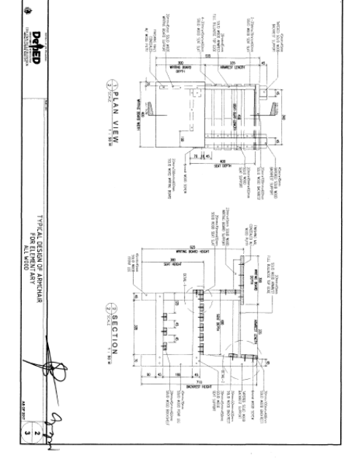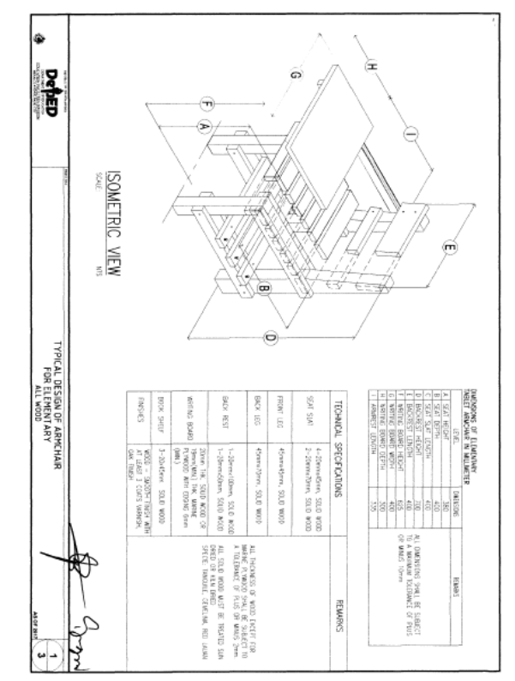
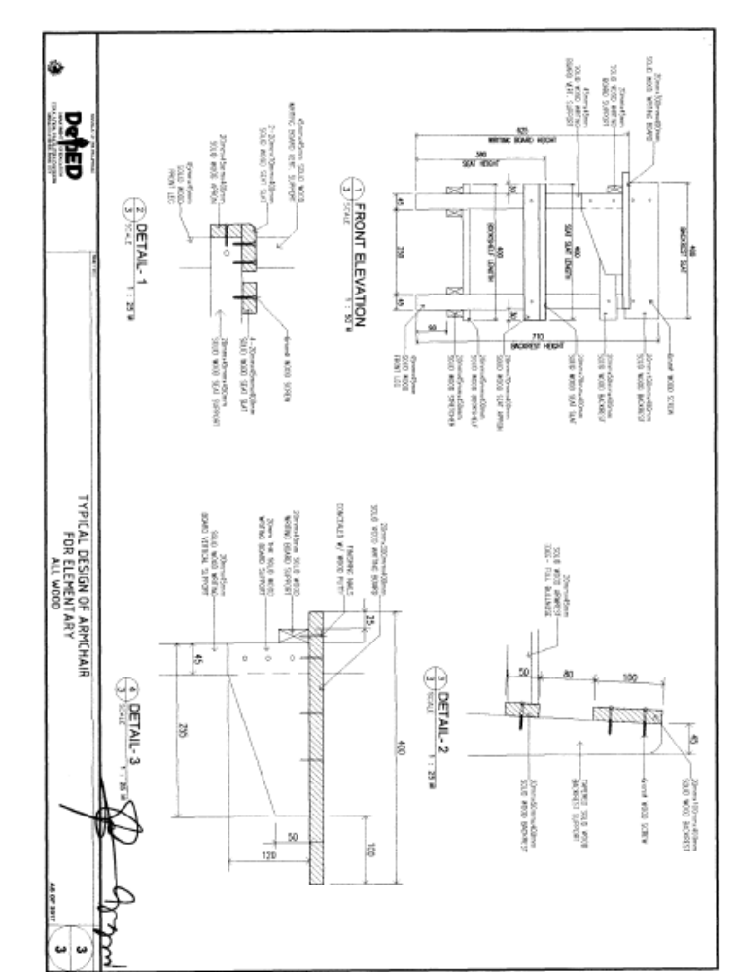

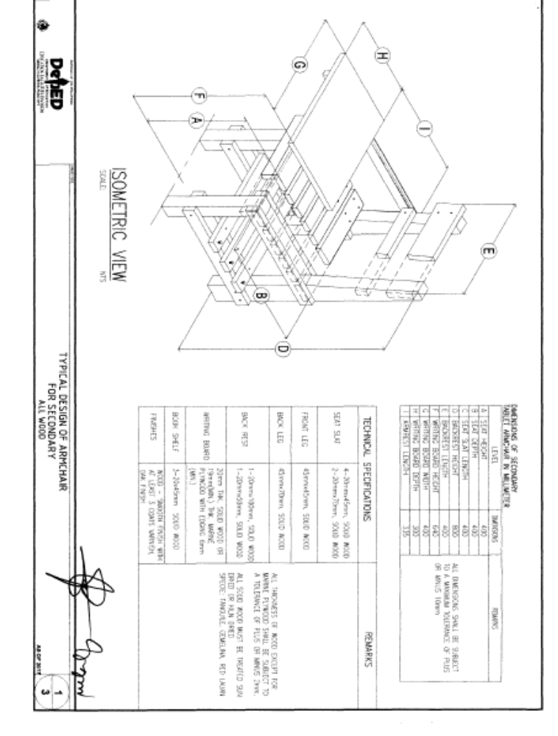

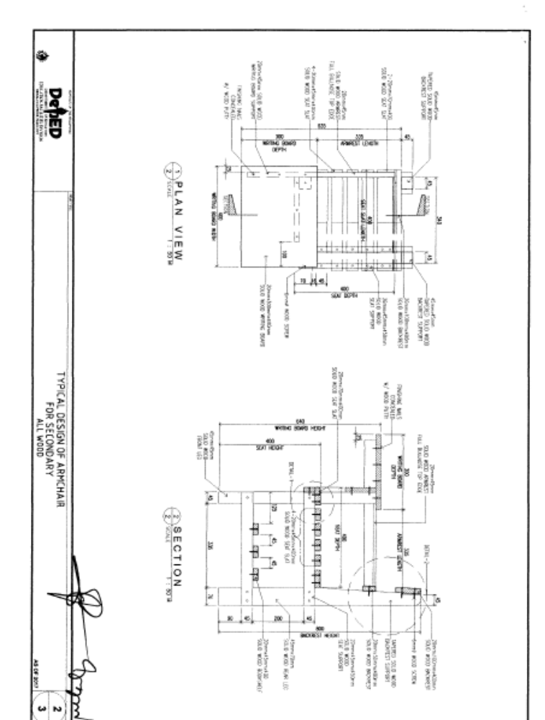

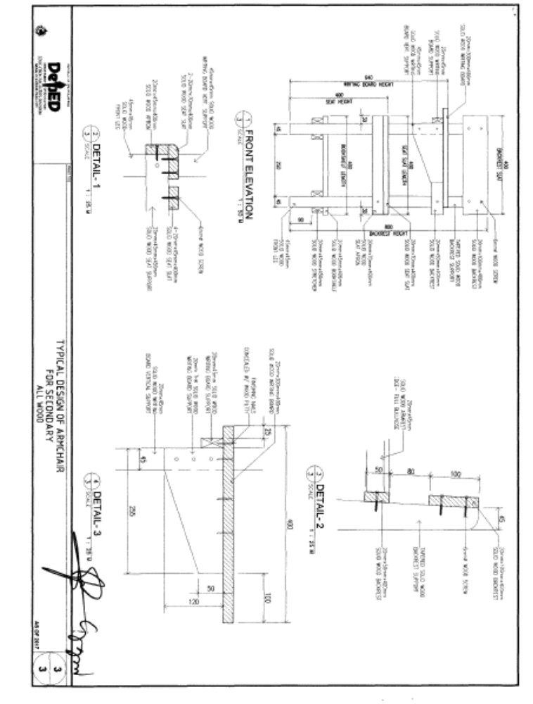

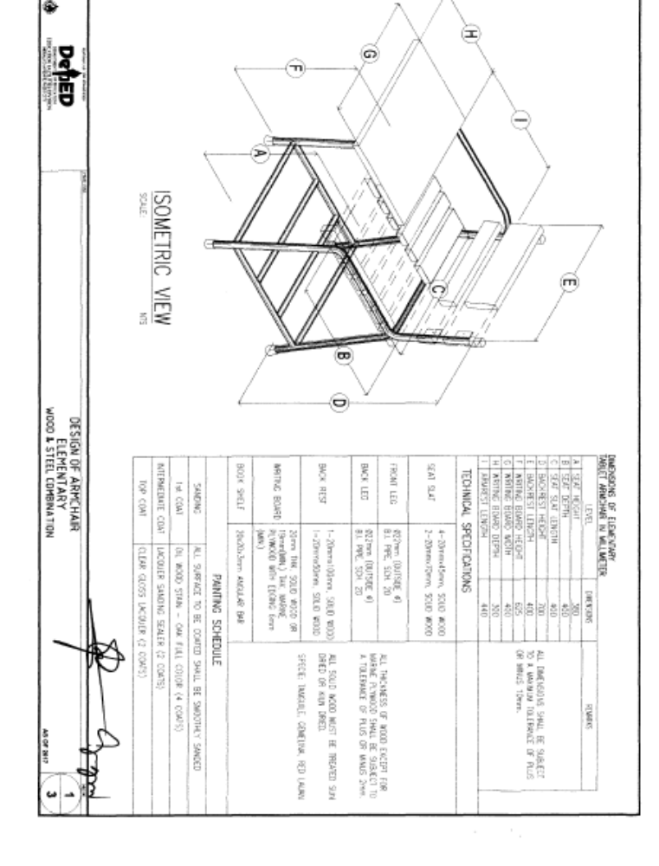

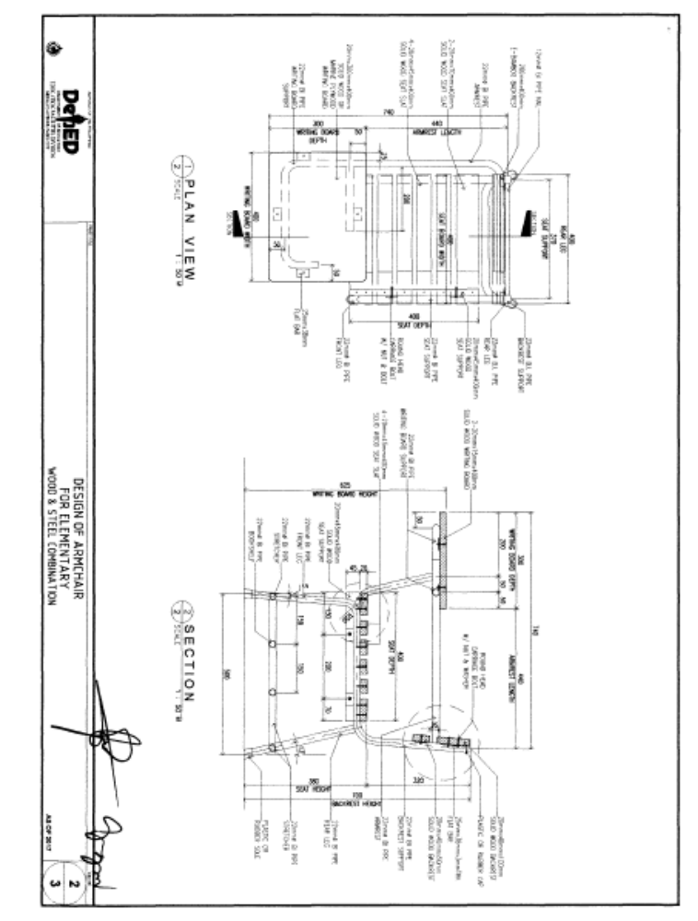

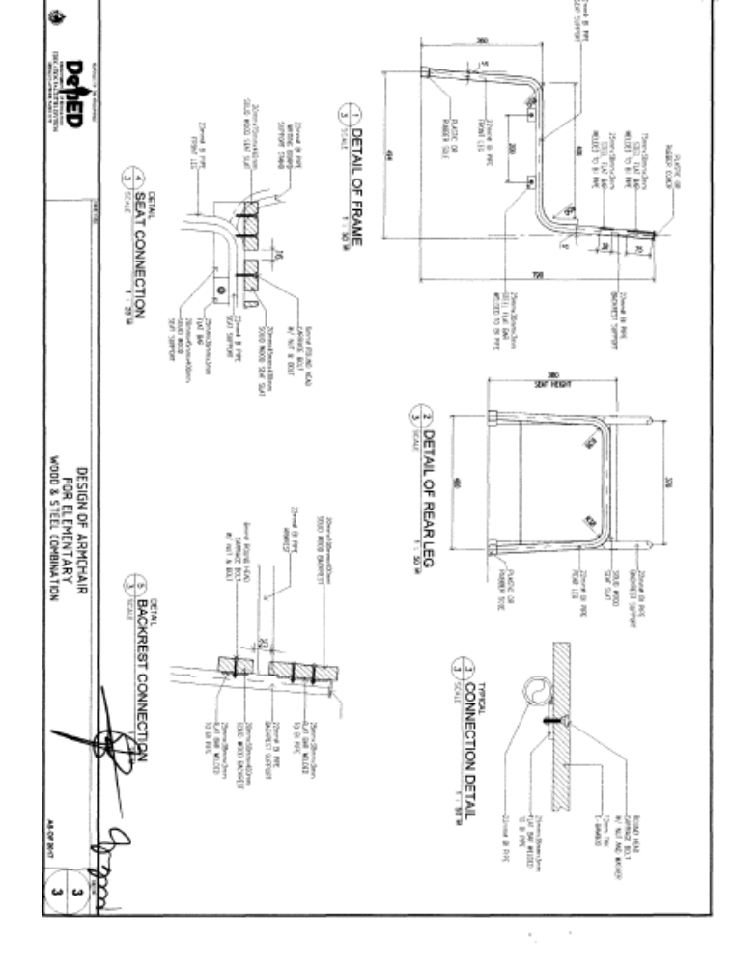

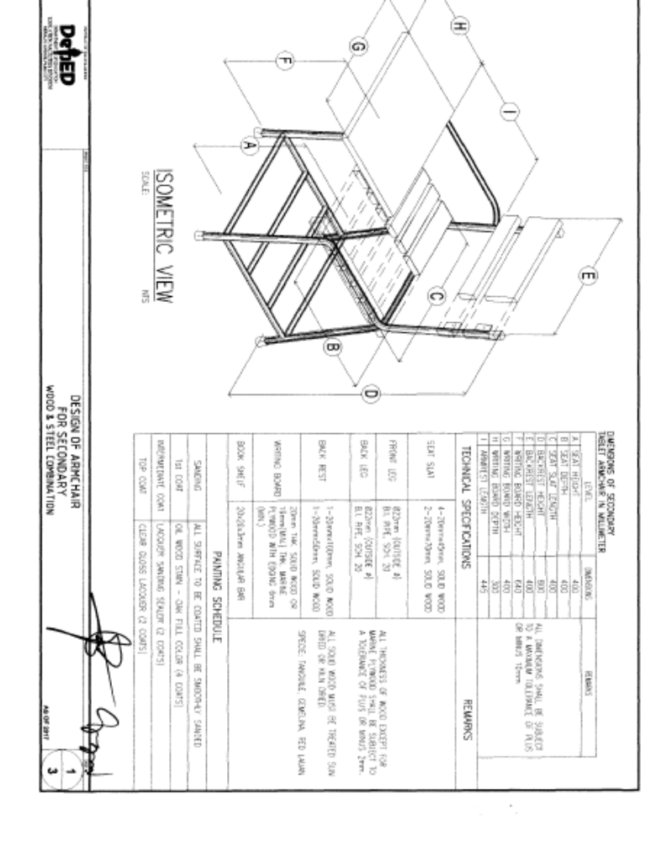

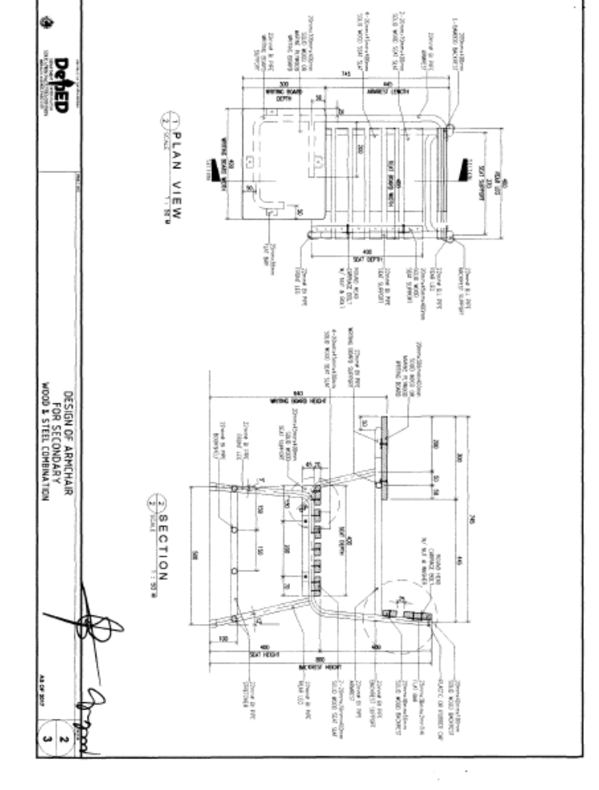

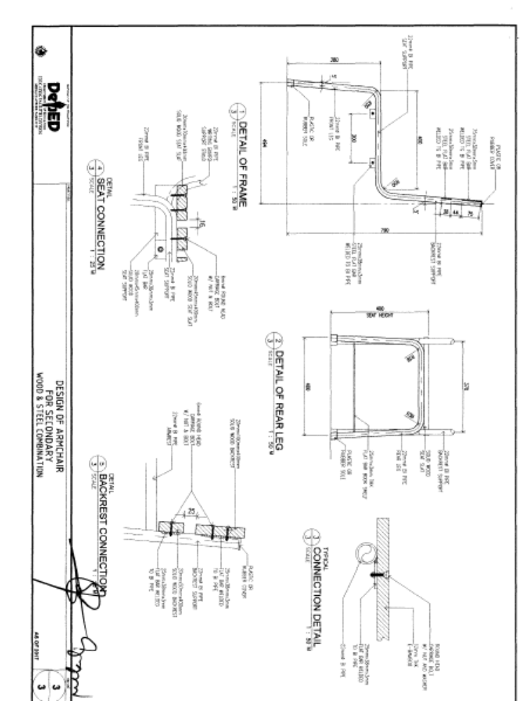

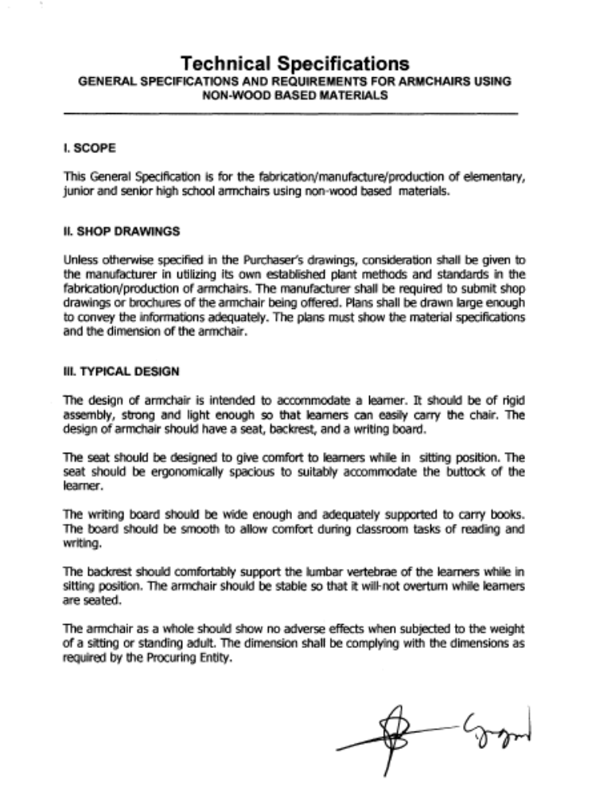

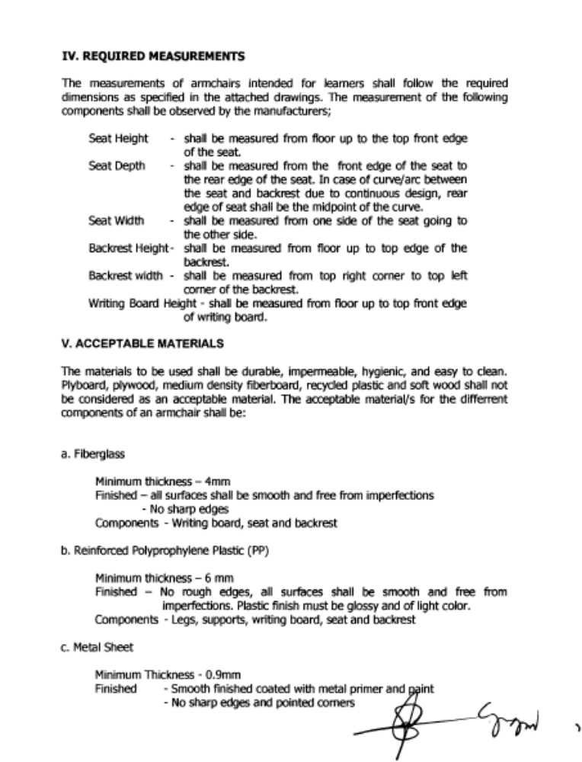

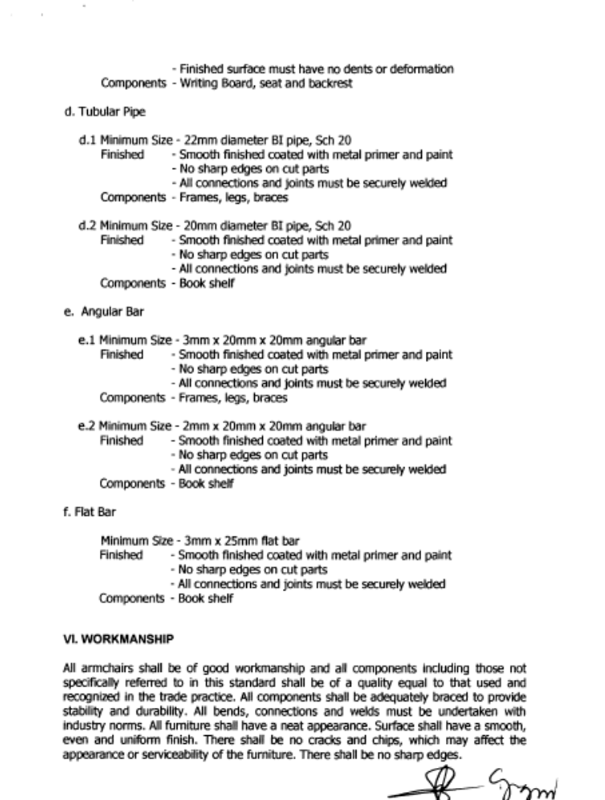

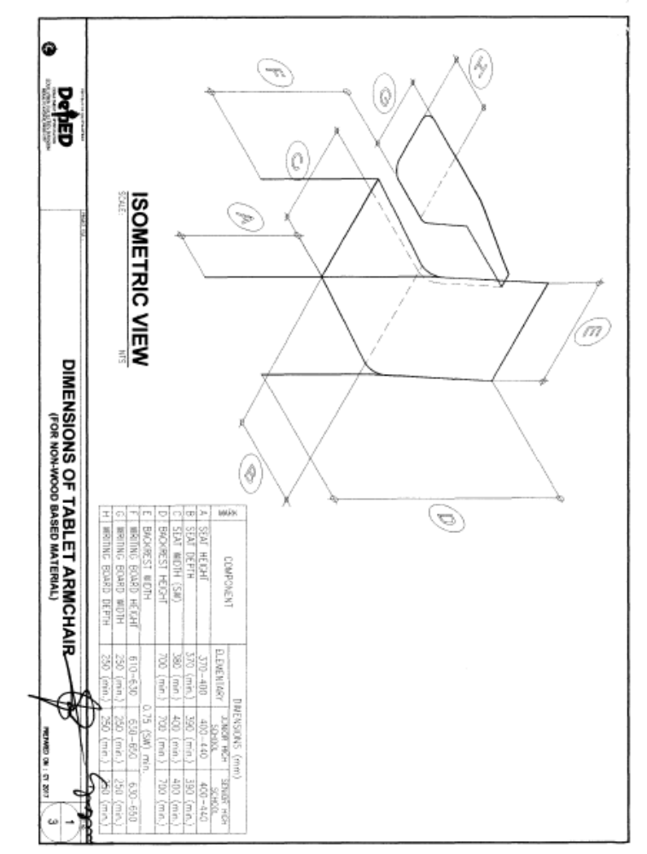

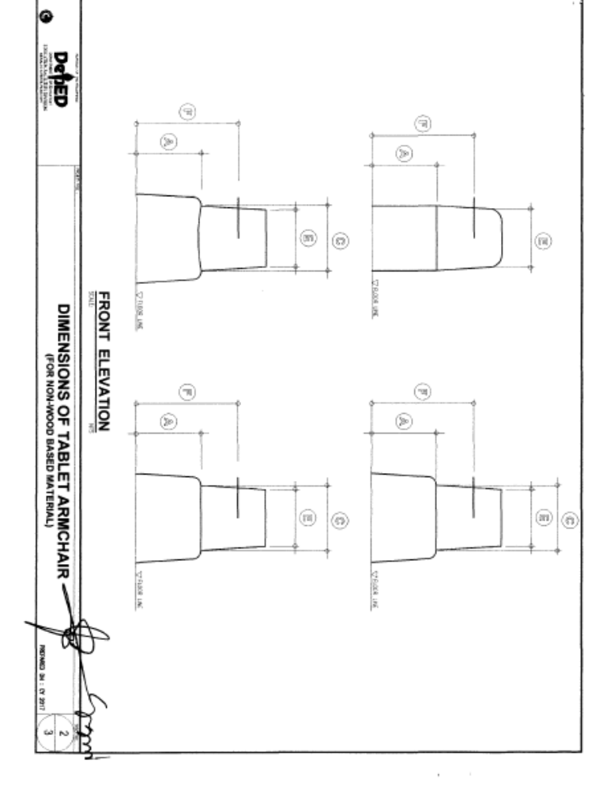

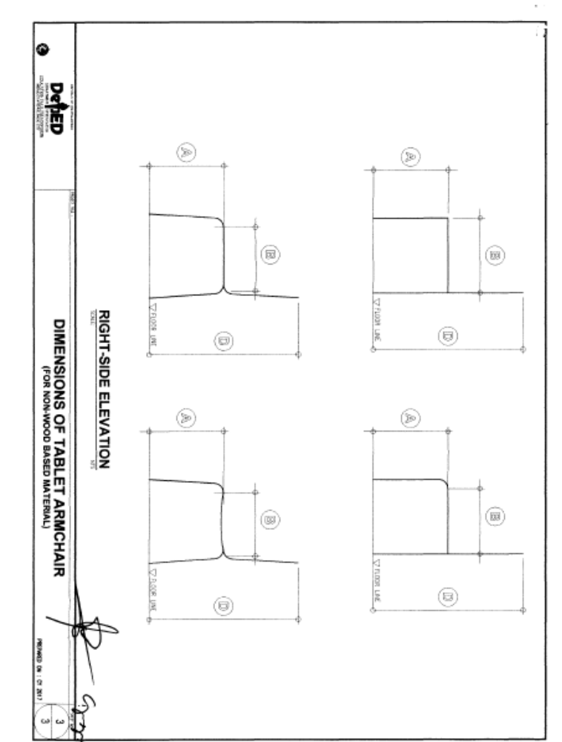

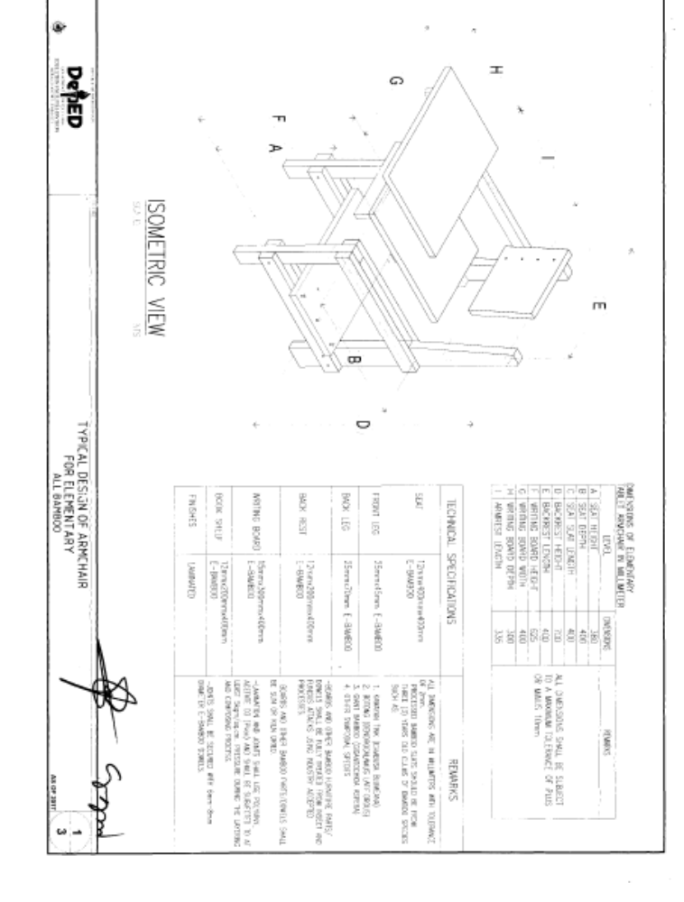

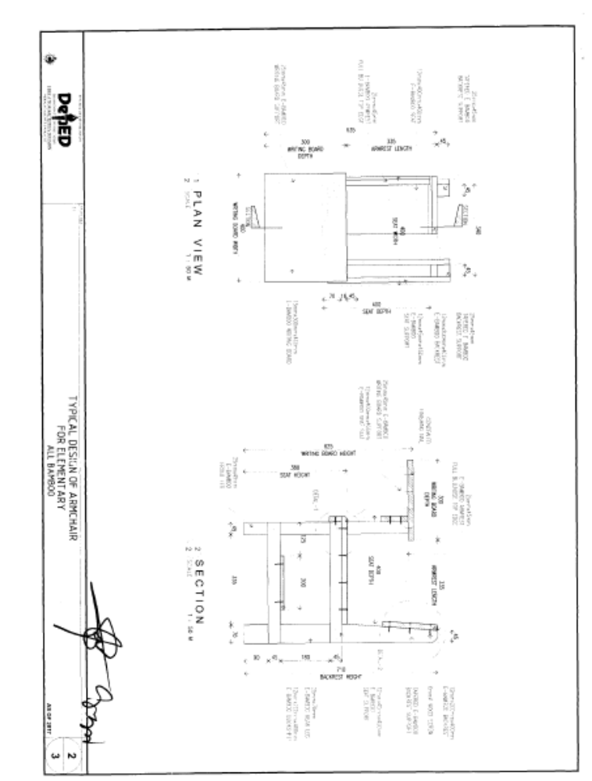

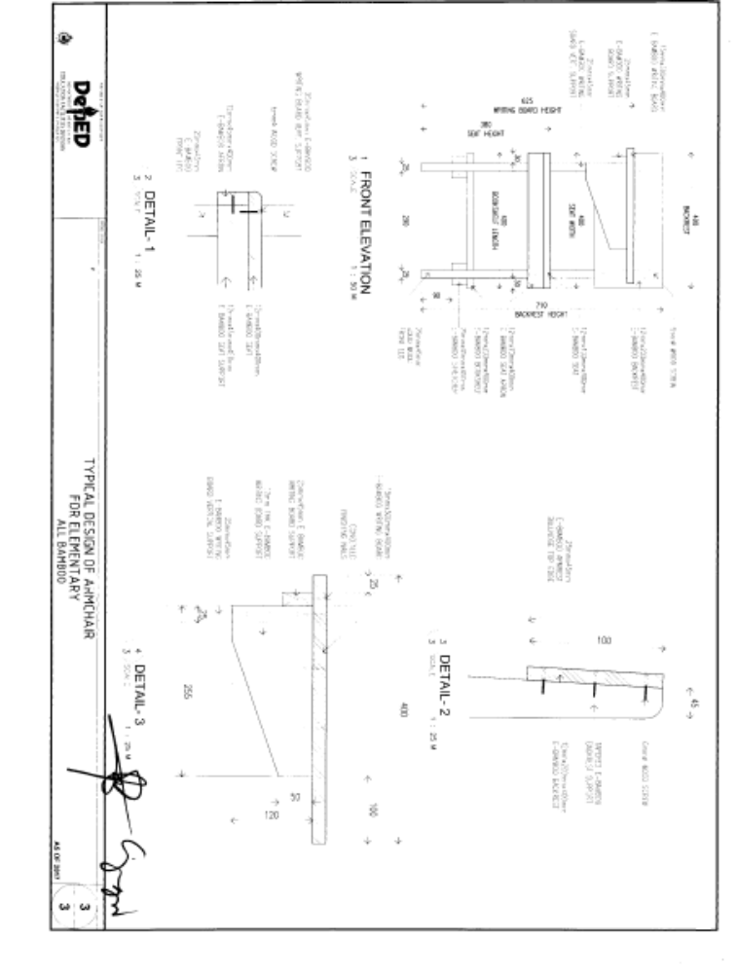

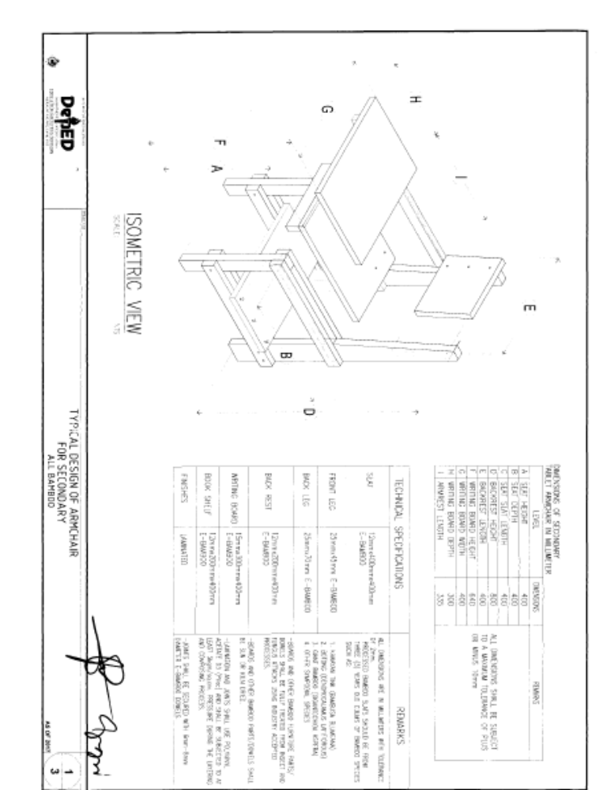

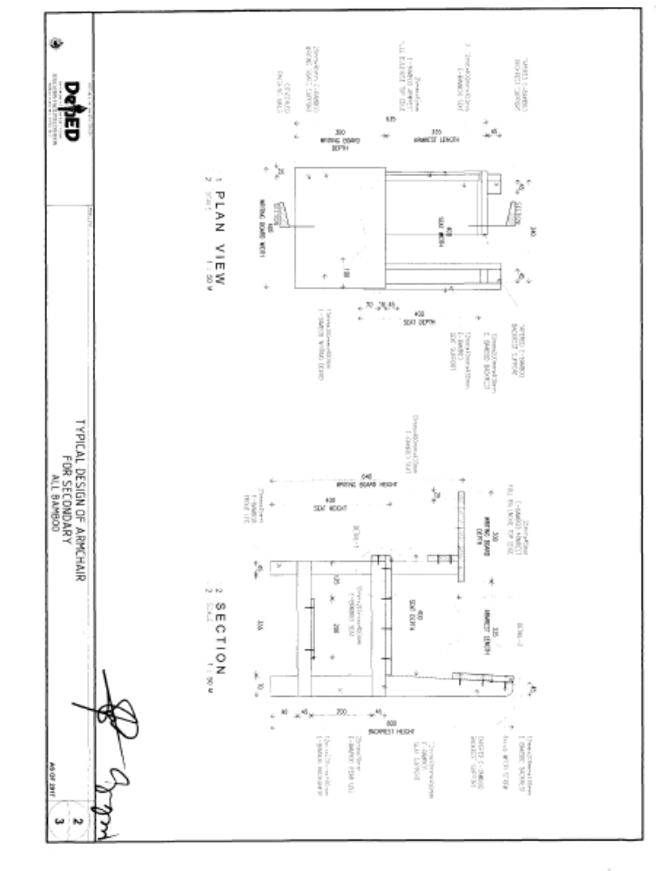

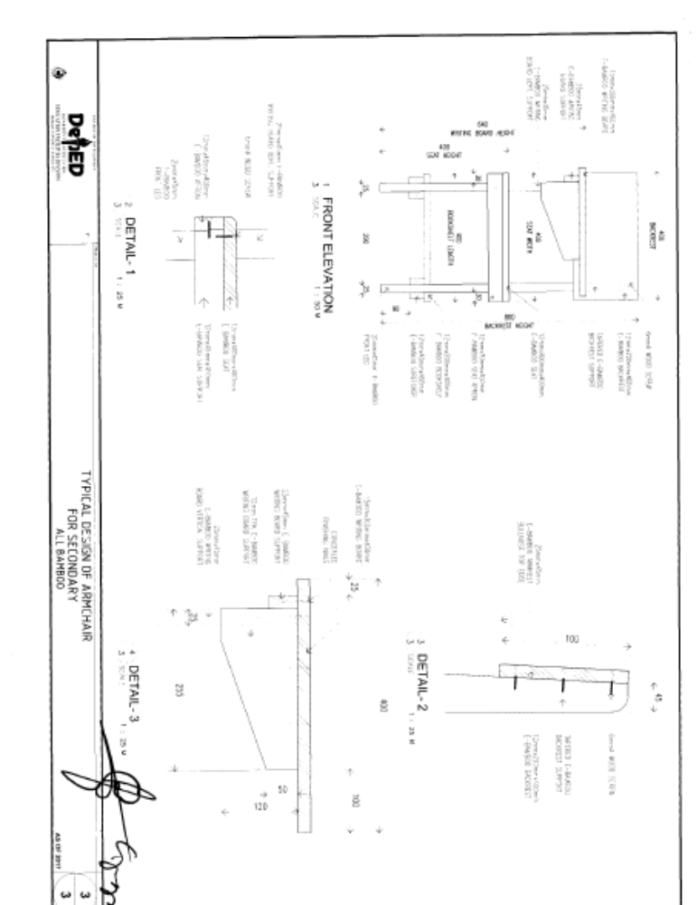

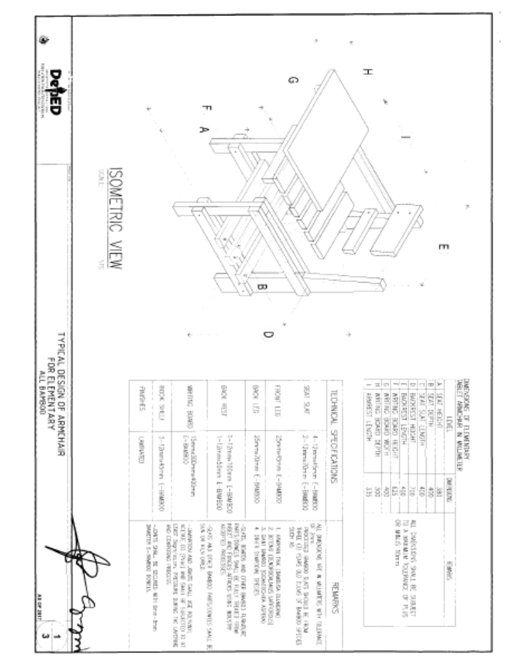

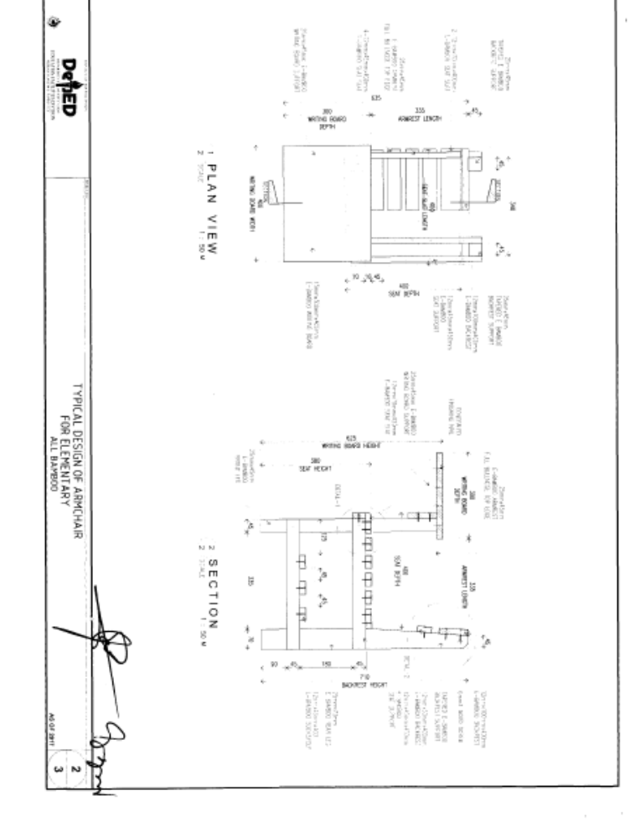

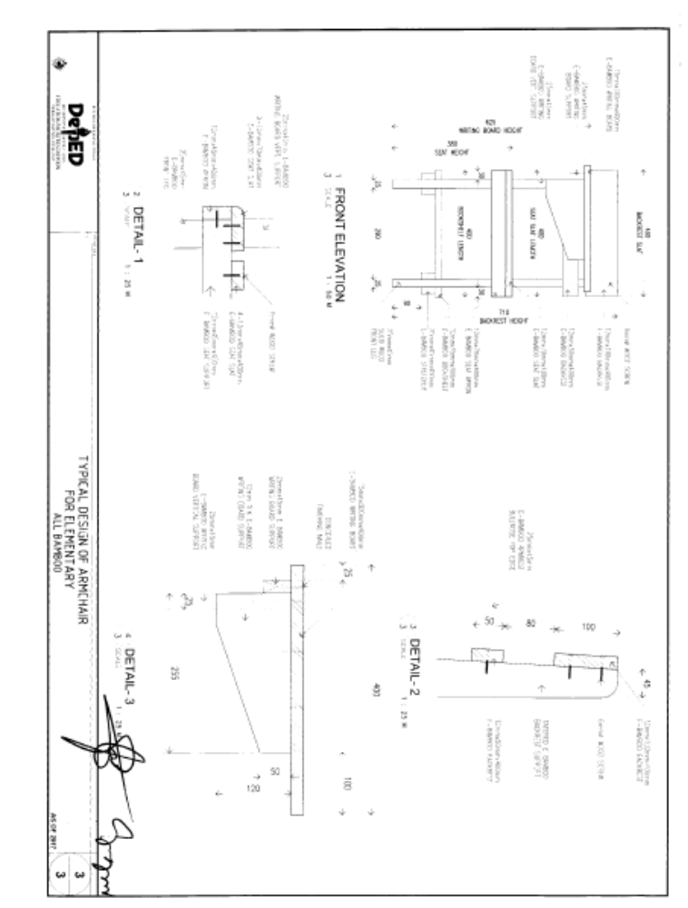

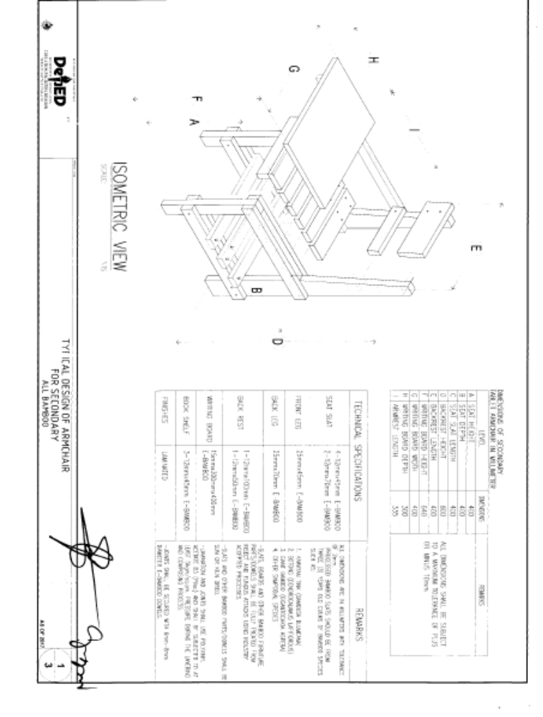

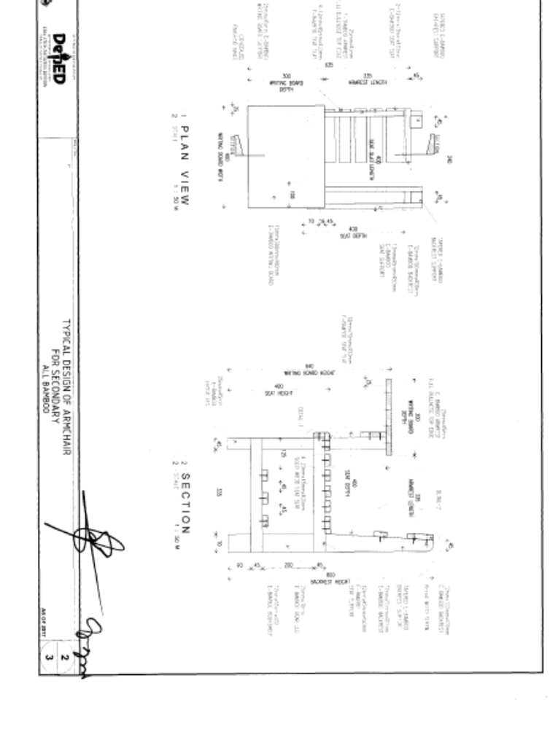

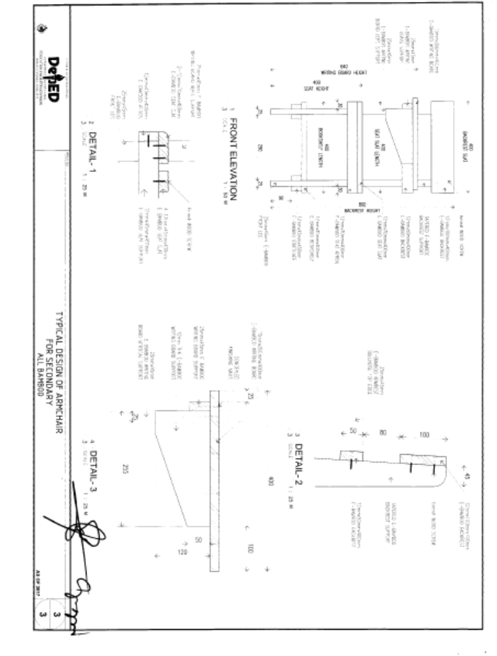

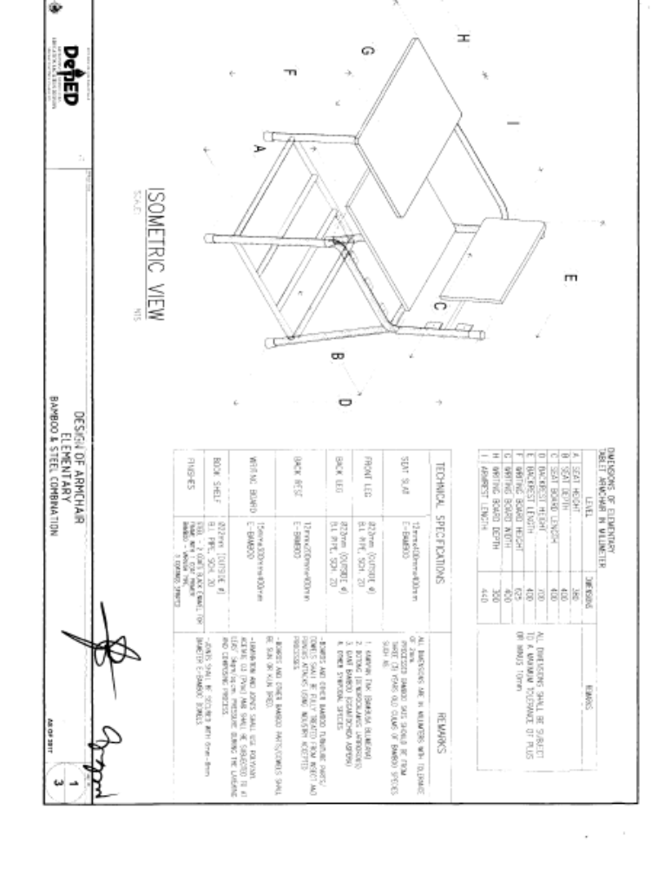

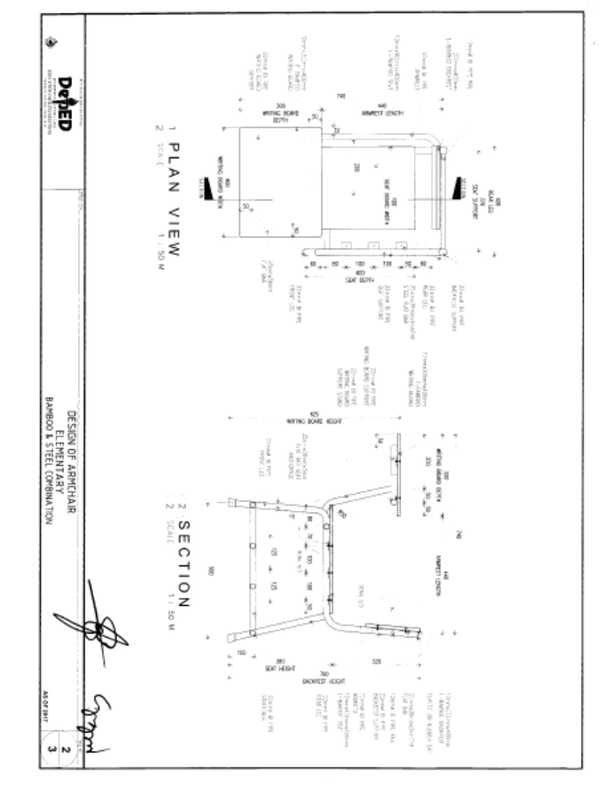

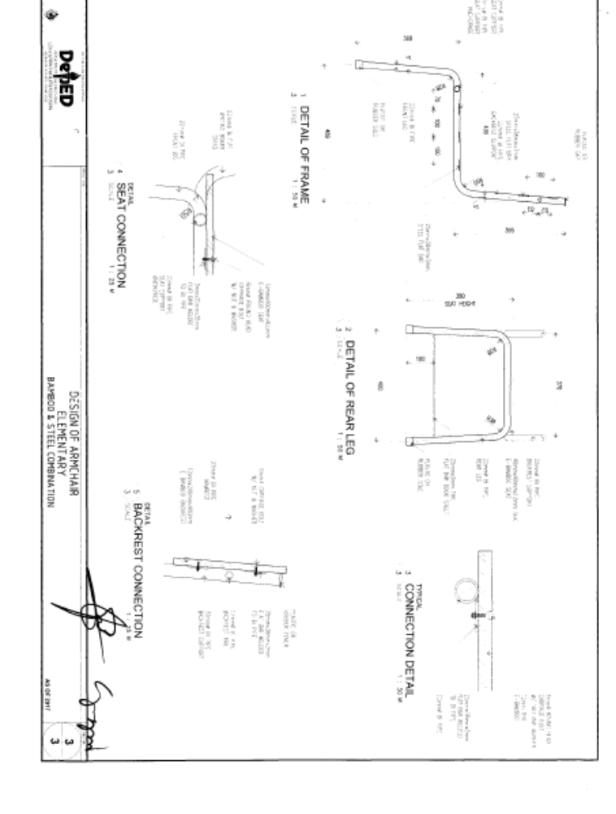

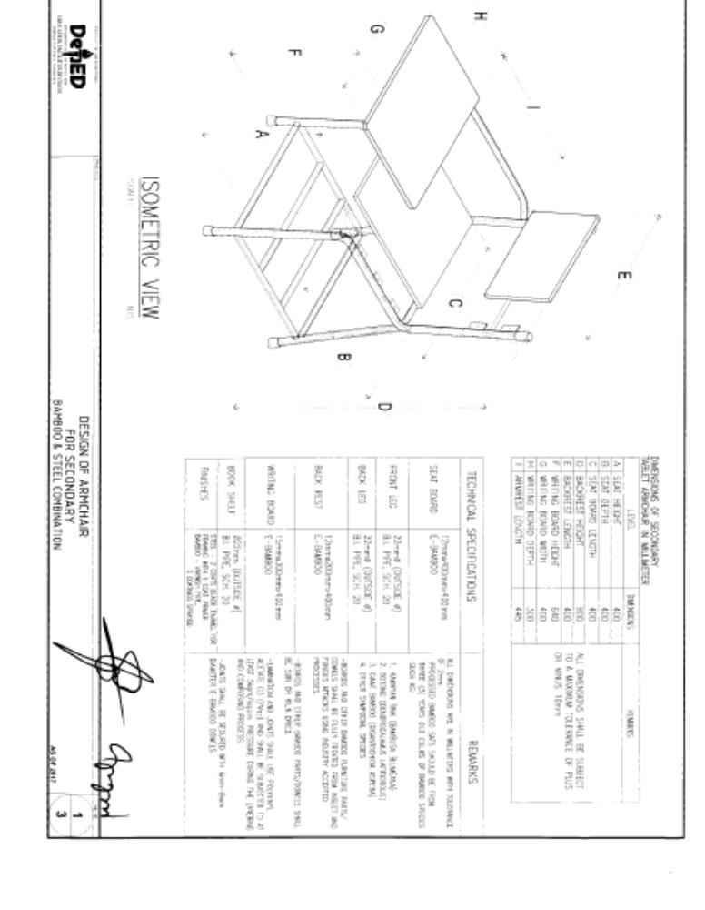

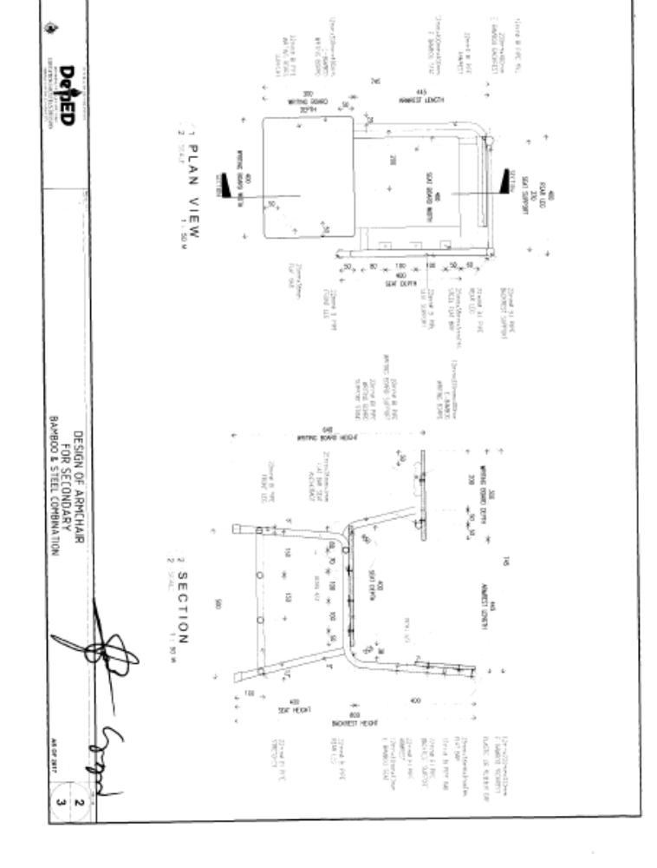

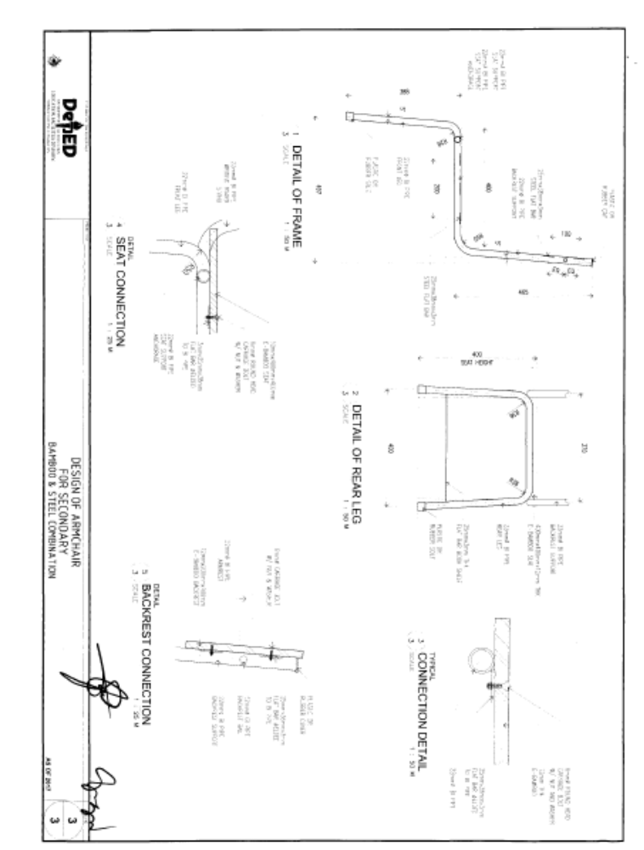

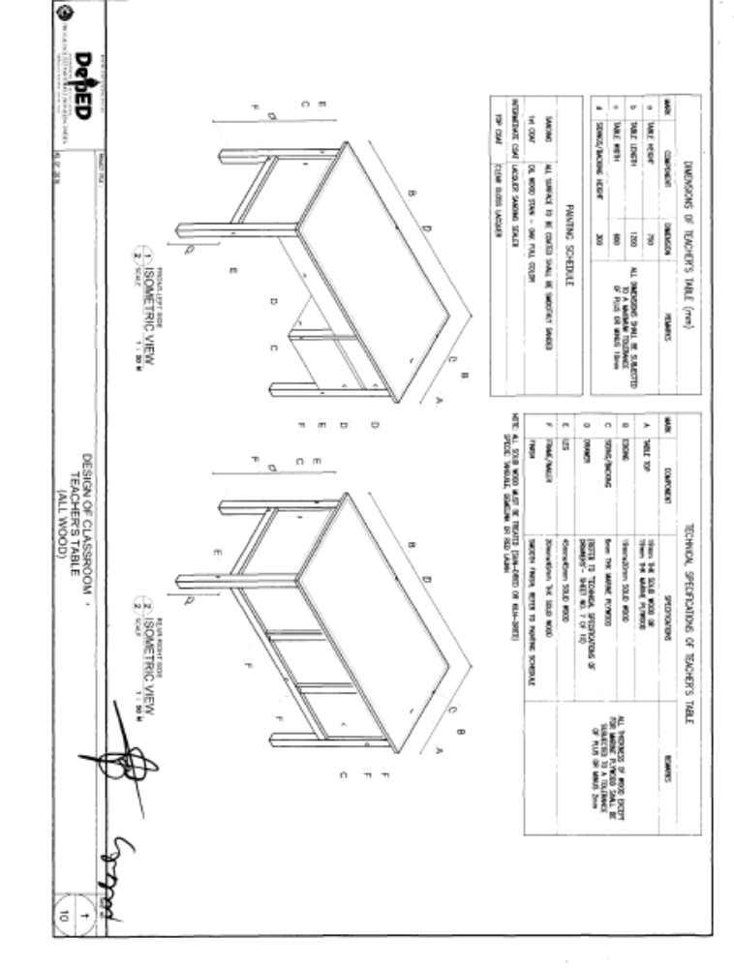

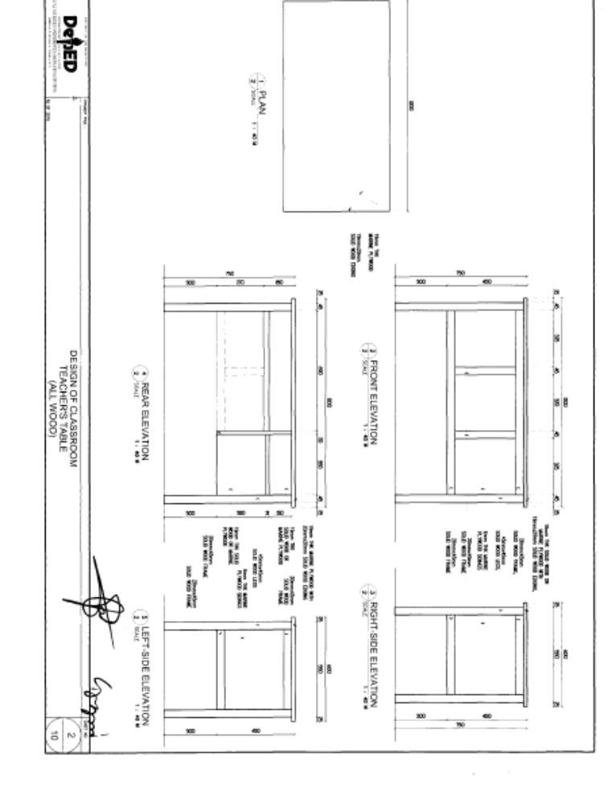

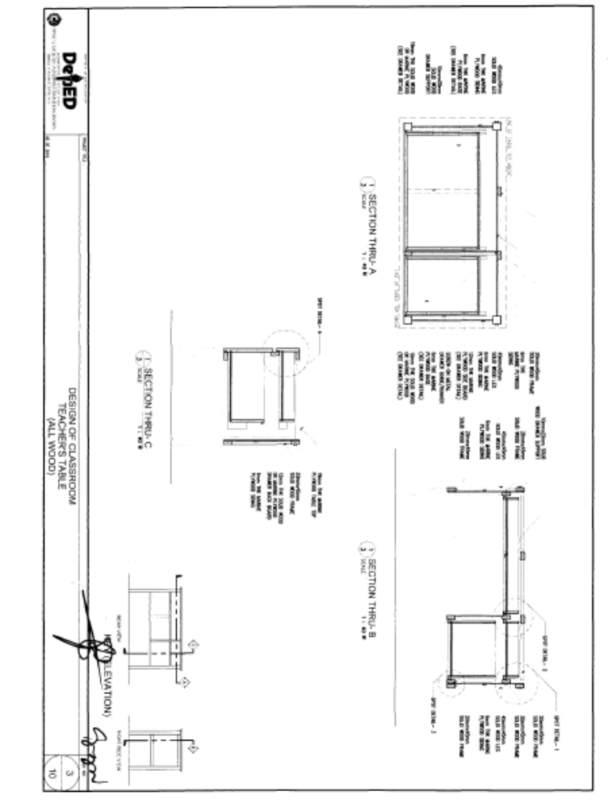

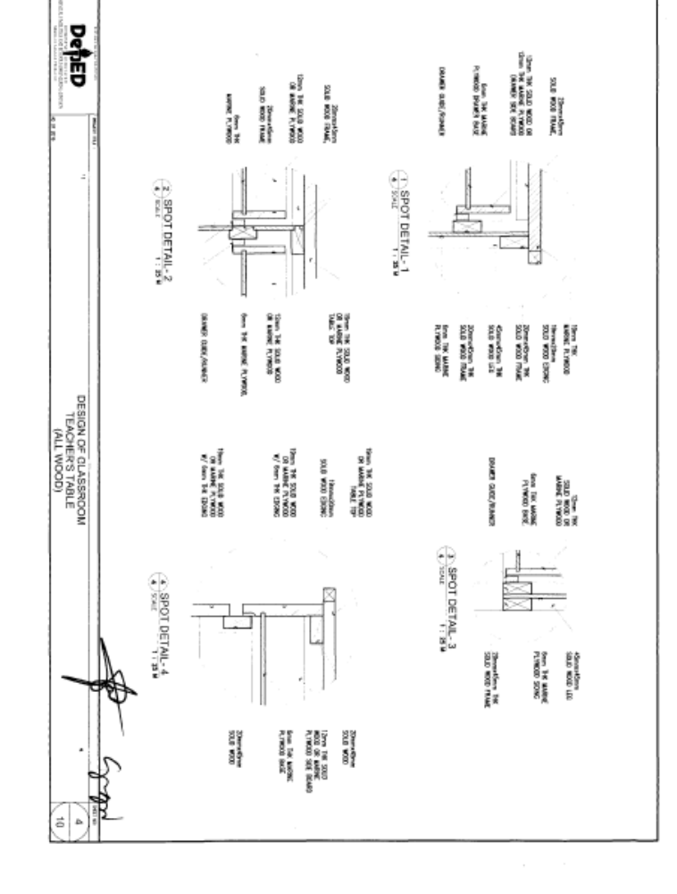

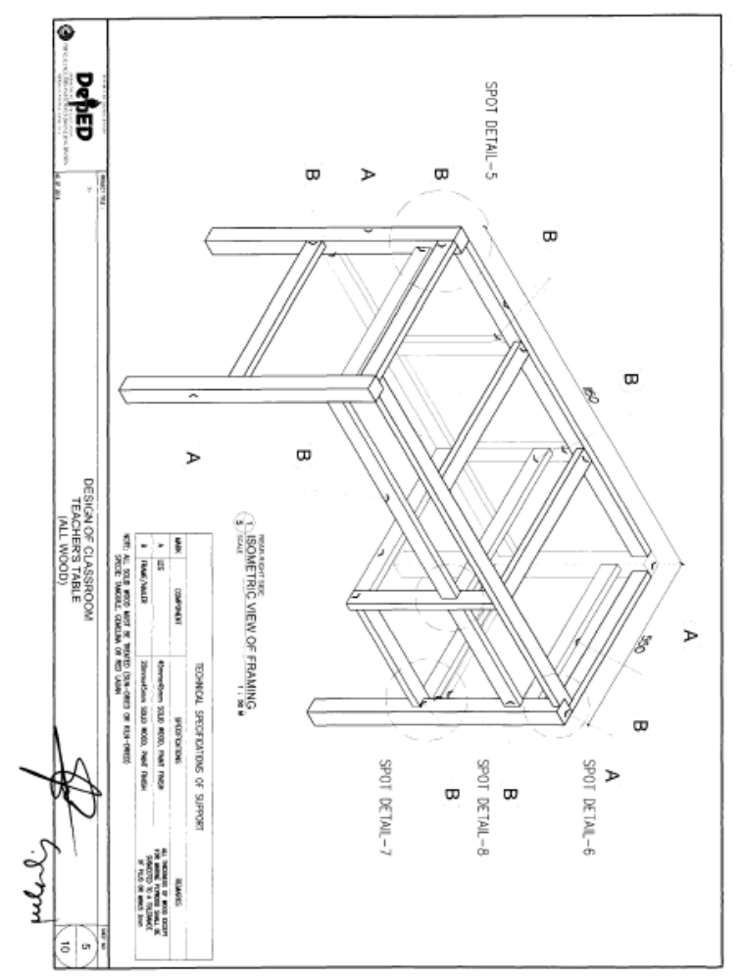

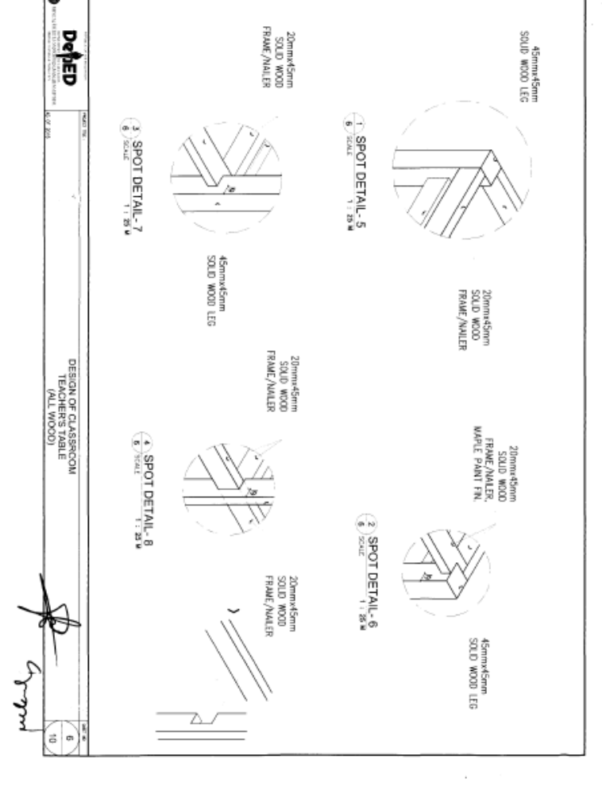

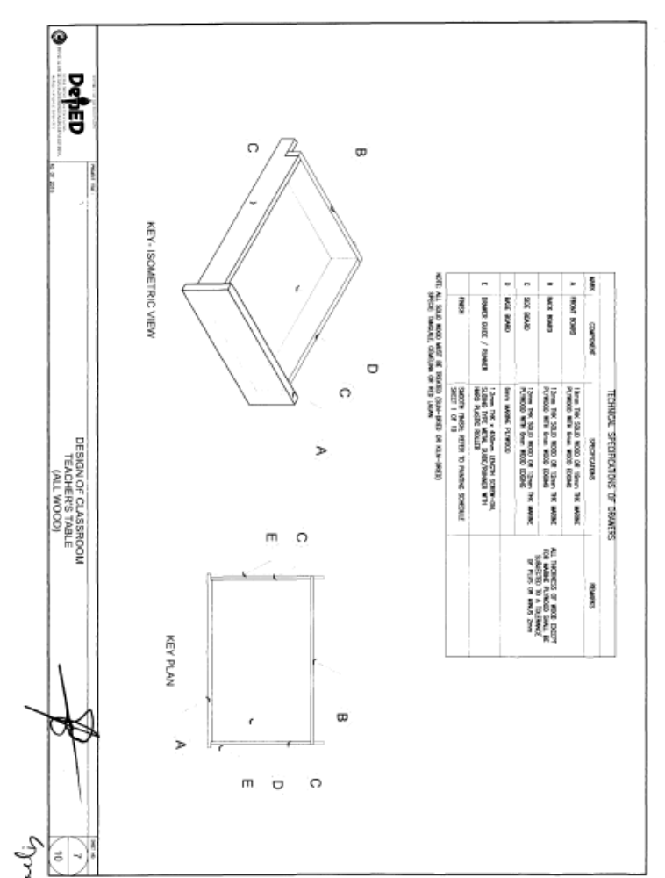

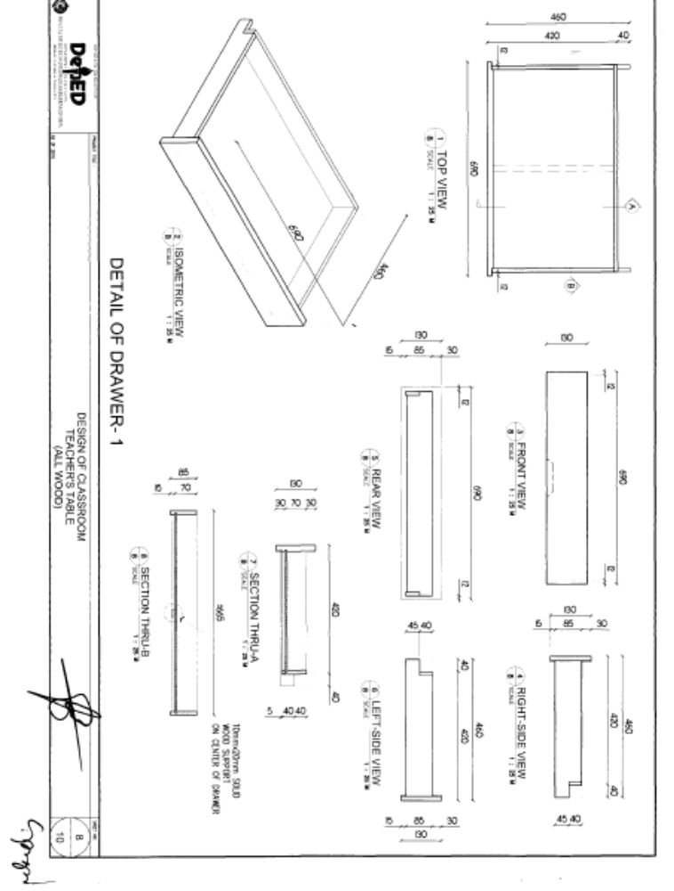

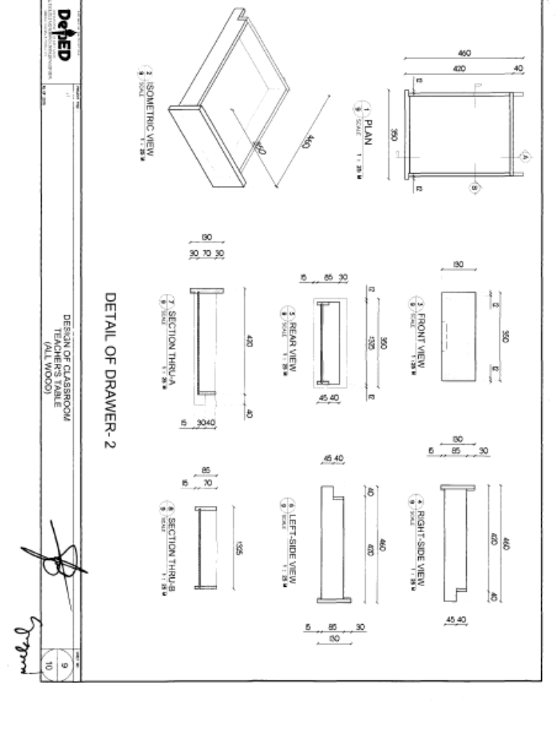

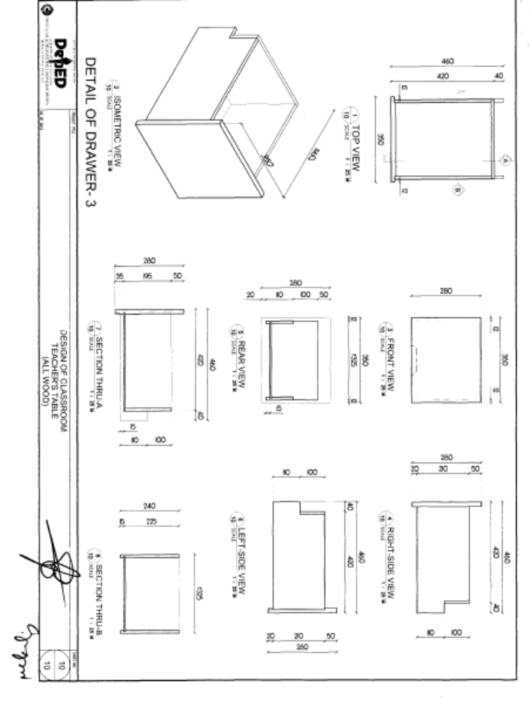

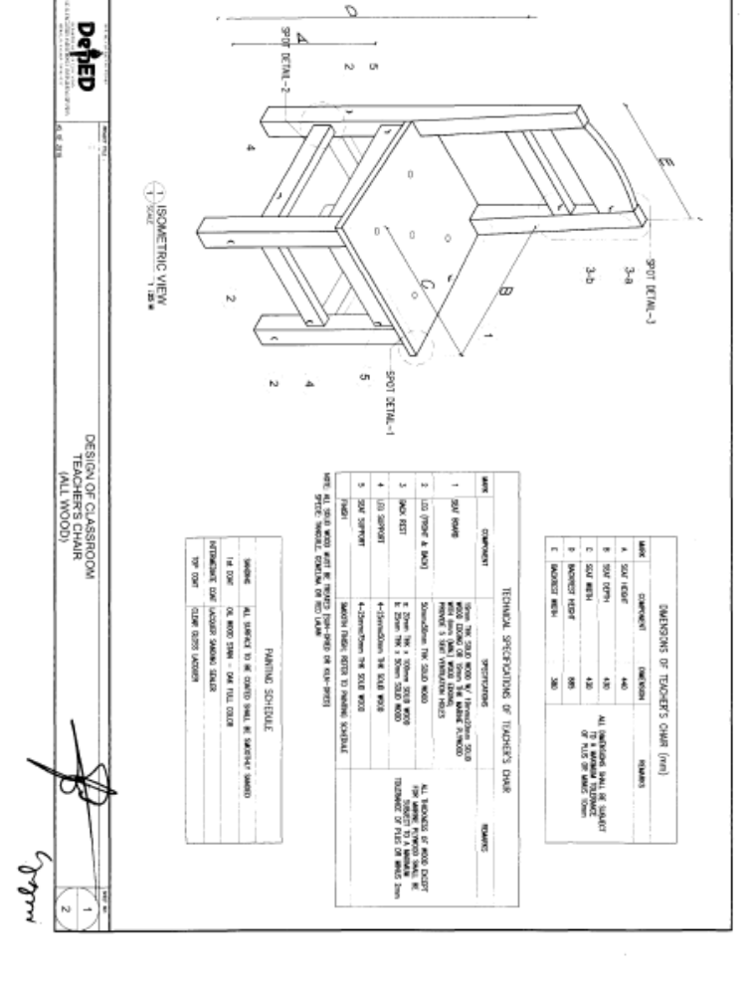

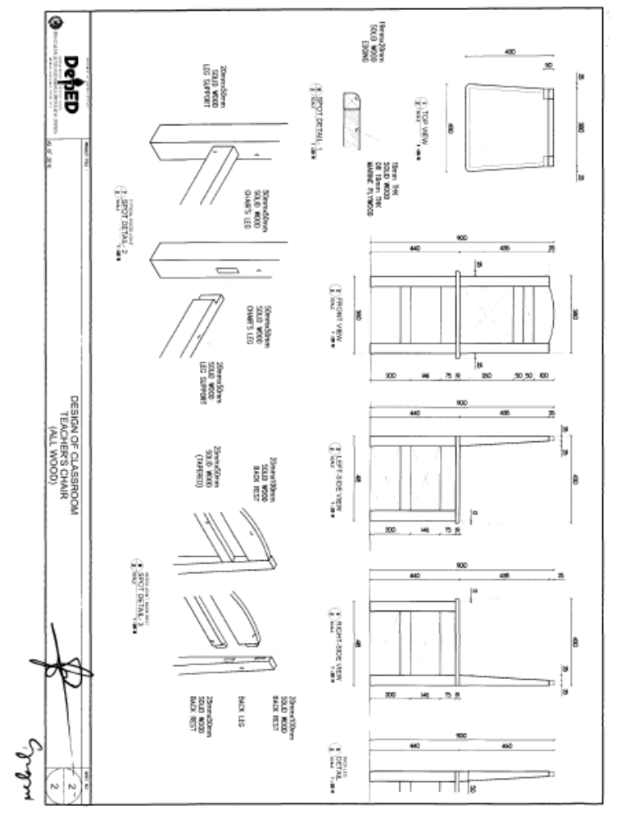

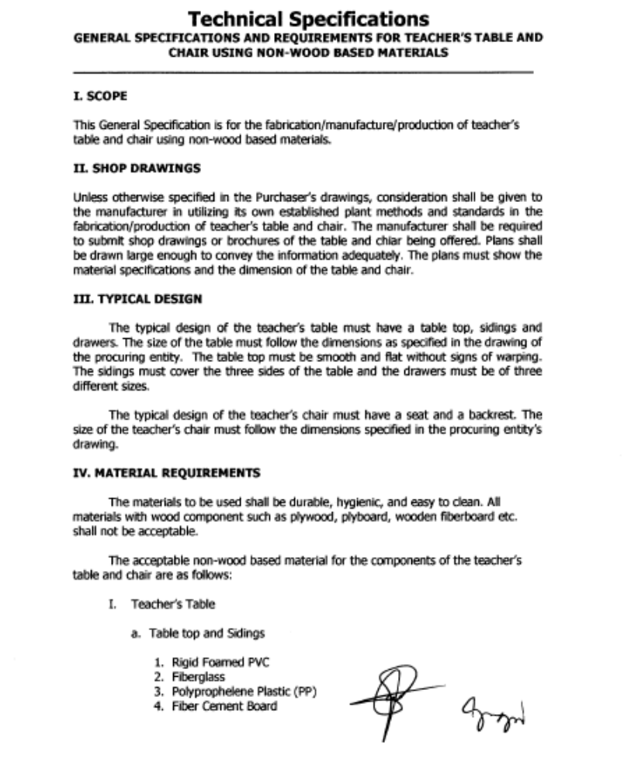

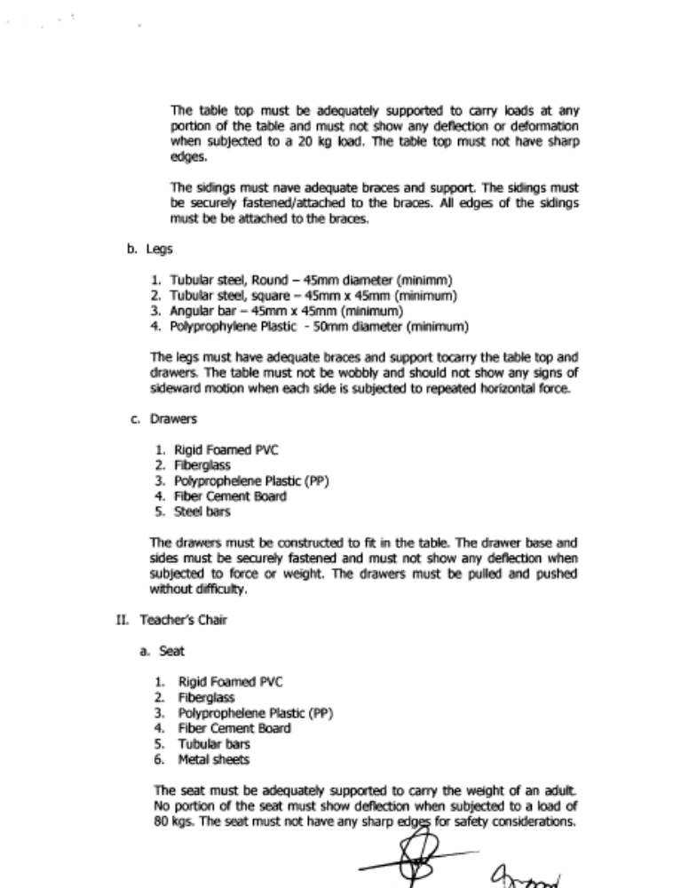

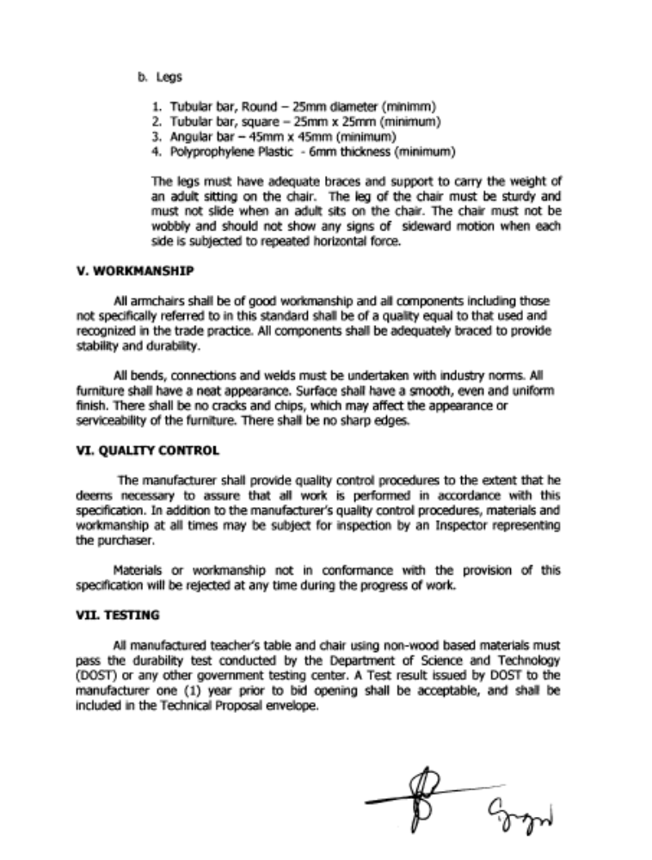

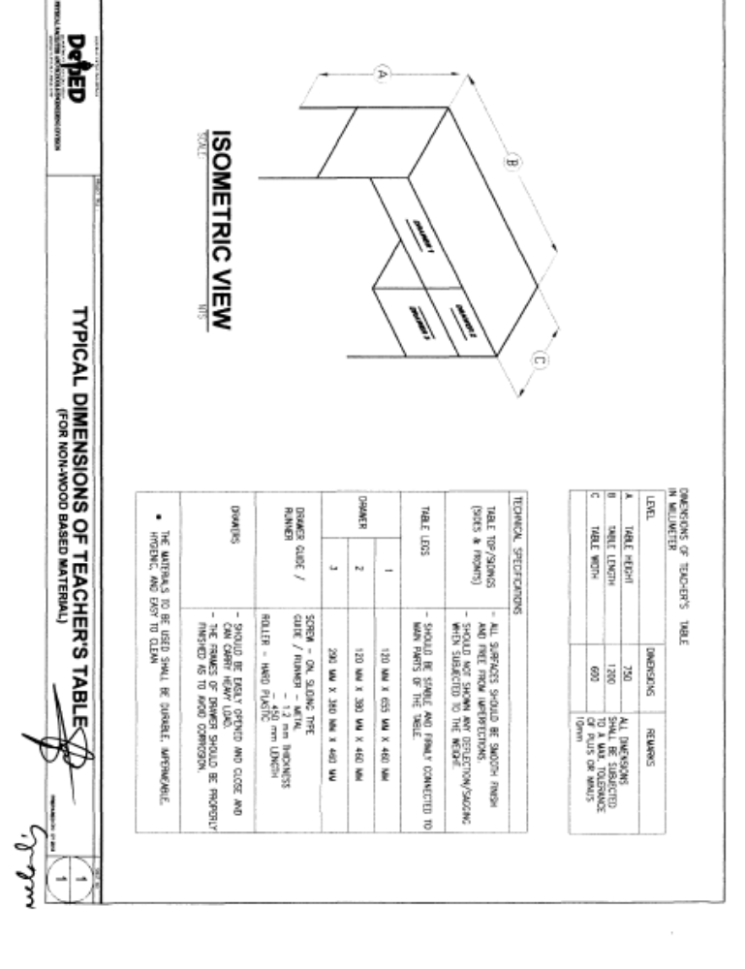

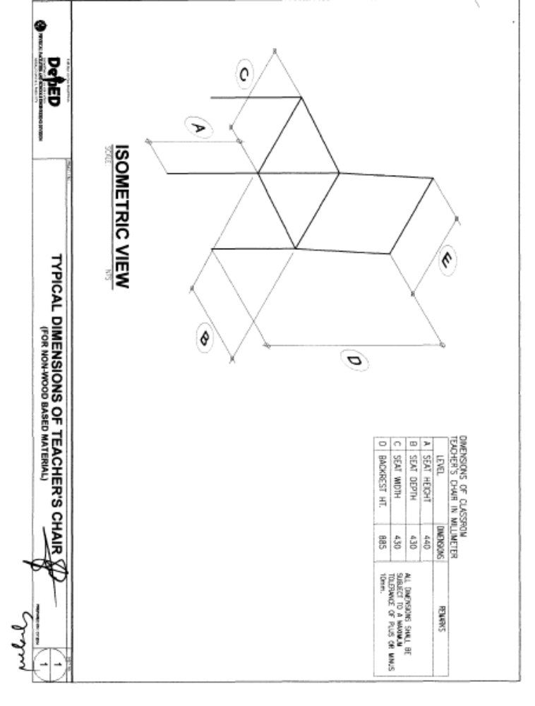

Section VIII. Bidding Forms

Notes on the Bidding Forms

The Bidder shall complete and submit with its Bid the Bid Form and Price Schedules in accordance with ITB Clause 15 with the requirements of the Bidding Documents and the format set out in this Section.

When requested in the BDS, the Bidder should provide the Bid Security, either in the form included hereafter or in another form acceptable to the Entity, pursuant to ITB Clause 18.1.

The Contract Agreement Form, when it is finalized at the time of contract award, should incorporate any corrections or modifications to the accepted Bid resulting from price corrections. The Price Schedule and Schedule of Requirements deemed to form part of the contract should be modified accordingly.

The Performance Security Form and Bank Guarantee Form for Advance Payment should not be completed by the Bidders at the time of their Bid preparation. Only the successful Bidder will be required to provide performance security and bank guarantee for advance payment in accordance with one of the forms indicated herein or in another form acceptable to the Procuring Entity and pursuant to GCC Clause 48 and its corresponding SCC provision.

The sworn affidavit must be completed by all Bidders in accordance with ITB Clause 4.2. Failure to do so and submit it with the bid shall result in the rejection of the bid and the Bidder’s disqualification.

TABLE OF CONTENTS

Bid Form 77
Contract Agreement Form 87
Omnibus Sworn Statement 89
Bank Guarantee Form for Advance Payment 86
BID SECURING DECLARATION FORM ……………………………………………87

Bid Form

Date:
Invitation to Bid Nº:

To: [name and address of Procuring Entity]

Gentlemen and/or Ladies:

Having examined the Bidding Documents including Bid Bulletin Numbers [insert numbers], the receipt of which is hereby duly acknowledged, we, the undersigned, offer to [supply/deliver/perform] [description of the Goods] in conformity with the said Bidding Documents for the sum of [total Bid amount in words and figures] or such other sums as may be ascertained in accordance with the Schedule of Prices attached herewith and made part of this Bid.

We undertake, if our Bid is accepted, to deliver the goods in accordance with the delivery schedule specified in the Schedule of Requirements.

If our Bid is accepted, we undertake to provide a performance security in the form, amounts, and within the times specified in the Bidding Documents.

We agree to abide by this Bid for the Bid Validity Period specified in BDS provision for ITB Clause 18.2 and it shall remain binding upon us and may be accepted at any time before the expiration of that period.

Commissions or gratuities, if any, paid or to be paid by us to agents relating to this Bid, and to contract execution if we are awarded the contract, are listed below:

Name and address of agent |  | Amount and Currency |  | Purpose of Commission or gratuity
(if none, state “None”)

Until a formal Contract is prepared and executed, this Bid, together with your written acceptance thereof and your Notice of Award, shall be binding upon us.

We understand that you are not bound to accept the Lowest Calculated Bid or any Bid you may receive.

We certify/confirm that we comply with the eligibility requirements as per ITB Clause 5 of the Bidding Documents.

We likewise certify/confirm that the undersigned, [for sole proprietorships, insert: as the owner and sole proprietor or authorized representative of Name of Bidder, has the full power and authority to participate, submit the bid, and to sign and execute the ensuing contract, on the latter’s behalf for the Name of Project of the Name of the Procuring Entity] [for partnerships, corporations, cooperatives, or joint ventures, insert: is granted full power and authority by the Name of Bidder, to participate, submit the bid, and to sign and execute the ensuing contract on the latter’s behalf for Name of Project of the Name of the Procuring Entity].

We acknowledge that failure to sign each and every page of this Bid Form, including the attached Schedule of Prices, shall be a ground for the rejection of our bid.

Dated this ________________ day of ________________ 20______.

[signature] [in the capacity of]

Duly authorized to sign Bid for and on behalf of ____________________________

For Goods Offered From Abroad

Name of Bidder . Invitation to Bid Number __. Page of .

1 | 2 | 3 | 4 | 5 | 6 | 7 | 8 | 9
Item | Description | Country of origin | Quantity | Unit price cif port of entry (specify port) or cip named place  (specify border point or place of destination) | Total cif or cip price per item  (col. 4 x 5) | Unit Price Delivered Duty Unpaid (DDU) | Unit price Delivered Duty Paid (DDP) | Total Price delivered DDP  (col 4 x 8)

[signature] [in the capacity of]

Duly authorized to sign Bid for and on behalf of ____________________________

For Goods Offered From Within the Philippines

Name of Bidder . Invitation to Bid Number . Page of .

1 | 2 | 3 | 4 | 5 | 6 | 7 | 8 | 9 | 10
Item | Description | Country of origin | Quantity | Unit price exw per item | Transportation and Insurance and all other costs incidental to delivery, per item | Sales and other taxes payable if Contract is awarded, per item | Cost of Incidental Services, if applicable, per item | Total Price,  per unit  (col 5+6+7+8) | Total Price delivered Final Destination  (col 9) x (col 4)

[signature] [in the capacity of]

Duly authorized to sign Bid for and on behalf of ____________________________

Contract Agreement Form

THIS AGREEMENT made the _____ day of __________ 20_____ between [name of PROCURING ENTITY] of the Philippines (hereinafter called “the Entity”) of the one part and [name of Supplier] of [city and country of Supplier] (hereinafter called “the Supplier”) of the other part:

WHEREAS the Entity invited Bids for certain goods and ancillary services, viz., [brief description of goods and services] and has accepted a Bid by the Supplier for the supply of those goods and services in the sum of [contract price in words and figures] (hereinafter called “the Contract Price”).

NOW THIS AGREEMENT WITNESSETH AS FOLLOWS:

1. In this Agreement words and expressions shall have the same meanings as are respectively assigned to them in the Conditions of Contract referred to.

2. The following documents shall be deemed to form and be read and construed as part of this Agreement, viz.:

(a) the Supplier’s Bid, including the Technical and Financial Proposals, and all other documents/statements submitted (e.g. bidder’s response to clarifications on the bid), including corrections to the bid resulting from the Procuring Entity’s bid evaluation;
(b) the Schedule of Requirements;
(c) the Technical Specifications;
(d) the General Conditions of Contract;
(e) the Special Conditions of Contract;
(f) the Performance Security; and
(g) the Entity’s Notice of Award.

3. In consideration of the payments to be made by the Entity to the Supplier as hereinafter mentioned, the Supplier hereby covenants with the Entity to provide the goods and services and to remedy defects therein in conformity in all respects with the provisions of the Contract

4. The Entity hereby covenants to pay the Supplier in consideration of the provision of the goods and services and the remedying of defects therein, the Contract Price or such other sum as may become payable under the provisions of the contract at the time and in the manner prescribed by the contract.

IN WITNESS whereof the parties hereto have caused this Agreement to be executed in accordance with the laws of the Republic of the Philippines on the day and year first above written.

Signed, sealed, delivered by the (for the Entity)

Signed, sealed, delivered by the (for the Supplier).

Omnibus Sworn Statement

REPUBLIC OF THE PHILIPPINES )
CITY/MUNICIPALITY OF ______ ) S.S.

AFFIDAVIT

I, [Name of Affiant], of legal age, [Civil Status], [Nationality], and residing at [Address of Affiant], after having been duly sworn in accordance with law, do hereby depose and state that:

- Select one, delete the other:

If a sole proprietorship: I am the sole proprietor or authorized representative of [Name of Bidder] with office address at [address of Bidder];

If a partnership, corporation, cooperative, or joint venture: I am the duly authorized and designated representative of [Name of Bidder] with office address at [address of Bidder];

- Select one, delete the other:

If a sole proprietorship: As the owner and sole proprietor, or authorized representative of [Name of Bidder], I have full power and authority to do, execute and perform any and all acts necessary to participate, submit the bid, and to sign and execute the ensuing contract for [Name of the Project] of the [Name of the Procuring Entity], as shown in the attached duly notarized Special Power of Attorney;

If a partnership, corporation, cooperative, or joint venture: I am granted full power and authority to do, execute and perform any and all acts necessary to participate, submit the bid, and to sign and execute the ensuing contract for [Name of the Project] of the [Name of the Procuring Entity], as shown in the attached [state title of attached document showing proof of authorization (e.g., duly notarized Secretary’s Certificate, Board/Partnership Resolution, or Special Power of Attorney, whichever is applicable;)];

- [Name of Bidder] is not “blacklisted” or barred from bidding by the Government of the Philippines or any of its agencies, offices, corporations, or Local Government Units, foreign government/foreign or international financing institution whose blacklisting rules have been recognized by the Government Procurement Policy Board;

- Each of the documents submitted in satisfaction of the bidding requirements is an authentic copy of the original, complete, and all statements and information provided therein are true and correct;

- [Name of Bidder] is authorizing the Head of the Procuring Entity or its duly authorized representative(s) to verify all the documents submitted;

- Select one, delete the rest:

If a sole proprietorship: The owner or sole proprietor is not related to the Head of the Procuring Entity, members of the Bids and Awards Committee (BAC), the Technical Working Group, and the BAC Secretariat, the head of the Project Management Office or the end-user unit, and the project consultants by consanguinity or affinity up to the third civil degree;

If a partnership or cooperative: None of the officers and members of [Name of Bidder] is related to the Head of the Procuring Entity, members of the Bids and Awards Committee (BAC), the Technical Working Group, and the BAC Secretariat, the head of the Project Management Office or the end-user unit, and the project consultants by consanguinity or affinity up to the third civil degree;

If a corporation or joint venture: None of the officers, directors, and controlling stockholders of [Name of Bidder] is related to the Head of the Procuring Entity, members of the Bids and Awards Committee (BAC), the Technical Working Group, and the BAC Secretariat, the head of the Project Management Office or the end-user unit, and the project consultants by consanguinity or affinity up to the third civil degree;

- [Name of Bidder] complies with existing labor laws and standards; and

- [Name of Bidder] is aware of and has undertaken the following responsibilities as a Bidder:

  - Carefully examine all of the Bidding Documents;

  - Acknowledge all conditions, local or otherwise, affecting the implementation of the Contract;

  - Made an estimate of the facilities available and needed for the contract to be bid, if any; and

  - Inquire or secure Supplemental/Bid Bulletin(s) issued for the [Name of the Project].

- [Name of Bidder] did not give or pay directly or indirectly, any commission, amount, fee, or any form of consideration, pecuniary or otherwise, to any person or official, personnel or representative of the government in relation to any procurement project or activity.

IN WITNESS WHEREOF, I have hereunto set my hand this __ day of ___, 20__ at ____________, Philippines.

_____________________________________
Bidder’s Representative/Authorized Signatory

SUBSCRIBED AND SWORN to before me this ___ day of [month] [year] at [place of execution], Philippines. Affiant/s is/are personally known to me and was/were identified by me through competent evidence of identity as defined in the 2004 Rules on Notarial Practice (A.M. No. 02-8-13-SC). Affiant/s exhibited to me his/her [insert type of government identification card used], with his/her photograph and signature appearing thereon, with no. ________ and his/her Community Tax Certificate No. _______ issued on ____ at ______.

Witness my hand and seal this ___ day of [month] [year].

NAME OF NOTARY PUBLIC
Serial No. of Commission _______________
Notary Public for _______ until __________
Roll of Attorneys No. __________________
PTR No. ______ [date issued], [place issued]
IBP No. ______ [date issued], [place issued]

Doc. No. _____
Page No. _____
Book No. _____
Series of _____

* This form will not apply for WB funded projects.

Bank Guarantee Form for Advance Payment

To: [name and address of PROCURING ENTITY]
[name of Contract]

Gentlemen and/or Ladies:

In accordance with the payment provision included in the Special Conditions of Contract, which amends Clause 45 of the General Conditions of Contract to provide for advance payment, [name and address of Supplier] (hereinafter called the “Supplier”) shall deposit with the PROCURING ENTITY a bank guarantee to guarantee its proper and faithful performance under the said Clause of the Contract in an amount of [amount of guarantee in figures and words].

We, the [bank or financial institution], as instructed by the Supplier, agree unconditionally and irrevocably to guarantee as primary obligator and not as surety merely, the payment to the PROCURING ENTITY on its first demand without whatsoever right of objection on our part and without its first claim to the Supplier, in the amount not exceeding [amount of guarantee in figures and words].

We further agree that no change or addition to or other modification of the terms of the Contract to be performed thereunder or of any of the Contract documents which may be made between the PROCURING ENTITY and the Supplier, shall in any way release us from any liability under this guarantee, and we hereby waive notice of any such change, addition, or modification.

This guarantee shall remain valid and in full effect from the date of the advance payment received by the Supplier under the Contract until [date].

Yours truly,

Signature and seal of the Guarantors

[name of bank or financial institution]

[address]

[date]

BID SECURING DECLARATION FORM

REPUBLIC OF THE PHILIPPINES)
CITY OF _______________________) S.S.

x------------------------------------------------------x

BID SECURING DECLARATION
Invitation to Bid: [Insert Reference number]

To: [Insert name and address of the Procuring Entity]

I/We, the undersigned, declare that:

1. I/We understand that, according to your conditions, bids must be supported by a Bid Security, which may be in the form of a Bid-Securing Declaration.

2. I/We accept that: (a) I/we will be automatically disqualified from bidding for any contract with any procuring entity for a period of two (2) years upon receipt of your Blacklisting order; and, (b) I/we will pay the applicable fine provided under Section 6 of the Guidelines on the Use of Bid Securing Declaration, within fifteen (15) days from receipt of the written demand by the procuring entity for the commission of acts resulting to the enforcement of the bid securing declaration under Sections 23.1(b), 34.2, 40.1 and 69.1, except 69.1(f), of the IRR of RA 9184; without prejudice to other legal action the government may undertake.

3. I/We understand that this Bid Securing Declaration shall cease to be valid on the following circumstances:

(a) Upon expiration of the bid validity period, or any extension thereof pursuant to your request;

(b) I am/we are declared ineligible or post-disqualified upon receipt of your notice to such effect, and (i) I/we failed to timely file a request for reconsideration or (ii) I/we filed a waiver to avail of said right;

(c) I am/we are declared the bidder with the Lowest Calculated Responsive Bid, and I/we have furnished the performance security and signed the Contract.

IN WITNESS WHEREOF, I/We have hereunto set my/our hand/s this ____ day of [month] [year] at [place of execution].

[Insert NAME OF BIDDER’S AUTHORIZED
REPRESENTATIVE]
[Insert Signatory’s Legal Capacity]
Affiant

SUBSCRIBED AND SWORN to before me this ___ day of [month] [year] at [place of execution], Philippines. Affiant/s is/are personally known to me and was/were identified by me through competent evidence of identity as defined in the 2004 Rules on Notarial Practice (A.M. No. 02-8-13-SC). Affiant/s exhibited to me his/her [insert type of government identification card used], with his/her photograph and signature appearing thereon, with no. ________ and his/her Community Tax Certificate No. _______ issued on ____ at ______.

Witness my hand and seal this ___ day of [month] [year].

NAME OF NOTARY PUBLIC
Serial No. of Commission _______________
Notary Public for _______ until __________
Roll of Attorneys No. __________________
PTR No. ______ [date issued], [place issued]
IBP No. ______ [date issued], [place issued]

Doc. No. _____
Page No. _____
Book No. _____
Series of _____

Section IX. Foreign-Assisted Projects
Notes on Foreign-Assisted Projects
This Section is intended to assist the Procuring Entity in providing the specific information for foreign-assisted projects of the Asian Development Bank (ADB), the Japan International Cooperation Agency (JICA), and the World Bank.
- If the Funding Source is ADB, the Procuring Entity should use the ADB Bid Data Sheet and the ADB Special Conditions of Contract..
- If the Funding Source is JICA, the Procuring Entity should use Section III. Bid Data Sheet and Section V. Special Conditions of Contract, both of the GOP.
- If the Funding Source is World Bank, the Procuring Entity should use the World Bank Bid Data Sheet and the World Bank Special Conditions of Contract of the GOP.
The Procuring Entity shall use these PBDs with minimum changes as necessary to address project-specific conditions. Any such changes shall be introduced only through the Bid Data Sheet or through the Special Conditions of Contract, and not by introducing changes in the standard wording of the Instructions to Bidders and the General Conditions of Contract.
The Procuring Entity shall allow the Bidders sufficient time to study the Bidding Documents, prepare and complete responsive bids, and submit their bids. A period of at least twenty (20) days for bid preparation shall be required.
Notes on the Invitation to Bid
The Invitation to Bid provides information that enables potential Bidders to decide whether to participate in the procurement at hand. The Invitation to Bid shall be:
(a) Advertised at least once in a newspaper of general nationwide circulation which has been regularly published for at least two (2) years before the date of issue of the advertisement, subject to Sections 21.2.1 (c) of the IRR of R.A. 9184;
(b) Posted continuously in the Philippine Government Electronic Procurement System (PhilGEPS) website, the website of the Procuring Entity concerned, if available, and the website prescribed by the foreign government/foreign or international financing institution, if applicable, from the time the Invitation to Bid is advertised until the deadline for the submission and receipt of bids; and
(c) Posted at any conspicuous place reserved for this purpose in the premises of the Procuring Entity concerned from the time the Invitation to Bid is advertised until the deadline for the submission and receipt of bids, as certified by the head of the Bids and Awards Committee (BAC) Secretariat of the Procuring Entity concerned.
Apart from the essential items listed in the Bidding Documents, the Invitation to Bid should also indicate the following:
- The date of availability of the Bidding Documents, which shall be from the time the Invitation to Bid is first advertised/posted until the deadline for the submission and receipt of bids.
- The place where the Bidding Documents may be acquired or the website where it may be downloaded.
- The deadline for the submission and receipt of bids; and
- Any important bid evaluation criteria.
The Invitation to Bid should be incorporated into the Bidding Documents. The information contained in the Invitation to Bid must conform to the Bidding Documents and in particular to the relevant information in the BDS.
Notes on the Bid Data Sheet
This Section is intended to assist the Procuring Entity in providing the specific information in relation to the corresponding clauses in the ITB, and has to be prepared for each specific procurement.
The Procuring Entity should specify in the BDS information and requirements specific to the circumstances of the Procuring Entity, the processing of the procurement, the applicable rules regarding Bid price and currency, and the Bid evaluation criteria that will apply to the Bids. In preparing this Section, the following aspects should be checked:
(a) Information that specifies and complements provisions of Section II. Instructions to Bidders must be incorporated.
(b) Amendments and/or supplements, if any, to provisions of Section II. Instructions to Bidders as necessitated by the circumstances of the specific procurement, must also be incorporated.
Notes on the Special Conditions of the Contract
Similar to the Section III. Bid Data Sheet, the clauses in this Section are intended to assist the Procuring Entity in providing contract-specific information in relation to corresponding clauses in the GCC.
The provisions of this Section complement the GCC, specifying contractual requirements linked to the special circumstances of the Procuring Entity, the Procuring Entity’s country, the sector, and the Goods procured. In preparing this Section, the following aspects should be checked:
- Information that complements provisions of Section IV. General Conditions of Contract must be incorporated.
- Amendments and/or supplements to provisions of Section IV. General Conditions of Contract, as necessitated by the circumstances of the specific project, must also be incorporated.
However, no special condition which defeats or negates the general intent and purpose of the provisions of Section IV. General Conditions of Contract should be incorporated herein.

Table of Contents
Invitation to Bid for Foreign-Assisted Projects 99
Asian Development Bank Bid Data Sheet 102
Asian Development Bank Special Conditions of Contract 109
World Bank Bid Data Sheet 112
World Bank Special Conditions of Contract 116

Invitation to Bid for Foreign-Assisted Projects

[Letterhead of the Procuring Entity]
Invitation to Bid for [Insert name of Project]

            - The Government of the Philippines (GOP) [has received/has applied for/intends to apply for] a [Loan/Grant] from the [state the foreign government/foreign or international financing institution, (e.g. Asian Development Bank, Japan International Cooperative Agency, or World Bank)] toward the cost of [insert name of project], and it intends to apply part of the proceeds of this [Loan/Grant] to payments under the contract for [insert name/no. of contract].

Select this for lot-procurement:

The Government of the Philippines (GOP) [has received/has applied for/intends to apply for] a [Loan/Grant] from the [state the foreign government/foreign or international financing institution, (e.g. Asian Development Bank, Japan International Cooperative Agency, or World Bank)] toward the cost of [insert name of project], and it intends to apply part of the proceeds of this [Loan/Grant] to payments under the contract for [insert name/no. of contract] for Lot [insert number and identification of lot].

            - The [insert name of Procuring Entity] now invites bids for [insert brief description of Goods to be procured]. Delivery of the Goods is required [insert the required delivery date or expected contract duration]. Bidders should have completed, within [insert relevant period] from the date of submission and receipt of bids, a contract similar to the Project. The description of an eligible bidder is contained in the Bidding Documents, particularly, in Sub-section 5, Section II. Instructions to Bidders and the corresponding {[insert Asian Development Bank or World Bank, as appropriate]} Bid Data Sheet.

            - Bidding will be conducted in accordance with relevant procedures for open competitive bidding as specified in the Implementing Rules and Regulations (IRR) of Republic Act (RA) 9184, otherwise known as the “Government Procurement Reform Act”, with some amendments, as stated in these Bidding Documents and is open to all Bidders from eligible source countries as defined in the applicable procurement guidelines of the [state the foreign government/foreign or international financing institution concerned (e.g. Asian Development Bank, Japan International Cooperation Agency, or World Bank)]. The contract shall be awarded to the Lowest Calculated Responsive Bidder (LCRB) who was determined as such during post-qualification. The approved budget for the contract (ABC) {in case of lot-procurement, insert: “for Lot [insert number and identification]} is [insert here the amount of the ABC].

[If ADB-funded project, ABC may be published, but it shall not be stated or implied that bid prices may not exceed ABC.]

            - Interested bidders may obtain further information from [insert name of the Procuring Entity] and inspect the Bidding Documents at the address given below during [insert office hours].

            - A complete set of Bidding Documents may be acquired by interested Bidders on [insert date of availability of Bidding Documents] from the address below {[Insert if necessary: and upon payment of the applicable fee for the Bidding Documents, pursuant to the latest Guidelines issued by the GPPB, in the amount of [insert amount in Pesos]. Note: For lot procurement, the maximum fee for the Bidding Documents for each lot shall be based on its ABC, in accordance with the Guidelines issues by the GPPB; provided that the total fees for the Bidding Documents of all lots shall not exceed the maximum fee prescribed in the Guidelines for the sum of the ABC of all lots.}

It may also be downloaded free of charge from the website of the Philippine Government Electronic Procurement System (PhilGEPS) {[insert and the website of the Procuring Entity, as applicable]} provided that Bidders shall pay the applicable fee for the Bidding Documents not later than the submission of their bids.

            - The [insert name of the Procuring Entity] will hold a Pre-Bid Conference on [insert time and date] at [insert address for Pre-Bid Conference, if applicable], which shall be open to prospective bidders.

            - Bids must be duly received by the BAC Secretariat at the address below on or before [insert time and date]. All Bids must be accompanied by a bid security in the amount of __________ in [insert the acceptable form].

Bid opening shall be on [insert time and date] at [insert address for Bid opening]. Bids will be opened in the presence of the Bidders’ representatives who choose to attend at the address below. Late bids shall not be accepted.

            - [Insert such other necessary information deemed relevant by the Procuring Entity]

            - The [insert name of the Procuring Entity] reserves the right to accept or reject any bid, to annul the bidding process, and to reject all bids at any time prior to contract award, in accordance with Section 41 of RA 9184 and its IRR, without thereby incurring any liability to the affected bidder or bidders.

            - For further information, please refer to:

[Insert name of officer]
[Insert name of office]
[Insert postal address] and/or [Insert street address]
[Insert telephone number, indicate city code]
[Insert contact’s email address]
[Insert facsimile number]
[Insert website address, if applicable]

_________________________________
[Insert Name and Signature of the BAC Chairperson or the Authorized Representative of the BAC Chairperson]

Asian Development Bank Bid Data Sheet

ITB Clause
1.1 | The Procuring Entity is [insert name of Procuring Entity]
1.2 | The lot(s) and reference is/are:  [insert name]
2 | The Funding Source is the Asian Development Bank (ADB) through [indicate the Loan/Grant/Financing No.] in the amount of [insert amount of funds].  The name of the Project is: [Insert the name of the project]  Payments by the Foreign Funding Source will be made only at the request of the Procuring Entity and upon approval by the Funding Source in accordance with the terms and conditions of Loan {[or Grant, or Financing]} Agreement No. _________ (hereinafter called the "Financing Agreement"), and will be subject in all respect to the terms and conditions of that Financing Agreement and the applicable law. No party other than the Procuring Entity shall derive any rights from the Financing Agreement or have any claim to the funds.
3.1 | ADB’s Anticorruption Policy requires Borrowers (including beneficiaries of ADB-financed activity), as well as Bidders, Suppliers, and Contractors under ADB-financed contracts, observe the highest standard of ethics during the procurement and execution of such contracts. In pursuance of this policy, ADB  (a) defines, for the purposes of this provision, the terms set forth below as follows:  (i) “corrupt practice” means the offering, giving, receiving, or soliciting, directly or indirectly, anything of value to influence improperly the actions of another party;  (ii) “fraudulent practice” means any act or omission, including a misrepresentation, that knowingly or recklessly misleads, or attempts to mislead, a party to obtain a financial or other benefit or to avoid an obligation;  (iii) “coercive practice” means impairing or harming, or threatening to impair or harm, directly or indirectly, any party or the property of the party to influence improperly the actions of a party;  (iv) “collusive practice” means an arrangement between two or more parties designed to achieve an improper purpose, including influencing improperly the actions of another party;  (v) “obstructive practice” means (a) deliberately destroying, falsifying, altering, or concealing of evidence material to an ADB investigation; (b) making false statements to investigators in order to materially impede an ADB investigation; (c) failing to comply with requests to provide information, documents or records in connection with an Office of Anticorruption and Integrity (OAI) investigation; (d) threatening, harassing, or intimidating any party to prevent it from disclosing its knowledge of matters relevant to the investigation or from pursuing the investigation; or (e) materially impeding ADBʼs contractual rights of audit or access to information; and  (vi) “integrity violation" is any act which violates ADB’s Anticorruption Policy, including (i) to (v) above and the following: abuse, conflict of interest, violations of ADB sanctions, retaliation against whistleblowers or witnesses, and other violations of ADB's Anticorruption Policy, including failure to adhere to the highest ethical standard.  (b) will reject a proposal for award if it determines that the Bidder recommended for award has, directly or through an agent, engaged in corrupt, fraudulent, collusive, coercive, or obstructive practices or other integrity violations in competing for the Contract;  (c) will cancel the portion of the financing allocated to a contract if it determines at any time that representatives of the borrower or of a beneficiary of ADB-financing engaged in corrupt, fraudulent, collusive, coercive, or obstructive practices or other integrity violations during the procurement or the execution of that contract, without the borrower having taken timely and appropriate action satisfactory to ADB to remedy the situation;  (d) will impose remedial actions on a firm or an individual, at any time, in accordance with ADB’s Anticorruption Policy and Integrity Principles and Guidelines (both as amended from time to time), including declaring ineligible, either indefinitely or for a stated period of time, to participate in ADB-financed, administered, or supported activities or to benefit from an ADB-financed, administered, or supported contract, financially or otherwise, if it at any time determines that the firm or individual has, directly or through an agent, engaged in corrupt, fraudulent, collusive, coercive, or obstructive practices or other integrity violations; and  (e) will have the right to require that a provision be included in bidding documents and in contracts financed by ADB, requiring Bidders, suppliers and contractors to permit ADB or its representative to inspect their accounts and records and other documents relating to the bid submission and contract performance and to have them audited by auditors appointed by ADB.
5.1 | Eligible Bidders are as described in ADB Procurement Guidelines as stated in the Financing Agreement and as described on Asian Development Bank’s web page www.adb.org.  An Eligible Bidder shall be deemed to have the nationality of a country if it is a citizen or constituted or incorporated, and operates in conformity with the provisions of the laws of that country.
5.2 | Eligible Bidders are as described in ADB Procurement Guidelines as stated in the Financing Agreement and as described on Asian Development Bank’s web page www.adb.org.
5.4 | Instruction is the same as the GOP Bid Data Sheet
7 | Eligible goods and services shall have their origin in eligible source countries as described in ADB Procurement Guidelines as stated in the Financing Agreement and as described on Asian Development Bank’s web page www.adb.org.  For the purpose of this Clause, origin means the country where the goods have been grown in, mined, cultivated, produced, manufactured, or processed; or through manufacture, processing, or assembly, another commercially recognized article results that differs substantially in its basic characteristics from its imported components.
8.1 | Instruction is the same as the GOP Bid Data Sheet
8.2 | Instruction is the same as the GOP Bid Data Sheet
9.1 | Instruction is the same as the GOP Bid Data Sheet
10.1 | Instruction is the same as the GOP Bid Data Sheet
12.1 | The first envelope shall contain the following eligibility and technical documents:  a. Eligibility Requirements  i. Registration Certification of the Company;  ii. List and copy of relevant contracts that comply to the experience requirement as specified in ITB Clause 5.4;  iii. Audited financial statement for the past two years;  iv. Committed Line of Credit from a universal or commercial bank, in accordance with ITB Clause 5.5  v. In case of Joint Venture, the JV Agreement, if existing, or a signed Statement from the partner companies that they will enter into a JV in case of award of contract;  b. Technical Documents  vi. Bid Security or Bid Securing Declaration as required in the ITB 18;  vii. Conformity with the technical specifications, as enumerated and specified in Sections VI and VII of the Bidding Documents;  viii. Sworn statement in accordance with Section 25.3 of the IRR of RA 9184 and using the form prescribed in Section VIII. Bidding Forms.  Foreign bidders may submit the equivalent documents, if any, issued by the country of the foreign bidder.
12.1(a)(ii) | Instruction is the same as the GOP Bid Data Sheet
13.1 | Instruction is the same as the GOP Bid Data Sheet
13.1(b) | Domestic preference is not applicable
13.1(c) | Instruction is the same as the GOP Bid Data Sheet
13.2 | ABC does not apply as ceiling for bid prices
15.4(a)(iv) | Instruction is the same as the GOP Bid Data Sheet
15.4(b) | Instruction is the same as the GOP Bid Data Sheet
16.1(b) | Instruction is the same as the GOP Bid Data Sheet
16.3 | Instruction is the same as the GOP Bid Data Sheet
17.1 | Instruction is the same as the GOP Bid Data Sheet
18.1 | Instruction is the same as the GOP Bid Data Sheet
18.2 | Instruction is the same as the GOP Bid Data Sheet
20.3 | Instruction is the same as the GOP Bid Data Sheet
21 | Instruction is the same as the GOP Bid Data Sheet
24.1 | The BAC shall open the bids in public on [insert date and time of bid opening], at [insert place of bid opening].  The time for the bid opening shall be the same as the deadline for receipt of bids or promptly thereafter. Rescheduling the date of the opening of bids shall not be considered except for force majeure, such as natural calamities. In re-scheduling the opening of bids, the BAC shall issue a Notice of Postponement to be posted at the PhilGEPS and the procuring entity’s websites.
24.2 | During Bid opening, if the first envelope lacks any of the documents listed in the ADB BDS 12.1, the bid shall be declared non-responsive but the documents shall be kept by the Procuring Entity. Only the unopened second envelope shall be returned to the Bidder.
24.3 | The BAC shall immediately open the financial proposals in the second envelope of the responsive bids. The bid price shall be read and recorded.
27.1 | Domestic preference is not applicable
28.3(a) | Instruction is the same as the GOP Bid Data Sheet
28.3(b) | Instruction is the same as the GOP Bid Data Sheet
28.4 | ABC does not apply as ceiling for bid prices
29.2 | Instruction is the same as the GOP Bid Data Sheet
32.4(f) | Instruction is the same as the GOP Bid Data Sheet

Asian Development Bank Special Conditions of Contract

The ADB adopts the provisions of the Special Conditions of Contract of the GOP as contained in the Harmonized Philippine Bidding Documents dated ________, except GCC Clause 1.1(j) (Funding Source) and GCC Clause 2.1 (Corrupt, Fraudulent, Collusive, and Coercive Practices) which shall read as follows:
SCC Clause
1.1(j) | The Funding Source is the Asian Development Bank (ADB) through [indicate the Loan/Grant/Financing No.] in the amount of [insert amount of funds].
2.1 | ADB’s Anticorruption Policy requires Borrowers (including beneficiaries of ADB-financed activity), as well as Bidders, Suppliers, and Contractors under ADB-financed contracts, observe the highest standard of ethics during the procurement and execution of such contracts. In pursuance of this policy, ADB  (a) defines, for the purposes of this provision, the terms set forth below as follows:  (i) “corrupt practice” means the offering, giving, receiving, or soliciting, directly or indirectly, anything of value to influence improperly the actions of another party;  (ii) “fraudulent practice” means any act or omission, including a misrepresentation, that knowingly or recklessly misleads, or attempts to mislead, a party to obtain a financial or other benefit or to avoid an obligation;  (iii) “coercive practice” means impairing or harming, or threatening to impair or harm, directly or indirectly, any party or the property of the party to influence improperly the actions of a party;  (iv) “collusive practice” means an arrangement between two or more parties designed to achieve an improper purpose, including influencing improperly the actions of another party;  (v) “obstructive practice” means (a) deliberately destroying, falsifying, altering, or concealing of evidence material to an ADB investigation; (b) making false statements to investigators in order to materially impede an ADB investigation; (c) failing to comply with requests to provide information, documents or records in connection with an Office of Anticorruption and Integrity (OAI) investigation; (d) threatening, harassing, or intimidating any party to prevent it from disclosing its knowledge of matters relevant to the investigation or from pursuing the investigation; or (e) materially impeding ADBʼs contractual rights of audit or access to information; and  (vi) “integrity violation" is any act which violates ADB’s Anticorruption Policy, including (i) to (v) above and the following: abuse, conflict of interest, violations of ADB sanctions, retaliation against whistleblowers or witnesses, and other violations of ADB's Anticorruption Policy, including failure to adhere to the highest ethical standard.  (b) will reject a proposal for award if it determines that the Bidder recommended for award has, directly or through an agent, engaged in corrupt, fraudulent, collusive, coercive, or obstructive practices or other integrity violations in competing for the Contract;  (c) will cancel the portion of the financing allocated to a contract if it determines at any time that representatives of the borrower or of a beneficiary of ADB-financing engaged in corrupt, fraudulent, collusive, coercive, or obstructive practices or other integrity violations during the procurement or the execution of that contract, without the borrower having taken timely and appropriate action satisfactory to ADB to remedy the situation; and  (d) will impose remedial actions on a firm or an individual, at any time, in accordance with ADB’s Anticorruption Policy and Integrity Principles and Guidelines (both as amended from time to time), including declaring ineligible, either indefinitely or for a stated period of time, to participate in ADB-financed, administered, or supported activities or to benefit from an ADB-financed, administered, or supported contract, financially or otherwise, if it at any time determines that the firm or individual has, directly or through an agent, engaged in corrupt, fraudulent, collusive, coercive, or obstructive practices or other integrity violations.

World Bank Bid Data Sheet

ITB Clause
1.1 | The Procuring Entity is [insert name of purchasing organization]
1.2 | The lot(s) and reference is/are:  [insert name]
2 | The Funding Source is the World Bank through [indicate the Loan/Grant No.] in the amount of [insert amount of funds].  The name of the Project is: [Insert the name of the project]
3.1 | The World Bank Guidelines on Anti-Corruption, as stated in the Loan Agreement and as annexed to the World Bank Standard Conditions of Contract, shall be adopted.
5.1 | No further instruction.
5.2 | The Loan/Grant Agreement provides that procurement shall follow the Bank’s Procurement Guidelines and Section 1.8 thereof permits the participation of firm from all countries except for those mentioned in Section 1.10 thereof.”.
5.4 | Instruction is the same as the GOP Bid Data Sheet
7 | Instruction is the same as the GOP Bid Data Sheet
8.1 | Instruction is the same as the GOP Bid Data Sheet
8.2 | Instruction is the same as the GOP Bid Data Sheet
9.1 | Instruction is the same as the GOP Bid Data Sheet
10.1 | Instruction is the same as the GOP Bid Data Sheet
12.1 | During Bid opening, if the first bid envelope lacks any of the following documents, the bid shall be declared non-responsive.  The first envelope shall contain the following eligibility and technical documents:  a. Eligibility Requirements  i. Registration Certification of the Company;  ii. List of relevant contracts that comply to experience requirement as specified in ITB Clause 5.4;  iii. Audited financial statement for the past 2 years;  iv. Line of Credit from a universal or commercial bank, in accordance with ITB Clause 5.5;  v. In case of Joint Venture, the JV Agreement, if existing, or a signed Statement from the partner companies that they will enter into a JV in case of award of contract.  b. Technical Document  v. Bid Security or bid securing declaration as required in ITB 18;  vi. Conformity with the technical specifications, as enumerated and specified in Sections VI and VII of the Bidding Documents;  vii. Sworn statement in accordance with Section 25.3 of the IRR of RA 9184 and using the form prescribed in Section VIII. Bidding Forms.  Foreign bidders may submit the equivalent documents, if any, issued by the country of the foreign bidder.
12.1(a)(ii) | Instruction is the same as the GOP Bid Data Sheet
13.1 | Instruction is the same as the GOP Bid Data Sheet
(b) | Domestic preference is not applicable.
13.2 | ABC does not generally apply as a ceiling for bid prices.  However, subject to prior concurrence of the World Bank, a ceiling may be applied to bid prices provided the following conditions are met:  - Bidding Documents are obtainable free of charge on a freely accessible website. If payment of Bidding Documents is required by the procuring entity, payment could be made upon the submission of bids.  - The procuring entity has procedures in place to ensure that the ABC is based on recent estimates made by the engineer or the responsible unit of the procuring entity and that the estimates are based on adequate detailed engineering (in the case of works) and reflect the quality, supervision and risk and inflationary factors, as well as prevailing market prices, associated with the types of works or goods to be procured.  - The procuring entity has trained cost estimators on estimating prices and analyzing bid variances. In the case of infrastructure projects, the procuring entity must also have trained quantity surveyors.  - The procuring entity has established a system to monitor and report bid prices relative to ABC and engineer’s/procuring entity’s estimate.  - The procuring entity has established a monitoring and evaluation system for contract implementation to provide a feedback on actual total costs of goods and works.
15.4(a)(iv) | Instruction is the same as the GOP Bid Data Sheet
15.4(b) | Instruction is the same as the GOP Bid Data Sheet
16.1(b) | Instruction is the same as the GOP Bid Data Sheet
16.3 | Instruction is the same as the GOP Bid Data Sheet
17.1 | Instruction is the same as the GOP Bid Data Sheet
18.1 | Instruction is the same as the GOP Bid Data Sheet
18.2 | Instruction is the same as the GOP Bid Data Sheet
20.3 | Instruction is the same as the GOP Bid Data Sheet
21 | Instruction is the same as the GOP Bid Data Sheet
24.1 | The BAC shall open the bids in public on [insert date and time of bid opening], at [insert place of bid opening].  The time for the bid opening shall be the same as the deadline for receipt of bids or promptly thereafter. Rescheduling the date of the opening of bids shall not be considered except for force majeure, such as natural calamities. In re-scheduling the opening of bids, the BAC shall issue a Notice of Postponement to be posted at the PhilGEPS and the procuring entity’s websites.
24.2 | During Bid opening, if the first envelope lacks any of the documents listed in World Bank BDS 12.1, the bid shall be declared non-responsive but the documents shall be kept by the Procuring Entity.
24.3 | The financial proposals in the second envelope of all the bidders shall be read for record purposes. The first and second envelopes shall not be returned to the bidders.
27.1 | No domestic preference is applicable.
28.3(a) | Instruction is the same as the GOP Bid Data Sheet
28.3(b) | Instruction is the same as the GOP Bid Data Sheet
28.4 | Follow Clause ITB No. 13.2 on whether ABC as a price ceiling will apply.
29.2 | Instruction is the same as the GOP Bid Data Sheet
32.4(f) | Instruction is the same as the GOP Bid Data Sheet

World Bank Special Conditions of Contract

The World Bank adopts the provisions of the Special Conditions of Contract of the GOP as contained in the Harmonized Philippine Bidding Documents dated ________, except GCC Clause 2.1 (Corrupt, Fraudulent, Collusive, and Coercive Practices) which shall read as follows:
SCC Clause
1.1(j) | The World Bank is the Funding Source through Loan Agreement No._____
1.1(k) | Instruction is the same as the GOP SCC
2.1 | Adopted is Guidelines on Preventing and Combating Fraud and Corruption in Projects Financed by IBRD Loans and IDA Credits and Grants dated October 15, 2006 and Revised in January 2011, that is Annex to the SCC.

6.2 | Instruction is the same as the GOP SCC
10.4 | Instruction is the same as the GOP SCC
10.5 | Instruction is the same as the GOP SCC
11.3 | Instruction is the same as the GOP SCC
13.4(c) | Instruction is the same as the GOP SCC
16.1 | Instruction is the same as the GOP SCC
17.3 | Instruction is the same as the GOP SCC
17.4 | Instruction is the same as the GOP SCC
21.1 | Instruction is the same as the GOP SCC



Unless the Treaty or International or Executive Agreement expressly provides use of foreign government/foreign or international financing institution procurement guidelines.
Two years after the effectivity of the 2016 Revised IRR of R.A. No. 9184 on 28 October 2016, advertisement in a newspaper of general nationwide circulation shall no longer be required. However, a procuring entity that cannot post its opportunities in the PhilGEPS for justifiable reasons shall continue to publish its advertisements in a newspaper of general nationwide circulation.
Ibid.
May be deleted in case the ABC is less than One Million Pesos (PhP1,000,000) where the Procuring Entity may not hold a Pre-Bid Conference.
If ADB, JICA and WB funded projects, use IFB.
Applicable only if the Funding Source is the ADB, JICA or WB.
If ADB, JICA and WB funded projects, use IFB.
If ADB, JICA and WB funded projects, use IFB.
Select one and delete the other. Adopt the same instruction for similar terms throughout the document.
Two years after the effectivity of the 2016 Revised IRR of RA 9184, on _________, advertisement in a newspaper of general nationwide circulation shall no longer be required. However, a procuring entity that cannot post its opportunities in the PhillGEPS for justifiable reasons shall continue to publish its advertisements in a newspaper of general circulation.
A brief description of the type(s) of Goods should be provided, including quantities, location of project, and other information necessary to enable potential bidders to decide whether or not to respond to the invitation.
For ADB-funded projects, the cost of bidding documents must be nominal, and may not be in accordance with the Guidelines issued by the GPPB. As such, the text “, pursuant to the latest Guidelines issued by the GPPB,” shall be deleted.
May be deleted in case the ABC is less than One Million Pesos (PhP 1,000,000.00) where the Procuring Entity may not hold a pre-bid conference.

